 | Guidance Notes for Mayor’s/Deputy Mayor’s Visit | 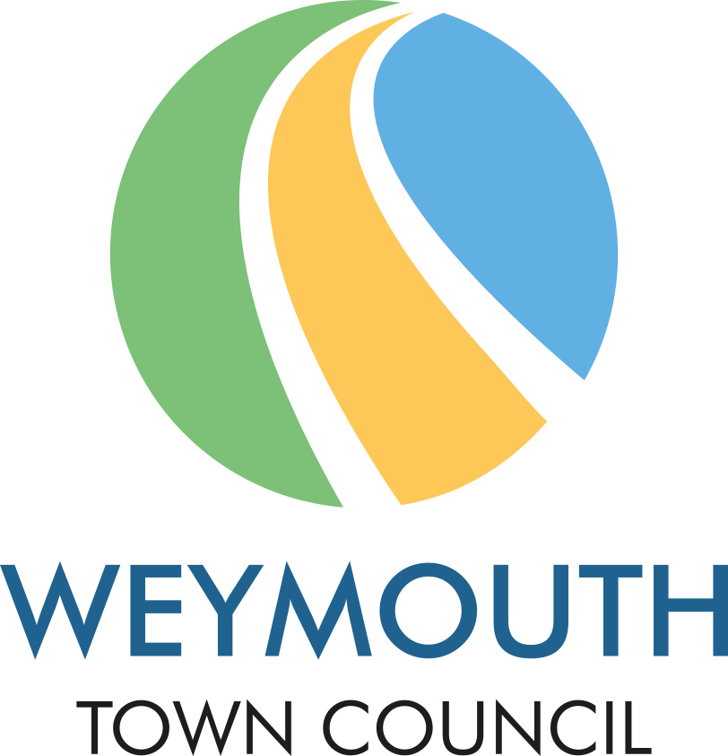

Mayor of Weymouth – Cllr Caroline Nickinson
Mayor’s Escort – Mr Richard Nickinson
Deputy Mayor of Weymouth – Cllr Thomas Taylor
Deputy Mayor’s Escort – Various

- Arrival - Please ensure that a responsible person is delegated to greet the Mayor/Deputy Mayor on arrival and that the Mayor/Deputy Mayor is then accompanied – not necessarily by the same person – for the whole event. The Mayor will normally arrive no more than 10 minutes before the commencement of the event.
When several Mayors are to be present at an event within the boundary of Weymouth, the arrival of the Mayor of Weymouth should be timed later than that of the other Mayors. If you require that the other Mayors are to wear their Chains of Office, permission must first be obtained from the Mayor of Weymouth.
- Precedence and Seating - The Mayor is the first citizen of the Town and only yields precedence within the Town to the Royal Family or the Lord Lieutenant representing H.M. The King in his official capacity. Accordingly, the Mayor should usually be seated on the immediate right of the President, Chairman or Host. The Mayoress/Consort or Escort sits on the immediate right of the Mayor or on the left of the Chairman. The Deputy Mayor, when acting for the Mayor, should be accorded the same precedence as that which would be accorded to the Mayor.

- Toasts and Speeches - If the Mayor is to be asked to speak at any dinner or similar event, his/her toast should appear early in the Toast List. Please enclose all relevant details which may be helpful to the Mayor in preparing his/her speech. (Guidelines should include the length of speech and details of anyone who should be referred to.)

- Car - Where possible it would be helpful if a parking space can be reserved at the main entrance to the venue for the Mayor’s vehicle.

- Royal Visits - If a member of the Royal Family is present the Mayor should be invited and on formal or public occasions they will be robed. Please seek advice and assistance from the Mayor’s Civic Officer at an early date regarding the necessary detailed arrangements for such occasions i.e. the Mayor must welcome the Royal visitor first and be the last person to take leave of the Royal visitor, (subject to the presence of the Lord Lieutenant).

- Mode of Address - The correct description for the purpose of printing or for formal introduction is: ‘The Worshipful the Mayor of Weymouth, Councillor X’ and if the Mayoress/Consort or Escort is present: ‘The Worshipful the Mayor and Mayoress/Consort or Escort of Weymouth, Councillor XXXX and Mr/Mrs/Ms/Miss X’. If the Deputy Mayor is present: ‘The Deputy Mayor of Weymouth, Councillor X’ and if the Deputy Mayoress or Deputy Mayor’s Consort or Escort is also present: ‘The Deputy Mayor and Deputy Mayoress/Deputy Mayor’s Consort or Escort, Councillor X and Mr/Mrs/Ms/Miss X’.

The correct verbal address when talking to the Mayor is ‘Mr/Madam Mayor’ and to the Mayoress, ‘Mayoress’. The Mayor is always referred to as a Mayor, whether male or female. A Mayoress is the female chosen by the Mayor to accompany them for the year. If the Mayor has a Consort or Escort, that person is referred to by name, (Mr/Mrs/Miss/Ms etc). The Deputy Mayor is addressed as ‘Mr/Madam Deputy Mayor and the Mayoress/Consort or Escort of the Deputy Mayor is addressed by name.

- Dress - Particular attention is requested to the information required on the attached form relating to the appropriate dress to be worn for the occasion. It is important to distinguish between ‘dinner jacket’ and ‘evening dress, (white tie and tails)’. Embarrassment over dress to the Civic Party can be avoided by a clear and full description.
- Duties - Please give some thought to what you wish to achieve by having the Mayor at your function and what you would like the Mayor to do. This may perhaps include making a presentation, receiving a cheque, reading a lesson, making a speech or drawing a raffle. Please also bear in mind that the Mayor often has several civic engagements following throughout the day and will need to leave your event on time, in order to maintain their schedule.

- Gifts – On occasion the Mayor is presented with a gift or flowers by organisers at events; if this is something you may be considering, the Mayor politely requests a donation to the charity fund be made instead.

- Other invitees – It would assist the Civic Office to be informed if any other VIP’s or Councillors will be attending your event.

