Weymouth Town Council - Community Governance Review

Draft response to public consultation March 2023
Weymouth Town Council (WTC) has carefully considered the draft proposals published by Dorset Council. There is now a single option presented to the public. WTC is pleased that we have been listened to regarding the northern extension of the boundary, to include the new development at Littlemoor, and the bridge at Ferry Bridge that moved in 1985. However, the option presented fails to fix historically anomalous boundaries on our western boundary contrary to guidance §16,26,84, nor does it address anomalies which will occur in the next few years. The proposed warding for Weymouth is a real concern, as there are two wards which are significantly undersized, which unbalances electoral integrity across the whole of Weymouth, contrary to guidance §166-167
WTC refers readers to background information presented in our three previous submissions:
- Items 41-45 https://www.dorsetcouncil.gov.uk/w/community-governance-review-initial-submissions/representations-received
- Items 13-15 https://www.dorsetcouncil.gov.uk/w/community-governance-review-submissions/representations-received-on-draft-recommendations
- And pages 40-48: https://www.dorsetcouncil.gov.uk/documents/35024/3292567/FINAL+Initial+consultation+responses+-+Weymouth+and+neighbouring+parishes+and+Vale+of+Allen+CGR+%281%29.pdf/68cd01ae-9e5d-5b4c-a630-7a6fadd45275?t=1675430738880

WTC Reasoning for Suggestions
WTC firmly believes that Camp Road and Mandeville Road are part of the community of Wyke Regis in Weymouth. Mandeville Road is 2.5 miles from Willowbed Hall, and over a mile by road to the existing Weymouth Boundary. ASDA in Weymouth would be its nearest Supermarket, but for services such as schools, doctors, libraries, mini-Tesco and community centres, Wyke Regis is the local community. As of 2021, there were only 3 properties “in west Dorset” on Mandeville Road, but more are under construction, and this boundary should be addressed pursuant to guidance §15.
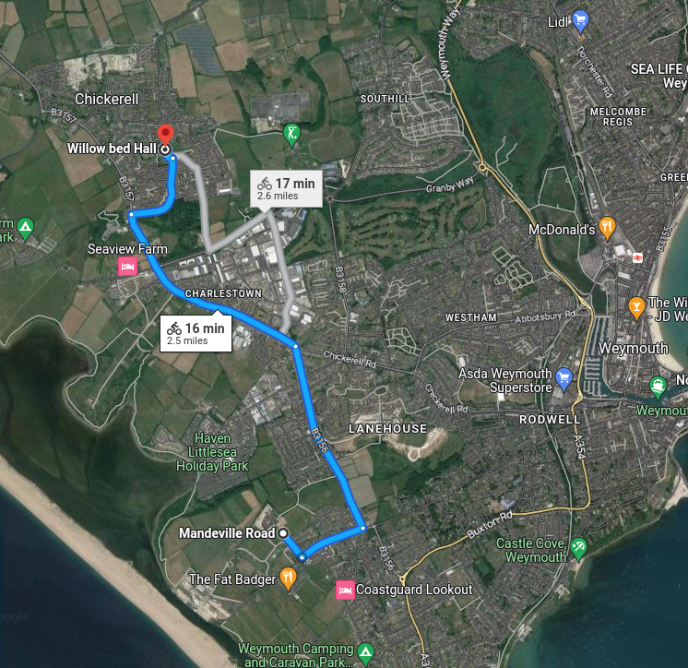
The proposed Southill Expansion will be accessed via Radipole Lane, and part of the Southill Community. Between this development and Chickerell Town is; a 45MW gas-fired power station and 400kV substation, an existing solar farm, a proposed solar farm and battery storage, a golf facility, Weymouth Football Club, and the main police station. Pursuant to the guidance §58, we believe the new development forms a neighbourhood with the existing Southill community.
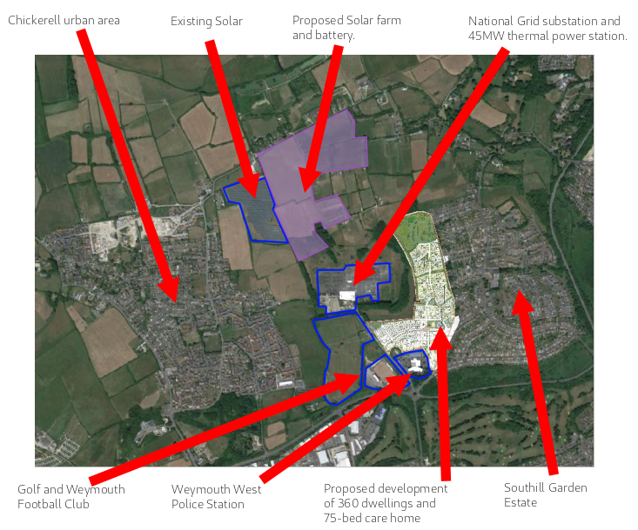
In distances, the new development will be 0.2mi from the access to the new development to Southill Centre, but over a mile further to Willowbed Hall.
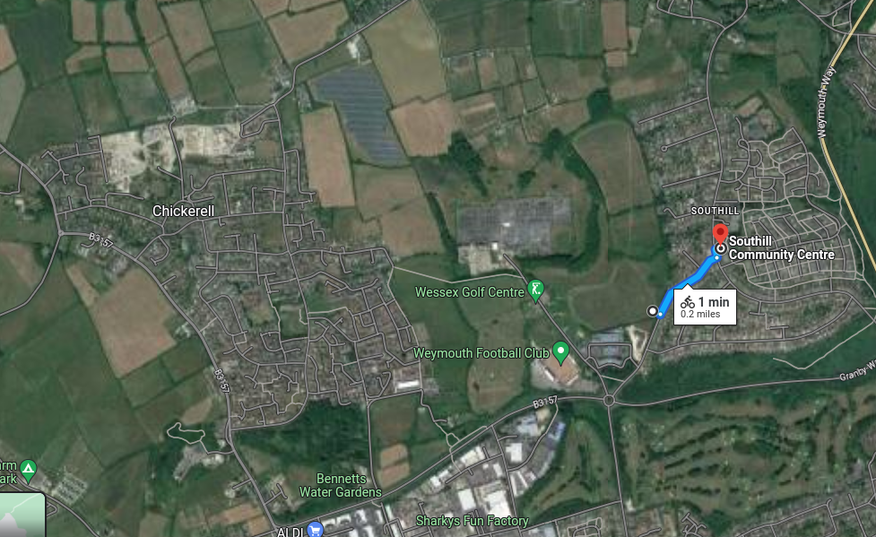
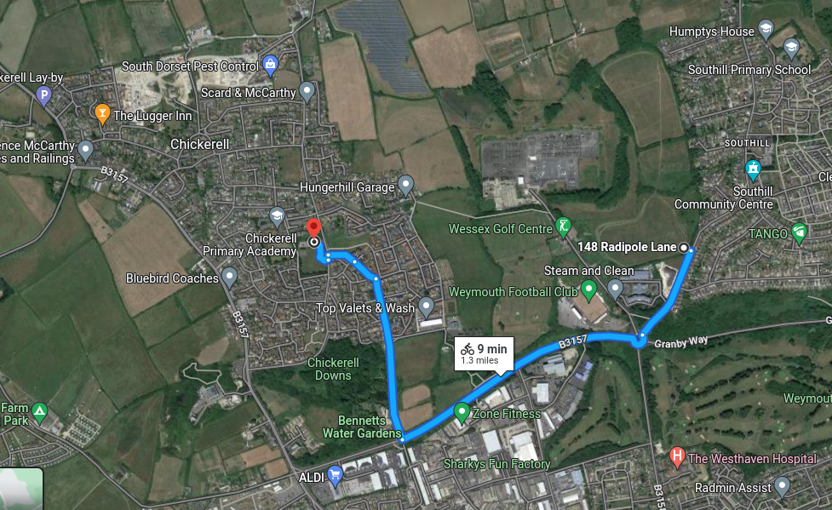
The football club at Radipole Lane is "Weymouth Football Club" having played at the old Recreation Ground until 1987, before the construction of ASDA. This is obviously part of the community of Weymouth. It is also worth noting that Chickerell has its own football team, Chickerell United, who play at The Stalls in the centre of Chickerell.
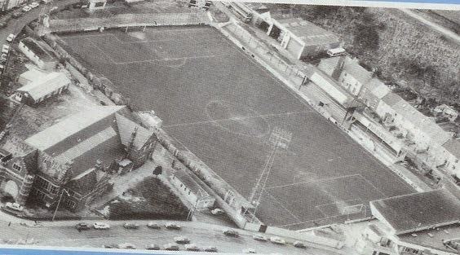
The old Recreation Ground, Sydney Hall in the foreground, Marsh Road Garages at back, date unknown.
For the reasons given above, WTC firmly believes the two future development areas, at Southill and Mandeville Road are part of the town of Weymouth and should be included within the Weymouth parish boundary.
WTC has listened to some comments regarding warding, from members of the Littlemoor community. WTC acknowledges that there is local opposition the development of the fields opposite, however that is a made planning decision. The CGR cannot over-turn a planning matter, even if people wish it could. We have looked at options and considered if it is possible to grant Littlemoor its own ward, and what the consequences of doing so would be for the wider town. The view of WTC is that the new development north of Littlemoor is approved, and the developer is making progress to commence building, the new residents will be best served democratically, warded with Littlemoor.
WTC has also considered the submissions by Chickerell Town Council (CTC). We have met with CTC on two occasions to discuss compromises and WTC has offered further meetings. CTC has not brought any options to the table, nor been able to consider how the circumstances have changed since the 1972 boundaries (pursuant to guidance §15,26,84), nor been willing to constructively address the obvious issues of anomalous boundaries. CTC’s written submission is more of a historical reflection, many of the points made lack relevance to the guidance for this process in the 21st century. It’s regrettable that CTC have been uncompromising, have not wished to meet with WTC further, and have supported a proposal that does not address historical anomalies and fails to re-establish a clear boundary between the two towns – pursuant to §83 of the guidance.
WTC remains concerned that these parish proposals are being aligned to upper boundaries. The guidance (and additionally the guidance for the review of Local Authority wards confirms) is clear that parish boundaries should be aligned to communities and will be used as building-blocks to improve the upper boundaries at the next review – pursuant to the guidance §17,29,85. WTC notes the Weymouth unitary wards were set in 2018, which were based almost entirely on the 1972 district boundaries. Continuing to set boundaries based on the past, is perpetuating the issues. WTC expects an opportunity to set sensible, community-based parish wards and boundaries, before the next review of the unitary wards – so that these historical anomalies can finally be resolved. WTC remains committed to making a proposal that fully complies with the guidance and will not make a proposal that might leave Dorset Council open to risk of legal review.
Weymouth Town Council presents two fresh preferences.

First Preference
WTC’s first preference is based on our previous suggestion. This preference is for 24 councillors in 12 wards, an average of 1795 electors/councillor (predicted 2030 numbers). Please see attached map. This addresses anomalous boundaries to the west, provides good electoral equality, aligns to communities, and is based on unitary wards at Cllr Flower’s request. In the below graphic, the unitary wards are shown, the red lines are parts we have retained for parish warding. The grey lines are the only areas where we have suggested small tweaks to improve community cohesion, pursuant to §83 of the guidance. The only “internal” boundary alteration is Goldcroft Road, which is clearly in Westham, and separate from and not connected to Southill/Radipole ward.
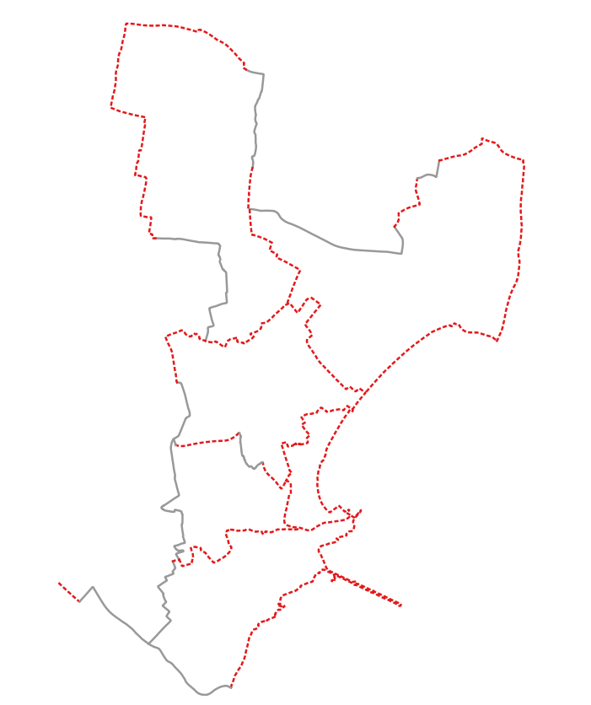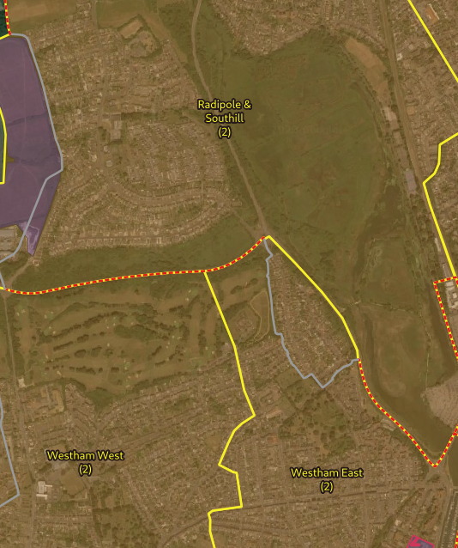
Ward name | Number of seats | Electors / seat 2030
All Saints Wyke Regis | 2 | 1778
Broadwey, Nottington & Upwey | 2 | 2012
Lanehouse | 1 | 1803
Littlemoor | 2 | 1869
Lodmoor | 2 | 1760
Melcombe Regis | 2 | 1755
Preston and Sutton Poyntz | 3 | 1465
Radipole and Southill | 2 | 1817
Rodwell | 2 | 1793
Westham East | 2 | 1881
Westham West | 2 | 1894
Wyke South | 2 | 1880

Second Preference
WTC’s second preference is a compromise. This preference is for 24 councillors in 11 wards, an average of 1752 electors/councillor (predicted 2030 numbers). Please see attached map. This partially addresses anomalous boundaries on the west, provides improved electoral equality, and is based on unitary wards at Cllr Flower’s request.
To try to improve the anomalous boundaries, we would be prepared to exchange 40 properties in Cobham Drive for 40 in Littlesea Estate. We make this suggestion without prejudice; WTC firmly believes that all evidence supports that both these areas are accepted parts of Weymouth Town. WTC is prepared to make this concession, as the proposal out for public consultation completely ignores this anomalous boundary, and the residents of both towns deserve better than to have boundaries that cut through semi-detached buildings. We have been unable to meet with CTC to discuss this proposal as our requests for meetings have not been accepted.
In the below graphics, the red line is the existing boundary, and the yellow area is the WTC proposal.
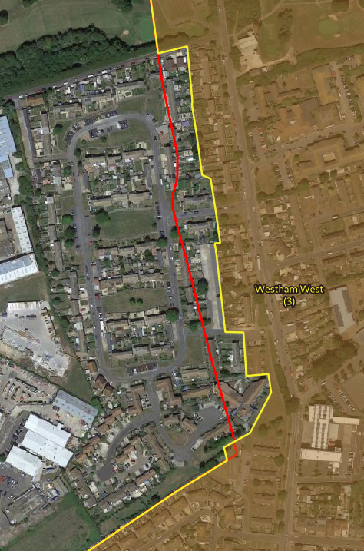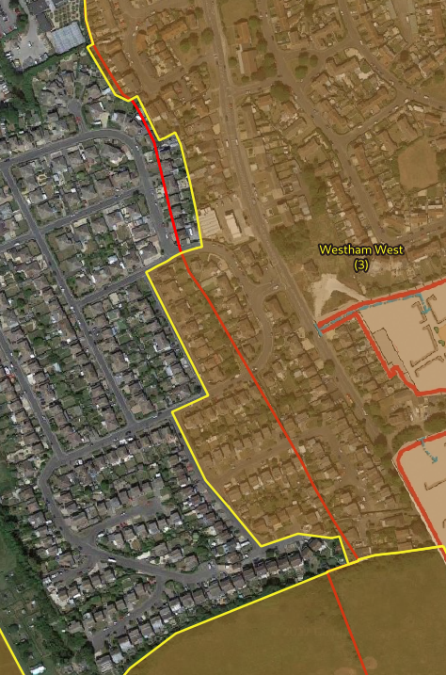
Ward name | Number of seats | Electors / seat 2030
All Saints Wyke Regis | 2 | 1782
Broadwey, Nottington & Upwey | 2 | 2012
Littlemoor | 2 | 1869
Lodmoor | 2 | 1761
Melcombe Regis | 2 | 1755
Preston and Sutton Poyntz | 3 | 1465
Radipole and Southill | 2 | 1816
Rodwell | 2 | 1793
Westham East | 2 | 1572
Westham West | 3 | 1729
Wyke South | 2 | 1880

