Council Offices, Commercial Road, Weymouth, Dorset, DT4 8NG
01305 239839 - office@weymouthtowncouncil.gov.uk

Councillors nominated to the Human Resources Committee are hereby summonsed to attend the following meeting. Please inform the Clerk if you are unable to attend.

NOTICE OF MEETING
MEETING: Human Resources Committee
DATE & TIME: Wednesday 08 February 2023 at 7:00pm.
PLACE: Civic Suite, The New Town Hall, Commercial Road, Weymouth, DT4 8NG

This is a meeting in public, not a public meeting.
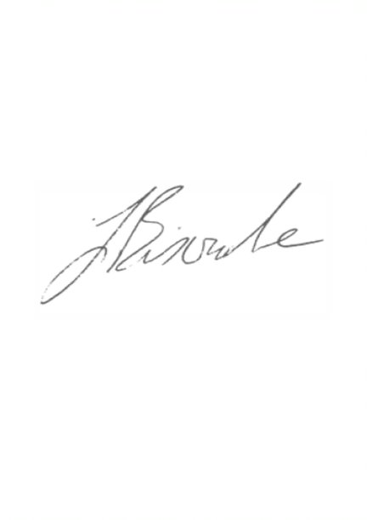
Should members of the public and press wish to attend meetings or ask a public question, please email office@weymouthtowncouncil.gov.uk
Agenda and papers are available at www.weymouthtowncouncil.gov.uk
Please do not attend the meeting if you feel unwell. Attendees will be asked to sign in to assist with health and safety including fire evacuation.

J L Biscombe, FSLCC, CiLCA
Town Clerk 02 February 2023 ____________________________________________________________________________

Agenda

- Apologies for Absence and Substitutions
- Declarations of Interest
- Minutes of last meeting
- Councillor questions and statements
- Public questions
- Information items:
- Actions from previous meetings
- Forward Plan
- Exclusion of Press and Public
- Staffing updates

Apologies for Absence and Substitutions
To approve apologies for absence and substitutions. Please note the requirements of Standing Orders for substitutions.

Declarations of Interest
To receive Councillor declarations of interest in matters on the agenda.

Minutes of last meeting
To approve the minutes of the last meeting held on 16 November 2022.

Recommendation:
Members are asked to agree the minutes of the last formal meeting held on 16 November 2022 as a true and accurate record, and that they be signed as such.

Councillor’s Questions and statements
In accordance with Standing Order 29, one clear day’s notice in writing to the Clerk of the meeting is required. In the case of urgent items permission must be sought from the Chairman and the question submitted to the Clerk of the meeting by 3:00pm on the day of the meeting.

Public Question Time
The length of time available for public questions will be determined by the Chairman.

Information Items

Actions from previous meetings
Date | Who | Action | Status
09/03/22 | JB | Investigate digital programme management tools for the Council. | In progress, no action since last meeting due to capacity.
09/03/22 | JB | Carry out a skills audit across the organisation (staff and Councillors) and arrange a HR workshop for May. | To be revisited in 2023
11/03/20 | JB | Bring forward an updated Apprentice Pay Policy | On hold

Forward Plan
Date | Meeting | Items for consideration
15/02/23 | Full Council | Risk management and internal controls  Asset register  Q3 Budget Monitoring  Release of earmarked reserves for seafront railings replacement  Nursery Relocation Business Case  Release of Project Support Reserve funds for Greenhill beach access improvements and beach hire equipment.  Operational Workforce Monitoring Policy
22/02/23 | HR | HR Support Review  Union recognition agreement
01/03/23 | Services | Events Programme 23  Seafront lighting (including lasers) - future options.  Applications for free use of Dorset Council car parks  Resort Service – service plan 2023-24  Review of public toilet provision.  Review from Development Board (info prior to FC)  PID – Sea Swimming Event
15/03/23 | F&G | Seafront digital advertising screens procurement  Asset maintenance programme.
22/03/23 | Full Council | Endorsement of Release of Draft Weymouth Neighbourhood Plan (Reg 14 Consultation)  Weymouth Business Improvement District (We Are Weymouth) Ballot  Review from Development Board (info)  Armed Forces Covenant update from Cllr James (following event on 23/02)
05/04/23 | HR | Staffing updates
12/04/23 | Services | Purple Flag – promotion and future options  Seafront Strategy Consultation Results
26/04/23 | F&G | Louviers twinning report
10/05/23 | Full Council | Annual Meeting  Election of Mayor, Deputy Mayor and Mayor Elect  Election of Leader and Deputy Leader  Nominations to Committees  Nomination of Champion roles  Nominations to outside bodies  Confirmation of Working Group membership

Recommendation:
That the Committee notes the information above.

Exclusion of the Press and Public
Under the Public Bodies (Admissions to Meetings) Act 1960 members of the public and press are required to leave the meeting due to the sensitive nature of the item next to be considered relating to individual members of staff.

Recommendation:
That Councillors agree to exclude the public and press.

Staffing Updates
Councillors will receive an update and proposed structure at the meeting. The full staff consultation concludes on 07 February 2023.

Recommendation:
That Councillors agree a staffing structure and arrangements for the Council.

