The New Town Hall, Commercial Road, Weymouth, Dorset, DT4 8NG
01305 239839
office@weymouthtowncouncil.gov.uk

Members of the Planning and Licensing Committee are hereby summoned to the following meeting

NOTICE OF MEETING
MEETING: Planning & Licensing Committee
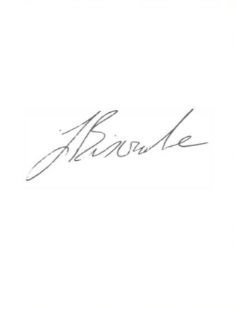
LOCATION: Council Chamber, The New Town Hall, Commercial Road, Weymouth,
DT4 8NG
DATE & TIME: Tuesday 6th September 2022, 7.00 pm

J Biscombe, FSLCC, CiLCA
Town Clerk 31st August 2022
This is a meeting in public, not a public meeting.
Members of the public are able to attend the meeting to ask a questions and this should be pre-arranged with the meeting clerk via office@weymouthtowncouncil.gov.uk by 9am on the day prior to the meeting.
Members of the public are reminded that Weymouth Town Council are not the planning authority and are only consultees on planning applications. Members of the public are encouraged to submit their views via the Dorset Council website as usual on the following link https://planning.dorsetcouncil.gov.uk/. Residents can also contact their local Town Councillor if they wish to discuss Weymouth Town Council’s comments on any application.
Attendees are asked to respect social distancing and are encouraged to wear masks if they wish. Please do not attend if you feel unwell.

Members of the public are urged to regularly check the Council’s social media for updates.

A G E N D A
- Apologies
- Declaration of Interests
- Minutes of last meeting
- Public Participation
- Planning Applications for discussion
- Planning Applications – no comment
- Planning Applications responded to under Delegated Powers (for information)
- Licensing, Enforcement, Appeals & Phone Masts
- Sitting Out License Applications – Standard Responses (for information)
- Other Development Consultations
- Traffic Calming and Parking Restriction Requests from the public
- Traffic Regulation Orders (TROs)
- Information Items
- Emergency Items

Item 1 – Apologies for absence
Members are asked to approve any apologies received.

Item 2 – Declarations of Interest
To receive Member’s declarations of interest in matters on the agenda.

Item 3 – Minutes of last meeting
To approve the minutes of the last formal meeting held on 16th August 2022 as a true and accurate record.

Recommendation:
Members are asked to agree the minutes of the last formal meeting held on 16th August 2022 as a true and accurate record, and that they be signed as such.

Item 4 – Public Participation
Members of the public are able to attend the meeting to ask questions and this should be pre-arranged with the meeting clerk via office@weymouthtowncouncil.gov.uk by 9am on the day prior to the meeting. The meeting will also be available to view live on the Council’s Facebook page.

Item 5 – Planning Applications for Discussion
Members have expressed a desire to discuss the following planning applications. Members are requested to review the following planning applications and recommend to the Town Clerk any comments to be forwarded to Dorset Council.

Planning applications and associated documents can be viewed at https://planning.dorset.gov.uk/public-access/

Plan No. | Details | Deadline
P/FUL/2022/03899 | Proposed mixed community use; Demolition and replacement buildings A, D and E, partial demolition and raising of eaves and ridge to Building B, Car parking at the top field, Provision of poly tunnels field 2, Cycle storage, Mini bus drop off, Electric charging point, PV panels, Access widening and retention of pathways | 14/09/22

The following planning applications were received just prior to agenda despatch and Members are therefore requested to decide whether a comment is required or if the applications can be added to the “en bloc” vote in Item 6.

Plan No. | Details | Deadline
P/LBC/2022/05295 | 50 St Mary Street Weymouth DT4 8PU  Replacement bay sliding sash window to first floor | 20/09/22
P/ADV/2022/05237 | 116 The Esplanade Weymouth Dorset DT4 7EJ  Installation of 1no. illuminated hanging box sign and 1no. bump top sign | 21/09/22
P/LBC/2022/05238 | 116 The Esplanade Weymouth Dorset DT4 7EJ  Alterations to facilitate the installation of internal & external signage | 21/09/22
P/HOU/2022/03512 | 81 Chafeys Avenue Weymouth Dorset DT4 0EJ  Erect Single storey rear extension and convert flat roof to pitched roof. | 21/09/22

Item 6 – Planning Applications – no objection
Members have expressed that they do not wish to make any comments on the following planning applications and therefore an en bloc comment of “no objection” will be submitted to Dorset Council.

Plan No. | Details | Deadline
P/VOC/2022/04691 | 262 Portland Road Weymouth Dorset DT4 9AF  Application for approval of reserved matters for appearance & landscaping in relation to Outline Approval WP/14/00921/OUT (Variation of conditions 1 & 2 of planning application reference P/VOC/2022/02724 - to reduce terraces parapets and replace with glazing and increase of height of balustrade on 1st floor. |  | 07/09/22  Extended
P/HOU/2022/04829 | 28 High West Street Weymouth Weymouth DT4 8JH  Erect decking and store to be refurbished with new roof. |  | 07/09/22  Extended
P/LBC/2022/04831 | 28 High West Street Weymouth DT4 8JH  Erect decking and store to be refurbished with new roof. External alterations including existing render to be made good and repainted, replace windows and new bifold door. Internal alterations including removal of partitions, replace kitchen and bathrooms. |  | 07/09/22  Extended
P/HOU/2022/04774 | 6 Mayfield Close Weymouth Weymouth DT4 0TE  Erect single storey side extension |  | 07/09/22  Extended
P/HOU/2022/04994 | 76 Radipole Lane Westham Weymouth Dorset DT4 9RS  Extensions and alterations to remodel existing bungalow. |  | 07/09/22  Extended
P/HOU/2022/04711 | 23 Greenhill Weymouth Weymouth DT4 7SW  Demolish existing garage and erect self-contained detached annex. |  | 07/09/22  Extended
P/VOC/2022/05086 | St Nicholas Church Buxton Road Weymouth Dorset DT4 9PJ  Demolition of the existing Church and erection of 18 flats (including at least 6 affordable units) with associated external amenity space, parking spaces and modification of existing vehicular access (with variation of condtion 1 of planning permission WP/19/01016/FUL - amend drawings and update conditions 3, 4, 5 and 7 as already approved and update condition 6 to reflect the changes in levels) | 07/09/22
P/HOU/2022/05011 | 827 Dorchester Road Weymouth Dorset DT3 5LB  Formation of a driveway and dropped kerb following removal of part of front wall | 07/09/22
P/HOU/2022/04088 | 20 Sutcliffe Avenue Weymouth DT4 9SA  Retain extension for use as leisure/hobbies room | 07/09/22
P/LBC/2022/05127 | 70a First Floor Flat St Thomas Street Weymouth Dorset DT4 8EL  Erection of timber partition to living area | 08/09/22
P/HOU/2022/03062 | Selwyns Puddledock Lane Weymouth Dorset DT3 6LZ  Proposed lower ground and two storey side extension and single storey rear extension | 08/09/22
P/HOU/2022/04715 | 8 Lakeside Gardens Weymouth DT3 5HQ  Erect rear extension | 13/09/22
P/FUL/2022/05234 | 91 Bowleaze Coveway Weymouth Dorset DT3 6PW  Change of Use from staff accommodation to ancillary office accommodation for adjacent holiday business | 14/08/22
P/RES/2021/04983 | Land to the north of Littlemoor Road Weymouth  Application for approval of reserved matters for access, layout, scale, appearance and landscaping in relation to outline applications WD/D/16/000739 and WP/16/00253/OUT | 08/09/22
P/FUL/2022/04669 | Land at rear of 205 Littlemoor Road Weymouth DT3 6AF  Conversion of existing storage building into 2no. 2 bedroom dwellings | 15/09/22

Recommendation:
That the Committee recommends to the Town Clerk that a comment of “no objection” is returned for the above planning applications.

Item 7 - Planning Applications responded to under Delegated Powers (gas central heating installation/electric vehicle charging points) (for information)
None

The delegations to Officers currently in place relate to gas central installation and the installation of electric vehicle charging points. Should Members wish to add anything into the scheme of delegation as the year progresses, they should speak to Charmaine Denny and the request can be brought to this Committee for consideration.

Item 8 - Licensing, Enforcement, Appeals & Phone Masts

Premises Licence Review Application
None

Appeals

P/OUT/2021/03467
Storage Land And Premises Weston Road Weymouth Dorset
Outline application for erection of 6no. dwellings
An appeal has been made to the Secretary of State against Appeal Against Refusal by Dorset Council.

You may view the documents relating to this appeal online at https://www.dorsetcouncil.gov.uk/planning-buildings-land/planning/planningapplication-search-and-comment.aspx

The appeal will be determined on the basis of Written representations. The procedure to be followed is set out in Part 1 of the Town and Country Planning (Appeals) (Written Representations Procedure) (England) Regulations 2009, as amended.

This means that you will be given the opportunity to summit representations on the appeal. We have forwarded all the representations made to us on the planning application to the Planning Inspectorate and the appellant. These will be considered by the Inspector when determining the appeal.

Any further representations you may wish to make must be received by 23 September 2022. Any representations submitted after the deadline will not usually be considered and will be returned. The Planning Inspectorate does not acknowledge representations. All representations must quote the Inspectorates appeal reference.

Planning Service privacy notice can be found at: www.dorsetcouncil.gov.uk/your-council/about-your-council/data-protection/service-privacynotices/planning.aspx representations. All representations must quote the Inspectorates appeal reference.

Please note that any representations you submit to the Planning Inspectorate will be copied to the appellant and this local planning authority and will be considered by the Inspector when determining the appeal.

Recommendation:
The planning application was considered by the Planning and Licensing Committee on the 12th October 2021. At that time, the Committee Members voted unanimous in favour of submitting a comment that the application is vast improvement on the previous one. However, concerns remain about the angling of security lighting and the protection of the historic stone wall that runs between the development site and Garibaldi Row.

P/HOU/2022/02552
9B Sycamore Road Weymouth Dorset DT4 9UF
Convert and extend garage to Annex.
An appeal has been made to the Secretary of State against Appeal Against Refusal by Dorset Council.

You may view the documents relating to this appeal online at https://www.dorsetcouncil.gov.uk/planning-buildings-land/planning/planningapplication-search-and-comment.aspx

As this appeal is proceeding under the Householder Appeals Service, there is no opportunity for you to submit comments. However, we have forwarded all the representations made to us on the application to the Planning Inspectorate and the appellant. These will be considered by the Inspector when determining the appeal. If you wish to withdraw any representations you made on the application, you must contact the planning inspectorate. You can do this my emailing, RT1@planninginspectorate.gov.ukor you can write to: (quoting the appeal reference)

Contact Name: Jessica Werrett
Address: RT1
The Planning Inspectorate
Temple Quay House
2 The Square
Bristol
BS1 6PN

Planning Service privacy notice can be found at: www.dorsetcouncil.gov.uk/your-council/about-your-council/data-protection/service-privacynotices/planning.aspx

Information provided in your representation will be published. This may include your name and address, but personal telephone numbers and email addresses and signatures of individuals will be removed. If you object to publication in this way, please contact the Planning Inspectorate.

Recommendation:
The planning application was considered by the Planning and Licensing Committee on the 3rd May 2022. Members voted unanimously in favour of returning a comment of “no objection” in relation to the planning application detailed above.

Item 9 – Sitting Out License Applications – Standard Responses (for information only)
None

Item 10 - Other development consultations
None

Item 11 – Traffic Calming and Parking Restriction Requests from The Public

Proposal for review of parking regulations at Bowleaze Coveway
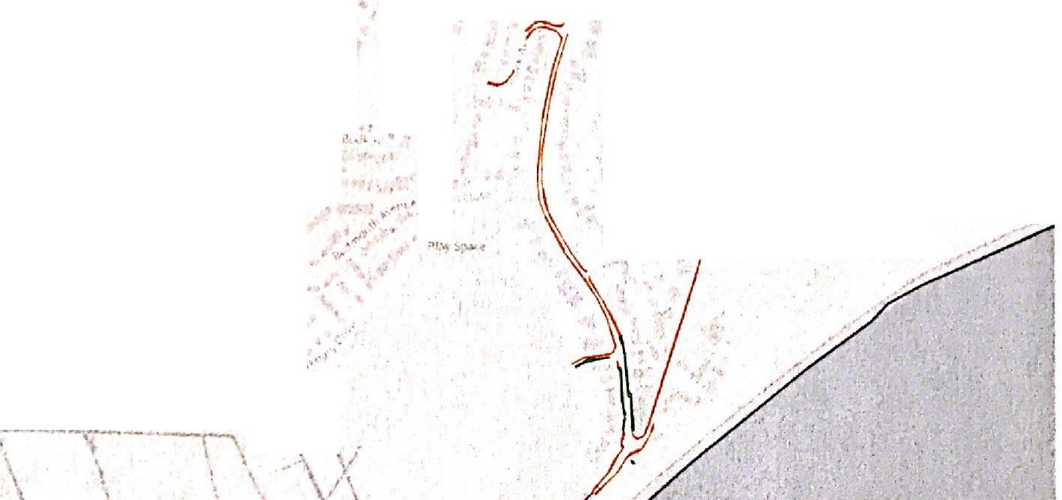
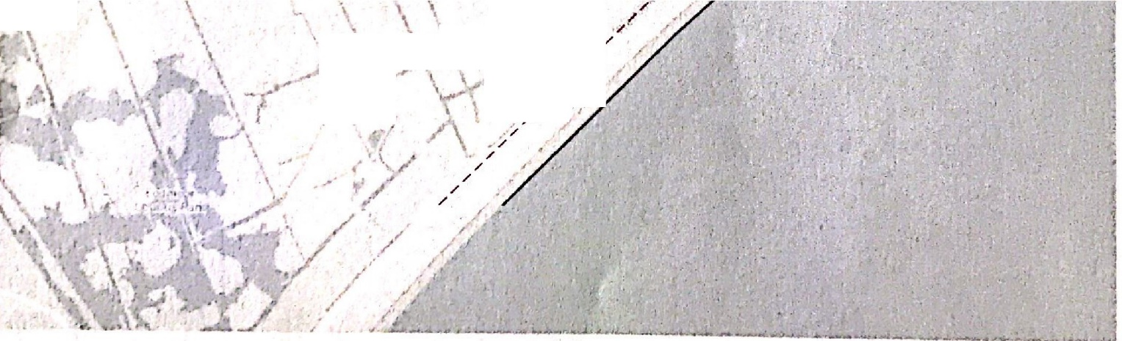

/! \.:,·•,.i._ ,' --(/ ·.
..
I,
....
Over ombe,
V
\
')'
.
' '.
\
\
_,.
\
/.'
\
.;,:I
\
/
> ; J.
/
_/ •"
//
\ ·' \
,,,... '··
/
,,,,i,' .
,./
.·/
/
/
/
/
/

A proposal has been put forward by a member of the public for a review of the parking restrictions at Bowleaze Coveway.

Currently on the water side of the road leading to Bowleaze Coveway a no parking restriction is in place from midnight to 06:00. Member of the public advises that this restriction is not being adhered to, and that Parking Services have recommended to them that a reduction in hours would make it easier for them to enforce and therefore prevent illegal parking.

The proposal would be to extend the restricted no parking on Bowleaze Coveway to 10:00-07:00 and to review if necessary.

This request has been made by a member of the public and is supported by Cllr Jan Bergmann and Cllr Tony Ferrari. It also has the support of Marion Fisher, Operations Manager (Interim) at Dorset Council.

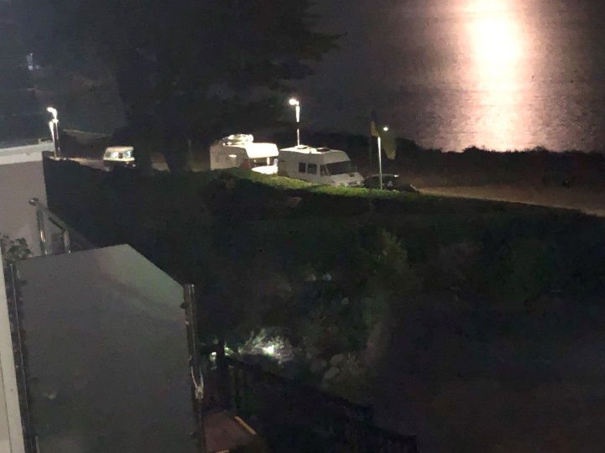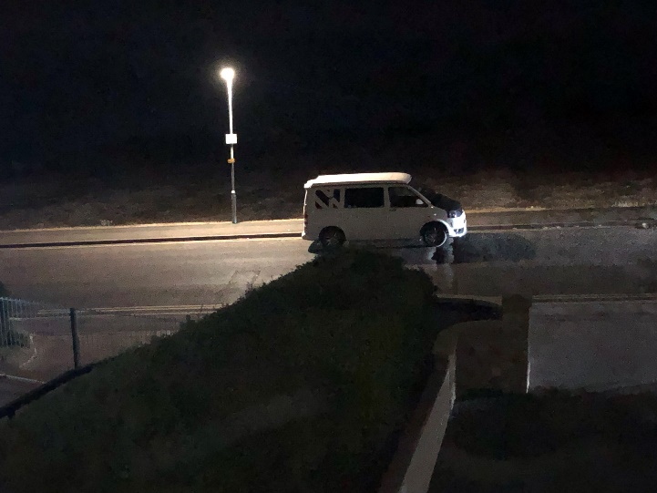

Recommendation:
Members are asked to consider the request above and agree whether or not they support the request going forward to Dorset Council for assessment.

Item 12 – Traffic Regulation Orders (TROs)
None

Item 13 – Information Items

P/NMA/2022/04833
8-10 Site Of Dorchester Road Weymouth Weymouth
The above Non Material Amendment application has been received by Dorset Council, and Weymouth Town Council is being notified for information purposes only. The application and any supporting documents can be viewed by clicking on the application number above. Should Members have any queries, the Case Officer can be contacted.

P/PALH/2022/04659
80 Westhill Road Weymouth Dorset DT4 9NE
Erect single storey flat roofed rear extension to extend 3.9m beyond the rear wall of the original house, to a maximum height of 2.8m and height to eaves of 2.5m for living room.
The above application has been received by Dorset Council, and Weymouth Town Council is being notified for information purposes only. This application is not a planning application but a request for Dorset Council to determine whether or not Prior Approval is required for the proposal. The application and any supporting documents can be viewed by clicking on the application number above. Should Members have any queries, the Case Officer can be contacted.

P/CLP/2022/04944
80 Westhill Road Weymouth DT4 9NE
Erect rear loft conversion with dormer.
The above Certificate of Lawful Use Proposed has been received by Dorset Council, and Weymouth Town Council is being notified for information purposes only. The application and any supporting documents can be viewed by clicking on the application number above. Should Members have any queries, the Case Officer can be contacted.

P/NMA/2022/05059 and P/NMA/2022/05058
Land To North Of Littlemoor Road Weymouth
Non material amendment to WP/16/00253/OUT and Non material amendment to WD/D/16/000739
The above Non Material Amendment application has been received by Dorset Council, and Weymouth Town Council is being notified for information purposes only. The application and any supporting documents can be viewed by clicking on the application number above. Should Members have any queries, the Case Officer can be contacted.

P/NMA/2022/05037
Waterside Holiday Park Bowleaze Coveway Weymouth DT3 6PP
Non material ammendment to WP/20/00756/FUL
The above Non Material Amendment application has been received by Dorset Council, and Weymouth Town Council is being notified for information purposes only. The application and any supporting documents can be viewed by clicking on the application number above. Should Members have any queries, the Case Officer can be contacted.

P/NMA/2022/05294
66 Elwell Street Weymouth Dorset DT3 5QF
Non material amendment - additional conservation rooflights & change of cladding to planning permission WP/19/00430/VOC
The above Non Material Amendment application has been received by Dorset Council, and Weymouth Town Council is being notified for information purposes only. The application and any supporting documents can be viewed by clicking on the application number above. Should Members have any queries, the Case Officer can be contacted.

Neighbourhood Planning Update (Standing Item)
A verbal update will be provided by Cllr Northam.

Recommendation:
Members are asked to note the information items.

Item 14 – Emergency Items
To be advised at the meeting.

