

Council Offices, Commercial Road, Weymouth, Dorset, DT4 8NG

01305 239839

[office@weymouthtowncouncil.gov.uk](mailto:office@weymouthtowncouncil.gov.uk)

Members of the Planning and Licensing Committee are hereby summoned to the following meeting

### NOTICE OF MEETING

MEETING: **Planning & Licensing Committee**

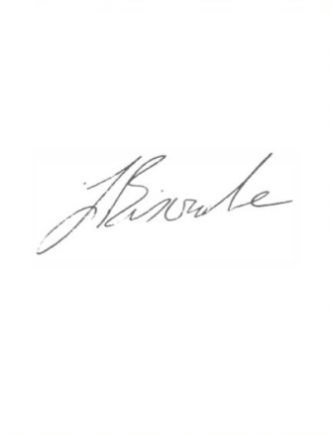LOCATION: **Council Chamber, Council Offices, Commercial Road, Weymouth,**

**DT4 8NG**

DATE & TIME: **Tuesday 24 May 2022, 7.00 pm**

J Biscombe, FSLCC, CiLCA

Town Clerk 18 May 2022

This is a meeting in public, not a public meeting.

Members of the public are able to attend the meeting to ask a questions and this should be pre-arranged with the meeting clerk via [office@weymouthtowncouncil.gov.uk](mailto:office@weymouthtowncouncil.gov.uk) by 9am on the day prior to the meeting.

Members of the public are reminded that Weymouth Town Council are not the planning authority and are only consultees on planning applications. Members of the public are encouraged to submit their views via the Dorset Council website as usual on the following link <https://planning.dorsetcouncil.gov.uk/>. Residents can also contact their local Town Councillor if they wish to discuss Weymouth Town Council’s comments on any application.

Attendees are asked to respect social distancing and are encouraged to wear masks if they wish. Please do not attend if you feel unwell.

## Members of the public are urged to regularly check the Council’s social media for updates.

## A G E N D A

1. Apologies
2. Election of Vice-Chair
3. Declaration of Interests
4. Minutes of last meeting
5. Public Participation
6. Planning Applications for discussion
7. Planning Applications – no comment
8. Planning Applications responded to under Delegated Powers (for information)
9. Licensing, Enforcement, Appeals & Phone Masts
10. Sitting Out License Applications – Standard Responses (for information)
11. Other Development Consultations
12. Traffic Calming and Parking Restriction Requests from the public
13. Traffic Regulation Orders (TROs)
14. Street Naming Bank
15. Information Items
16. Emergency Items

## Item 1 – Apologies for absence

Members are asked to approve any apologies received.

**Item 2 – Election of Vice-Chair**

Members of the Planning and Licensing Committee are asked to elect a Vice-Chair.

## Item 3 – Declarations of Interest

To receive Member’s declarations of interest in matters on the agenda.

**Item 4 – Minutes of last meeting**

To approve the minutes of the last formal meeting held on 3rd May 2022 as a true and accurate record.

### Recommendation:

Members are asked to agree the minutes of the last formal meeting held on 3rd May 2022 as a true and accurate record, and that they be signed as such.

## Item 5 – Public Participation

Members of the public are able to attend the meeting to ask questions and this should be pre-arranged with the meeting clerk via [office@weymouthtowncouncil.gov.uk](mailto:office@weymouthtowncouncil.gov.uk) by 9am on the day prior to the meeting. The meeting will also be available to view live on the Council’s Facebook page.

## Item 6 – Planning Applications for Discussion

Members have expressed a desire to discuss the following planning applications. Members are requested to review the following planning applications and recommend to the Town Clerk any comments to be forwarded to Dorset Council.

Planning applications and associated documents can be viewed at <https://planning.dorset.gov.uk/public-access/>

|  |  |  |
| --- | --- | --- |
| Plan No. | Details | Deadline |
| [P/OUT/2022/02620](https://planning.dorsetcouncil.gov.uk/plandisp.aspx?recno=381641) | Land At Ferrymans Way, Weymouth  Demolish exsiting buildings and structures and erect 25 no dwellings ( outlne application to determine access only ) | 25/05/22 |
| [P/VOC/2022/02765](https://planning.dorsetcouncil.gov.uk/plandisp.aspx?recno=386924) | Weyfish Ltd, Custom House Quay, Weymouth, DT4 8BE Change of use of first floor to form restaurant (removal of condition 9 - restriction of opening hours ) | 24/05/22 |

The following planning applications were received just prior to agenda despatch and Members are therefore requested to decide whether a comment is required or if the applications can be added to the “en bloc” vote in Item 5.

|  |  |  |
| --- | --- | --- |
| Plan No. | Details | Deadline |
| [P/FUL/2022/03098](https://planning.dorsetcouncil.gov.uk/plandisp.aspx?recno=387344) | 104 St Mary Street, Weymouth, DT4 8NY  Formation of additional storey and dormer extension to create 2no. dwellings | 08/06/22 |

## Item 7 – Planning Applications – no objection

Members have expressed that they do not wish to make any comments on the following planning applications and therefore an en bloc comment of “no objection” will be submitted to Dorset Council.

|  |  |  |
| --- | --- | --- |
| Plan No. | Details | Deadline |
| [P/FUL/2022/02109](https://planning.dorsetcouncil.gov.uk/plandisp.aspx?recno=381036) | 11 Lancaster Road, Weymouth, DT3 5BB  Erection of lodge in garden | 25/05/22 |
| [P/HOU/2022/02544](https://planning.dorsetcouncil.gov.uk/plandisp.aspx?recno=381548) | 4 Mayfield Close, Weymouth, DT4 0TE  Erect porch to main entrance with ramped access | 19/05/22 |
| [P/LBC/2022/02583](https://planning.dorsetcouncil.gov.uk/plandisp.aspx?recno=381598) | 4 Old Malthouse, Nottington Lane, Weymouth, DT3 4BH Replacement of existing windows in front and rear elevations, introduction of a vent to the roof plane above the kitchen on the rear elevation | 27/05/22 |
| [P/HOU/2022/02588](https://planning.dorsetcouncil.gov.uk/plandisp.aspx?recno=381603) | 9 St Julien Crescent, Weymouth, DT3 5DT  Enlargement and alteration of bungalow to provide accommodation over lower ground floor, ground floor and roof space. Form car paking and rebuild boundary wall. | 25/05/22 |
| [P/HOU/2022/02625](https://planning.dorsetcouncil.gov.uk/plandisp.aspx?recno=381652) | 3 Dale Avenue, Weymouth, DT4 7RB  Proposed alterations to existing ground storey roof | 25/05/22 |
| [P/HOU/2022/02642](https://planning.dorsetcouncil.gov.uk/plandisp.aspx?recno=381675) | Land and Building Opposite 66 Old Castle Road, Weymouth, DT4 8QE  Erect replacement garage | 25/05/22 |
| [P/HOU/2022/02263](https://planning.dorsetcouncil.gov.uk/plandisp.aspx?recno=381224) | 4 Mount Street, Weymouth, Dorset, DT4 8UU  Erect rear single storey extension. | 24/05/22 |
| [P/HOU/2022/02766](https://planning.dorsetcouncil.gov.uk/plandisp.aspx?recno=386925) | 3 Sussex Road, Weymouth, Dorset, DT4 0PL  Erect Single storey side and rear extensions | 25/05/22 |
| [P/HOU/2022/02767](https://planning.dorsetcouncil.gov.uk/plandisp.aspx?recno=386926) | 46 Chamberlaine Road, Weymouth, Dorset, DT4 9EY  Erect Single storey extension and porches. | 25/05/22 |
| [P/HOU/2022/02796](https://planning.dorsetcouncil.gov.uk/plandisp.aspx?recno=386959) | 4 Old Station Road, Weymouth, DT3 5NQ  Erect single storey rear extension | 25/05/22 |
| [P/HOU/2022/02783](https://planning.dorsetcouncil.gov.uk/plandisp.aspx?recno=386942) | 13 Marina Gardens, Weymouth, Dorset, DT4 9QZ  Erect single storey side and rear extensions | 25/05/22 |
| [P/HOU/2022/02834](https://planning.dorsetcouncil.gov.uk/plandisp.aspx?recno=387005) | Lansdene, Cross Road, Weymouth, DT4 9QX  First floor rear external terrace | 25/05/22 |
| [P/HOU/2022/02650](https://planning.dorsetcouncil.gov.uk/plandisp.aspx?recno=381683) | 1 Sycamore Road, Weymouth, Dorset, DT4 9UF  Erect single storey side extension, two storey rear extension and external alterations. | 26/05/22 |
| [P/HOU/2022/02874](https://planning.dorsetcouncil.gov.uk/plandisp.aspx?recno=387054) | 441 Radipole Lane, Westham, Weymouth DT4 0QF  2 Storey side extension. | 27/05/22 |
| [P/HOU/2022/02914](https://planning.dorsetcouncil.gov.uk/plandisp.aspx?recno=387108) | 13 Dale Avenue, Weymouth, Dorset, DT4 7RB  Replacement of conservatory and lean-to with single-storey extension. | 31/05/22 |
| [P/VOC/2022/02724](https://planning.dorsetcouncil.gov.uk/plandisp.aspx?recno=386868) | 262 Portland Road, Weymouth, Dorset, DT4 9AF  Application for approval of reserved matters for appearance & landscaping in relation to Outline Approval WP/14/00921/OUT (Variation of conditions 1, 2 & 3 of planning application reference P/VOC/2022/00393 - minor design changes) | 01/06/22 |
| [P/HOU/2022/02949](https://planning.dorsetcouncil.gov.uk/plandisp.aspx?recno=387153) | 11 Goldcroft Avenue, Weymouth, DT4 0ET  Proposed erection of a porch | 01/06/22 |
| [P/FUL/2022/02893](https://planning.dorsetcouncil.gov.uk/plandisp.aspx?recno=387082) | Land Between 38-40 Overcombe Drive Weymouth DT3 6QF  Erect 3 dwellings with No. 3 Bedrooms with associated parking | 02/06/22 |
| [P/FUL/2022/02955](https://planning.dorsetcouncil.gov.uk/plandisp.aspx?recno=387161) | Scout Hall Granby Close Weymouth DT4 0SW  Erection of extension to provide wheelchair accessible WC & shower facilities | 02/06/22 |

**Recommendation:**

That the Committee recommends to the Town Clerk that a comment of “no objection” is returned for the above planning applications.

## Item 8 - Planning Applications responded to under Delegated Powers (gas central heating installation/electric vehicle charging points) (for information)

|  |  |  |
| --- | --- | --- |
| [P/FUL/2022/02854](https://planning.dorsetcouncil.gov.uk/plandisp.aspx?recno=387030) | 2B Jubilee Close, Weymouth, Dorset, DT4 7BG  Installation of 2 rapid electric vehicle charging stations | 27/05/22 |

The delegations to Officers currently in place relate to gas central installation and the installation of electric vehicle charging points. Should Members wish to add anything into the scheme of delegation as the year progresses, they should speak to Charmaine Denny and the request can be brought to this Committee for consideration.

**Recommendation:**

Members are asked to note the information item above.

## Item 9 - Licensing, Enforcement, Appeals & Phone Masts

**Appeal**

[**P/FUL/2021/02148**](https://planning.dorsetcouncil.gov.uk/plandisp.aspx?recno=236993)

**36 Alexandra Road, Weymouth, DT4 7QQ**

**Replacement windows from timber sash to uPVC heritage sash windows**

An appeal has been made to the Secretary of State against Appeal Against Refusal by Dorset Council.

The documents relating to the appeal can be viewed online at <https://www.dorsetcouncil.gov.uk/planning-buildings-land/planning/planning-application-search-and-comment.aspx>.

The appeal will be determined on the basis of written representations. The procedure to be followed is set out in Part 2 of The Town and Country Planning (Appeals) (Written Representations Procedure)(England) Regulations 2009, as amended. This means that Weymouth Town Council will be given the opportunity to submit representations on the appeal. Dorset Council have forwarded all the representations made to them on the application to the Planning Inspectorate and the appellant. These will be considered by the Inspector when determining the appeal.

All representations must be received by 31 May 2022. Any representations submitted after the deadline will not usually be considered and will be returned. The Planning Inspectorate does not acknowledge representations. All representations must quote the appeal reference.

Please note that any representations submitted to the Planning Inspectorate will be copied to the appellant and the local planning authority and will be considered by the Inspector when determining the appeal.

If WTC wishes to make comments, or modify/withdraw its previous representation, WTC can do so online at <https://acp.planninginspectorate.gov.uk>

Information provided in any representation will be published. This may include names and addresses, but personal telephone numbers and email addresses and signatures of individuals will be removed. If WTC objects to publication in this way, the Planning Inspectorate should be contacted.

When made the decision will be published online at <https://acp.planninginspectorate.gov.uk>, and will be made available on the Dorset Council website where the appeal decision will form part of the application decision.

You can get a copy of one of the Planning Inspectorate’s Guide to taking part in planning appeals booklets free of charge from GOV.UK at <https://www.gov.uk/government/collections/taking-part-in-a-planning-listed-building-or-enforcement-appeal>.

This planning application was considered by the Planning and Licensing Committee on 10th August 2021. At that time, the Council objected to the application on the grounds of the loss of existing timber sash windows for UPVC replacements, in a property located within a Conservation Area.

**Recommendation:**

Members are asked to consider the information above and agree any comments to be made regarding the appeal, or whether the Committee wishes for WTC’s previous representation to be modified or withdrawn.

**Appeal**

[**P/FUL/2021/02774**](https://planning.dorsetcouncil.gov.uk/plandisp.aspx?recno=288918)

**84 Wyke Road, Weymouth, DT4 9QJ**

**Demolish existing dwelling and construct 1no. replacement dwelling**

An appeal has been made to the Secretary of State against Appeal Against Refusal by Dorset Council. The documents relating to the appeal can be viewed by clicking on the planning application above.

The appeal will be determined on the basis of written representations. The procedure to be followed is set out in Part 2 of The Town and Country Planning (Appeals) (Written Representations Procedure)(England) Regulations 2009, as amended. This means that WTC will be given the opportunity to submit representations on the appeal. Dorset Council has forwarded all the representations made to them on the application to the Planning Inspectorate and the appellant. These will be considered by the Inspector when determining the appeal.

All representations must be received by 21 June 2022. Any representations submitted after the deadline will not usually be considered and will be returned. The Planning Inspectorate does not acknowledge representations. All representations must quote the appeal reference.

Please note that any representations submitted to the Planning Inspectorate will be copied to the appellant and this local planning authority and will be considered by the Inspector when determining the appeal.

If WTC wishes to make comments, or modify/withdraw its previous representation, WTC can do so online at <https://acp.planninginspectorate.gov.uk>.

Information provided in any representation will be published. This may include names and addresses, but personal telephone numbers and email addresses and signatures of individuals will be removed. If WTC objects to publication in this way, the Planning Inspectorate should be contacted. When made the decision will be published online at <https://acp.planninginspectorate.gov.uk>, and will be made available on the Dorset Council website where the appeal decision will form part of the application decision. You can get a copy of one of the Planning Inspectorate’s Guide to taking part in planning appeals booklets free of charge from GOV.UK at <https://www.gov.uk/government/collections/taking-part-in-a-planning-listed-building-or-enforcement-appeal>.

This planning application was considered by the Planning and Licensing Committee on 12th October 2021. At that time, the Council had no objection to the application.

**Recommendation:**

Members are asked to consider the information above and agree any comments to be made regarding the appeal, or whether the Committee wishes for WTC’s previous representation to be modified or withdrawn.

**Licensing**

**New Application for Premises License**

**Beach Café, Brunswick Terrace, Weymouth**

An application for a premises license has been received by Dorset Council in respect of the above venue.

A copy of the application is attached. Any representations regarding the application must be received by no later than 7th June 2022.

When considering applications for a premises license, the four licensing objectives must be taken into account. These are:

* The prevention of crime and disorder
* The prevention of public nuisance
* Public safety
* The protection of children from harm

**Recommendation:**

Members are asked to agree any comments to be sent to Dorset Council regarding the attached application.

## Item 10 – Sitting Out License Applications – Standard Responses (for information only)

None

## Item 11 - Other development consultations

**SECTION 257, TOWN AND COUNTRY PLANNING ACT 1990**

**APPLICATION FOR A PUBLIC PATH DIVERSION ORDER – FOOTPATHS 79 & 92, WEYMOUTH AT CURTIS FIELDS**

Dorset Council has received an application to divert parts of Footpaths 79 and 92, Weymouth at Curtis Fields as shown on the attached Drawing (P236/22/1). Outline planning permission was granted in August 2016 (WP/14/00777/OUT) for the development of approximately 500 residential dwellings in 3 phases (phases 2 to 4) and Reserved Matters were approved in 2021 (WP/14/00777/OUT) for Access, Appearance, Landscaping, Layout and Scale of the outline application (68 dwellings).

The current definitive routes of Footpaths 79 and 92, Weymouth are affected by this development.

The current definitive route of Footpath 79, Weymouth runs from point A, generally north-east to point B and then continuing north-east to point C where it joins Markham Avenue.

The proposed new route of Footpath 79, Weymouth runs from point A north-east to point E, then south-east, north east and generally north to point F, then generally north east to point G, south east to point H, north north east to point I and north north west to Markham Avenue at point C where it re-joins the unaffected part of Footpath 79.

The current definitive route of Footpath 92, Weymouth runs from point D generally east south-east to point B where it meets Footpath 79, Weymouth.

The proposed new route of Footpath 92, Weymouth runs from point D, south-east to point J and then south east and east south east and generally south east to point E, where it meets the proposed new route of Footpath 79, Weymouth.

The current route of Footpath 79, Weymouth between points A – B – C is approximately 336 metres long and the proposed new route between points A – E – F – G – H – I – C is approximately 357 metres long. The current route of Footpath 92, Weymouth between points D – B is approximately 185 metres long and the proposed new route between points D – J – E is approximately 156 metres long.

The new footpaths, which will run alongside new roads through the development, will be 2 metres width and the surface will be tarmac, with a maximum gradient of 1:20.

Under section 257 of the Town and Country Planning Act 1990 Dorset Council may make an Order to divert a footpath if it is satisfied that it is necessary to do so to enable development to be carried out.

The current routes of Footpaths 79 and 92 are not available for inspection as they are currently closed by Temporary Traffic Regulation Order due to ongoing development. The proposed new routes have not yet been constructed. The site can be viewed from Markham Avenue, point A on Footpath 79, point D on Footpath 92 and from the alternative route around the east of the site which has been made available on a permissive basis during the temporary closure of the footpaths.

The development intends to enhance the existing network of public rights of way, providing new footpaths and cycleways through the site to encourage permeability and use of those modes of transport. The development of the site seeks to identify opportunities to create integration and connection between the site and the existing development surrounding it. As part of the planning conditions for the development, improvements to the surface of the existing public Right of Way known as Cockles Lane, located west of the development are being carried out. This will enhance the public rights of way network. A new public open space within Curtis Fields will open up private land to the public. This land, to the south and south-east of the development site, will remain undeveloped and be managed as public open space for the long term benefit of the local community and to protect and enhance its nature conservation interest. This will become a designated Local Greenspace delivering ecological benefits, varied planting and bio-diversity.

Weymouth Town Council is asked to submit any comments it may wish to make in writing by Friday 27th May 2022 so that they may be taken into consideration. WTC’s comments will be treated as public information and may be incorporated if a report is made to the Strategic and Technical Planning Committee.

The file is available for public inspection at County Hall, by prior appointment only. Members of the public are allowed limited public speaking at a Committee meeting. If the case is to be brought before the Committee, Dorset Council will write to those directly affected to advise them. If WTC wishes to be informed of the details of the meeting, Dorset Council should be informed of this.

To further assist Members, the follow images have been supplied by Cllr Luke Wakeling:

Existing Public Right of Way in red, proposed change in green, 5m contours in grey:

How does that compare to the site layout (from outline planning permission):

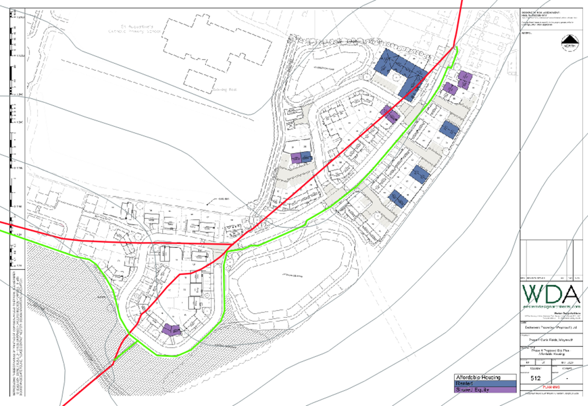

This item was considered at the last Planning and Licensing Committee meeting held on 3rd May 2022. At that time, Members voted unanimously in favour of the item being deferred in order that Officers could go back to Dorset Council for further clarity regarding the use of shared space, including the cycleway and footpaths, and requesting a map showing the changes superimposed on the new dwellings.

Attached is a plan of the proposed paths overlaid onto a plan of the development as requested, as well as the proposed diversion overlapped with the development. DC has advised that there does not appear to be any intention to fence the new routes of the footpaths. However, the developer has been asked for clarification regarding access to the open space and fencing of the new routes.

**Recommendation:**

Members are asked to consider the information above and attached, and agree any comments that WTC wishes to make.

## Item 12 – Traffic Calming and Parking Restriction Requests from The Public

None

## Item 13 – Traffic Regulation Orders (TROs)

None

**Item 14 – Street Naming Bank**

When new housing developments are built in the Town, an applicant, or Dorset Council (DC), should seek to engage with Weymouth Town Council (WTC) to consider street names that are appropriate; these suggestions are then passed onto DC.

DC do have a street naming and number policy (attached). Within this policy, it clearly details factors that need to be taken into consideration when considering street names.

Currently individual requests are brought to the Planning and Licensing Committee.

It is recommended to members that a list of appropriate street names suggestions is collated by the Planning and Licensing Committee on a six monthly basis. Through collating a list twice a year it allows the Committee to consider the names of anyone of significance that may have died within that time frame. A six monthly cycle also gives members time to collate street name suggestions from other members and their constituents.

Once agreed by the Committee officers will then be able to suggest these names to applicants when approached.

**Recommendation:**

That members of the Planning and Licensing Committee agree to a standing item on the agenda every six months to consider street names.

## Item 15 – Information Items

**Neighbourhood Plan Update (Standing Item)**

A verbal update will be given by Cllr Northam.

**THE DORSET COUNCIL (WAITING, LOADING, STOPPING AND PARKING PLACES) (MAP BASED) (AMENDMENT NO. 28) (BRUNSWICK TERRACE, WEYMOUTH) ORDER 2022**

Please find attached a copy of the notice in respect of a Traffic Regulation Order on Brunswick Terrace, Weymouth. The Order is a revised version of the proposal that was put forward for Brunswick Terrace in October 2021 due to the response that was received during the public consultation, regarding the change of restrictions of the parking bays. This order will implement a no loading restriction within the turning circle of the road.

A concern was raised by the committee in regards to the loading restriction as a loading bay is not in place. A loading bay has not been included as there is a single yellow line in place along the building side of the road which is not being changed. A single yellow line permits loading/unloading even when the restriction is in force, so long as the loading/unloading is constant.

This Order has now been made and will come into operation on 13th June 2022.

**Recommendation:**

Members are asked to note the information items.

## Item 16 – Emergency Items

To be advised at the meeting.