This policy links to:
Green Events Guide,
Biodiversity Policy
Decarbonisation Strategy

Single Use Plastic Policy

Introduction
The Single Use Plastic (SUP) Policy commits Weymouth Town Council to take action in the reduction and where possible, the removal of single use plastics from the Council’s operations and services. Within this policy, the current usage of SUP will be identified across all council departments and services. It will also discuss the steps that need to be taken to reduce any unnecessary SUP.
Background
The UK Government published its 25-Year Environment Plan in January 2018, which includes a target of “achieving zero avoidable plastic waste by the end of 2042”. In line with national policy, reducing SUP has become a priority for many local authorities across the UK and elsewhere.
In response to the 25 Year Environment Plan and The Special Report on Global Warming of 1.5°C, published by the Intergovernmental Panel on Climate Change in October 2018; Weymouth Town Council have declared a climate emergency and have committed to make the Council’s activities net zero carbon by 2030. As part of this commitment, Weymouth Town Council have pledged to phase out SUP where possible and where not possible, reduce or replace with alternatives.
SUP, often referred to as disposable plastics, are commonly used for packaging and are intended to be used only once before they are thrown away. They include items such as food packaging, bottles, straws, containers, cups, cutlery and grocery bags. SUP is also often described as being “avoidable” when a reusable or recyclable alternative could have been used instead.
Current Usage
An initial SUP audit will be carried out in order to identify the current usage across council departments and services. This will provide a detailed understanding of the SUP use in each service area. This information will provide an accurate baseline from which we can monitor and report on future actions to reduce and remove SUP. The current usage will be categorised by each department and whether alternatives are available will be identified. See Appendix 1 Current Usage.
Action

We have made initial progress on the first phase of work to eliminate SUPs where easily possible. This includes stopping the provision of plastic cups for the water dispenser and using jugs of waters and glasses at events and meetings.

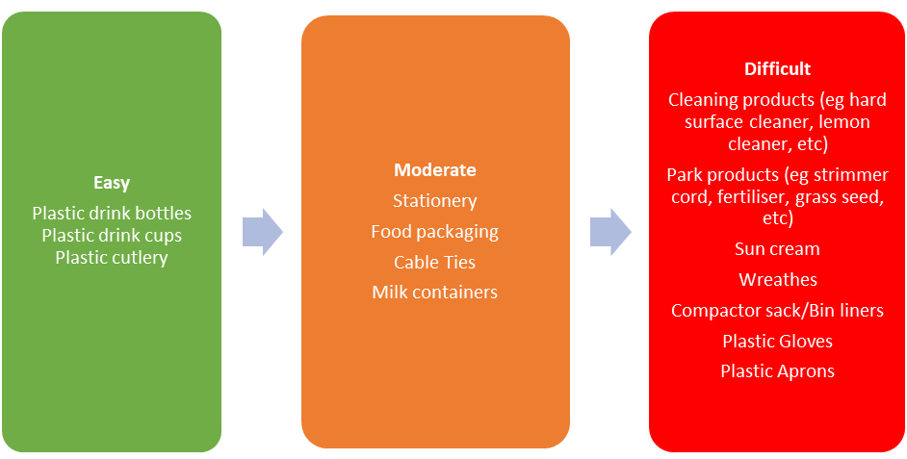

Some items may take longer to eliminate as environmentally friendly alternatives that are financially viable, are researched and sourced. The current usage of SUP can be categorised into levels of difficulty to eliminate, and a timeframe applied- from easy (6 months) to moderate (12 months) to difficult (18 months +). This information will feed into an Action Plan where realistic timescales will be set to remove, reduce, or replace each SUP. See Appendix 2 Action Plan
Monitoring and Reporting
In order to ensure that actions and progress are committed to across all service areas, a 6-month report to CEE working group will be required; followed by an annual report to Full Council.
In addition to an Action Plan, Weymouth Town Council will:
- Introduce SUP restrictions in external events taking place across Weymouth Town Council sites
- Raise staff awareness through internal education and training.
- Ensure the procurement process takes account of this policy in relation to our suppliers and contractors in finding sustainable SUP alternatives.
- Promote council actions on reducing SUP and offer advice on how the local community can eliminate usage.
- Share best practice and updates on actions that Weymouth Town Council are taking to reduce and remove SUP.
- Where SUP is unavoidable, encourage the use of recycled plastics and pursue pioneering recycling opportunities.
- Continue to support communities, beach cleans and litter-pick initiatives to ensure our parks, beaches and open spaces are free from plastic litter.

Changes to this Policy
The Single Use Plastic Policy will be kept under regular review.

Appendices
1 – WTC Single Use Plastic Usage – Services Survey
2 – Single Use Plastic Action Plan

