# Image result for Weymouth Town council

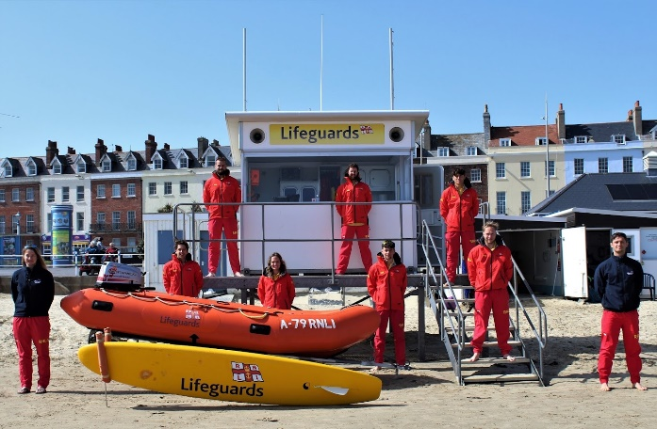

**WEYMOUTH CENTRAL & GREENHILL BEACH**

**Lifeguard Service Monitoring Report**

**Alice Higgins**

**24th November 2021**

*[Photo: Weymouth Main Beach, Easter Service RNLI Lifeguards, 2021]*

**Contents**

|  |  |
| --- | --- |
| 1. **Performance against contract**  * service delivery   + dates of operation   + hours of operation   + staffing levels   + equipment summary by beach      * contract specification compliance  1. **Service statistics**  * service statistics for the last three years * rescue and prevention statistics * incident overview  1. **Community engagement**  * public engagement statistics * major public events covered * face to face community engagement * third party relationships | 1. **Assistance required from the council**  * discussion with RNLI Shoreworks regarding the future of Weymouth Main Beach facilities. With the view to improve the existing council units on the beach that could be modernised and multi-purpose as well as reducing the amount of RNLI units that need to be installed and removed each year.      1. **Risk assessment**  * risk assessment headlines * full risk assessment review * annual review * signage/public rescue equipment review * recommendations for next year  1. **RNLI news and updates**  * RNLI management changes      1. **Report annexes** |

1. **Performance against contract**

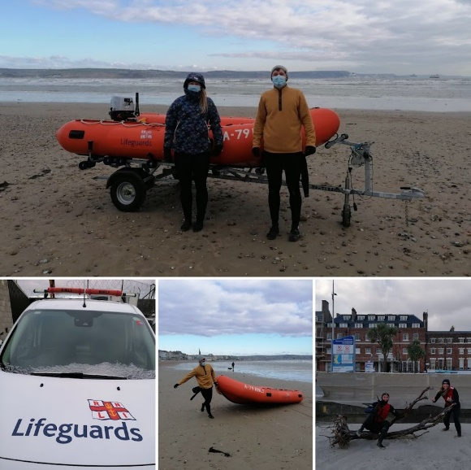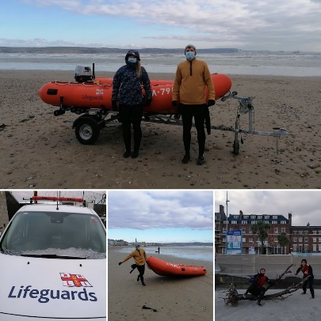

**Service delivery**

**Scheme of compliment**

*[Photo: February 2021, Supervisor Inductions]*

*[Photo: April 2021, Selection Day]*

*Dates of operation:*

[Please refer to season dates and staffing levels as provided at beginning of season in opening season date letter].

**Season Dates and Staffing Overview 2021:**

|  |  |  |  |  |  |  |  |  |  |  |  |  |  |  |
| --- | --- | --- | --- | --- | --- | --- | --- | --- | --- | --- | --- | --- | --- | --- |
| **Area** | **Beach Name** | **Early Season** | **No LGs** | **Full Start** | **No LGs** | **Main  start** | **No LGs** | **Peak  start** | **No LGs** | **Peak  Finish** | **No LGs** | **Main  Finish** | **Full  Finish** | **Late Season** |
| **WEYMOUTH** | Weymouth Main Beach | 01-Apr | 3 | 01-May | 3 | 29-May | 4 | 10-Jul | 5 | 05-Sep | 3 | N/A | 26-Sep | No |
| Greenhill |  |  |  |  |  |  | 10-Jul | 2 | 05-Sep | 2 |  |  |  |

*Hours of operation:*

1. A group of people on a beach

   Description automatically generated**–** **1800**

*Staffing levels:*

The RNLI met the scheme of compliment (SoC) 100% in 2021 for both Weymouth Main and Greenhill beaches. 8 Lifeguards were inducted on the 15th of March so to operate as two independent teams from the 1st April through to 1st May for an Easter Service at Weymouth. A 4-day shift pattern allowed a level of resilience against the continued requirement to self-isolate due to Covid. A successful Selection Day was held on the 24th of April for 20 candidates applying for 5 jobs (2 for Main and 3 for Peak Season). Two further volunteer inductions were held for 12 new lifeguards, 1 of which gained a paid position for Peak Season after the selection process. Our volunteers were invaluable in August, helping to cover the beaches when 6 of the team had either tested positive for Covid or come in contact and were asked to isolate.

*[Photo: Weymouth & West Dorset 2021 Team]*

**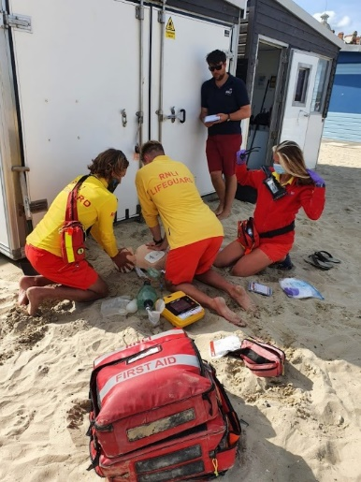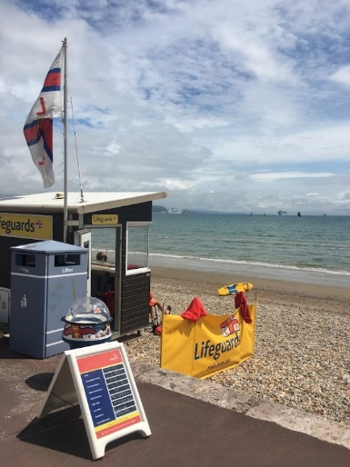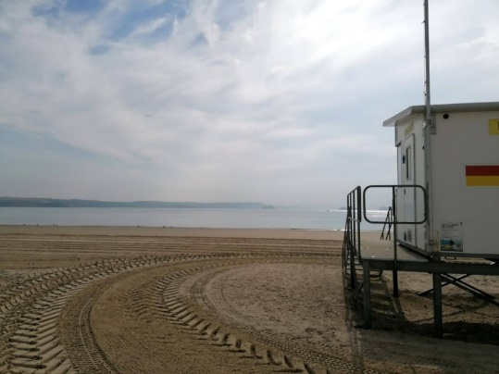***Equipment summary by beach:*

*[Photo: Weymouth BLU, 2021]*

|  |  |  |
| --- | --- | --- |
|  | **Weymouth Main Beach** | **Greenhill** |
| **ATV** | - | - |
| **Van** | - | - |
| **4WD** | - | - |
| **IRB** | **1** | - |
| **RWC** | - | - |
| **Boards** | **2** | **2** |
| **RNLI lifeguard facility** | **1 BLU**  **1 Boatshed**  **1 Office** | **1 BLU** |

*[Photo: Weymouth Units, 2021]*

*[Photo: Greenhill BLU, 2021]*

All Weymouth Main Beach RNLI Units were installed ready for the Easter Service starting on the 1st of April 2021, with the Boatshed and Office positioned back in their usual place (unable to in 2020) to the left of the Council Units on the beach when facing out to sea. A local Security firm were based in the ‘First Aid Room’ this season, but the Lifeguard team were still able to use the welfare facilities when needed. The Office Unit (absent in 2020) meant an additional area where the team could change, have a daily brief/debrief, store training first aid equipment, a dry area to carry out scenarios and supervisors use as an office space to sort out rotas etc. This space proved to be even more beneficial with the induction of 12 volunteers this year. Greenhill BLU and board bin were both installed ready for Peak Season commencing on the 10th of July 2021. All operational equipment for the area is maintained by systems technician Nick Colvile, according to the planned maintenance schedule. Being upheld at the declared levels, with any issues mitigated using spare operational equipment specifically allocated to Weymouth & West Dorset for that purpose.

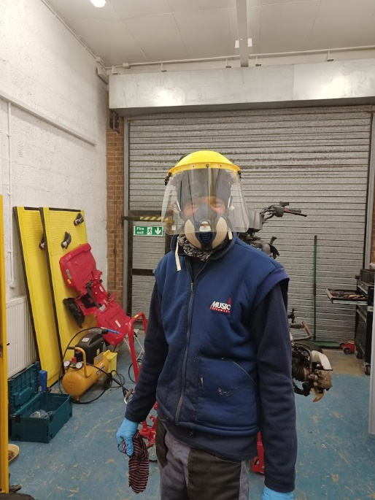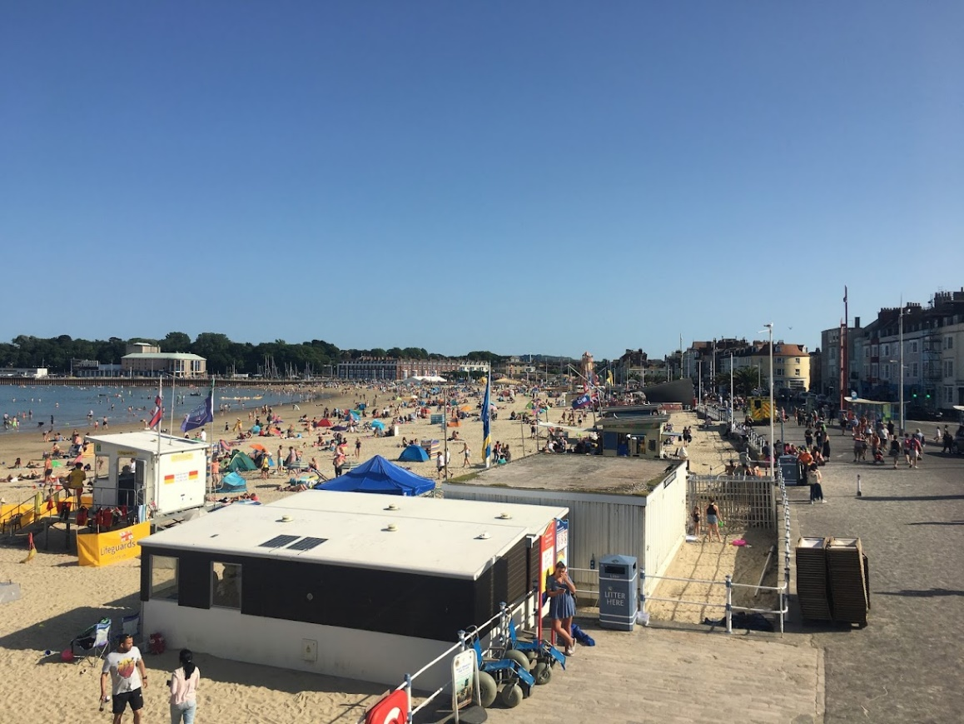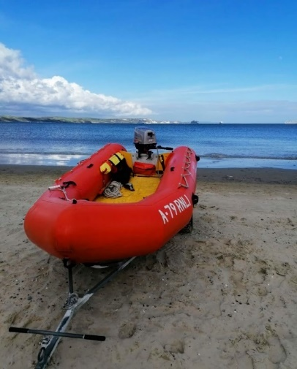

*[Photos: Operational Inshore Rescue Boat positioned shoreline (Left), all Units installed and their location 2021 (Right)]*

*[Photo: System Technician Nick Colville, 2021]*

**Contract specification compliance:**

The lifeguard service agreement contains a schedule of service specification, the below is a summary of how the RNLI performed against this schedule:

|  |  |  |  |  |
| --- | --- | --- | --- | --- |
|  | Met | Exceed | Failed | Narrative |
| Carry out a risk assessment in respect of the patrolled beaches. | X |  |  | Weymouth & Greenhill annual RA review carried out on 11th November 2020, which covered the 2021 season |
| Provide a lifeguard service on the beaches covering a series of operational areas as agreed with the beach operator. | X |  |  | Service provided across the area as described in the updated 2021 Covid service agreement. |
| Provide a lifeguard patrol during the season in accordance with the RNLI SOPs and LOPs. | X |  |  | Additional Covid SOPs |
| Provide the lifeguard patrol in accordance with the criteria for Blue Flag or similar award. | X |  |  | Lifeguard service provided at agreed designated locations. |
| Instruct its lifeguards to observe high standards of courtesy and consideration towards members | X |  |  | Any complaints were dealt with in a timely manner with no further consequences |
| Notify members of the public of the relevant local byelaws, which relate to beach safety. | X |  |  | Local Notice to Mariners still in place for Weymouth Main Beach stating no hard craft to go between the Red and Yellow flagged zone. |
| Inform the appropriate officer responsible for environmental services regarding any beach cleaning requirements or pollution incidents. | X |  |  |  |
| Complete incident reports, daily logs and staffing level records on a daily basis and included in an annual report to the beach operator. | X |  |  | Worked closely with Beach Control throughout the season |
| Ensure that all public relations, incident data, publicity and media releases are agreed between the parties beforehand. | X |  |  |  |

1. **Service statistics**

**WEYMOUTH MAIN BEACH**

**Incident**



**Incidents Actions**



**Preventative Actions**



**Visitors**



**Incident**



**Incidents Actions**



**STATISTICS REVIEW**

It is noticeable that the number of assists, casualty care, and minor first aid appeared to have reduced over the last two seasons.

Contributing factors for this could be due to the following:

* RNLI Covid procedures meant that Lifeguards were advised NOT to go ‘hands-on’ unless absolutely necessary. Small things such as giving members of public a disinfectant wipe and plaster and asking them to apply themselves, which subsequently meant a minor first aid form possibly not being filled in (a lesson learnt for 2022 season).
* Likewise in the water, Lifeguards were encouraged to not assist inflatable users in the IRB or in the board unless the last resort. Either paddling next to them, guiding them back into shallow water, or hanging off in the IRB and observing. Pre-Covid the team would have picked up those on inflatables and taken them back to the beach without having to think about the contact risk to themselves. And once again filling in a form had they physically assisted them in.
* Increased level of prevention. The Loudspeaker was increasingly used during Covid to give out safety advice regarding inflatable use in offshore winds, this hopefully acted to reduce the number of incidents.
* In 2021, 12 volunteer Lifeguards were inducted. This level of additional help meant a greater presence on the beaches in addition to the scheme of compliment. Increased interaction with the public will have helped to reduce the number of incidents by giving out additional safety advice that may have not been formally recorded in a paper record. Again, something that the Supervisor team will address in 2022.

**Preventative Actions**



**Visitors**



*Incident overview:*

**LAND BASED**

As per 2020, remarkably even with the potential of the Covid “staycation” affect and predicted increased visitor numbers to the Southwest, 2021 proved to be a relatively incident free season. This was the first year we have provided an Easter Service at Weymouth Main Beach, operational from the 1st to the 18th of April for the school holidays, then weekends only until full time again from the 1st of May through until the 26th of September. Unfortunately, the weather during the Easter break was not as warm as in previous years, but it did give the Lifeguards on duty ample opportunities to train, be it fitness, water skills (board and IRB) and casualty care scenarios.

As the weather improved the number of first aid incidents were on the rise. Numerous minor first aids (small cuts, grazes, weever fish stings etc) were dealt with in accordance with RNLI Covid procedures, as well as encouraging members of public to use the NHS 111 service if unsure about any ailment/injury that they presented to the Lifeguards with to get gain an appointment with the Minor Injury Unit (MIU) or potentially make their own way to the Emergency Department at Dorchester County Hospital so to free up the Ambulance Service.

During July and a spell of warm weather there was a noticeable increase of alcohol related incidents. The two most serious included an unresponsive male who was face down in the sand and the other a gentleman who was extremely intoxicated and jumped feet first into the shallow Zorbing pool resulting in a significant lower leg break. Both used up Lifeguard resources as well as those from Beach Control, Security, Police and the Ambulance Service.

Other noteworthy casualty care “Big Sick” incidents the Lifeguard dealt with this summer included a 1-year-old child having a seizure near to the clock tower, an elderly woman falling and hitting her head in a bus shelter and a 6-year-old just out of the sea who vomited and went unresponsive.

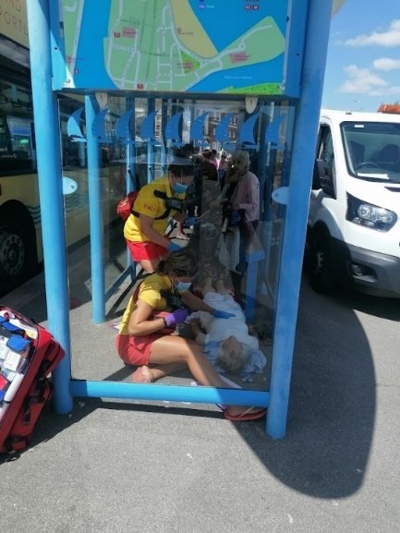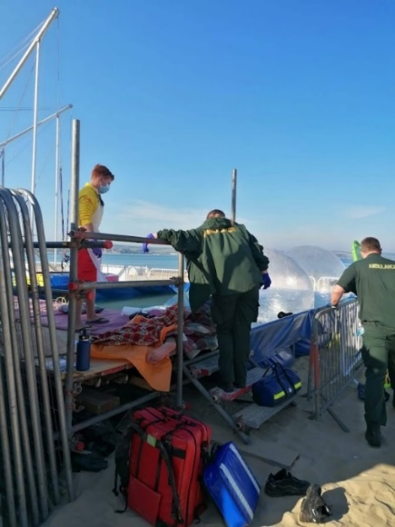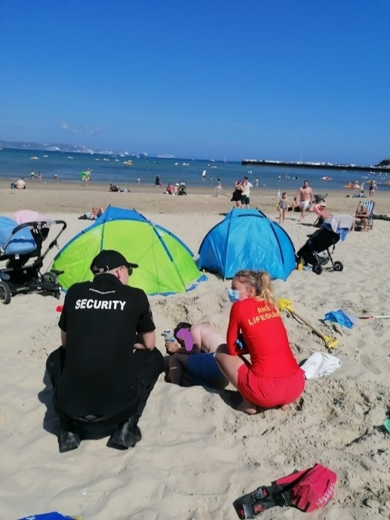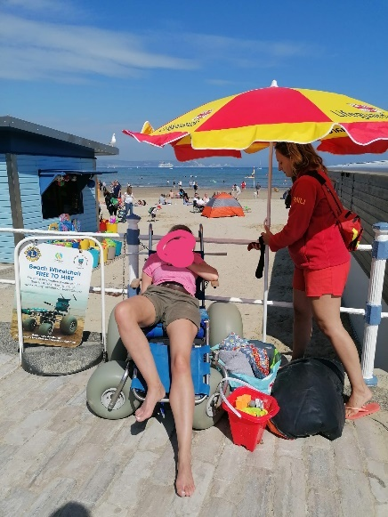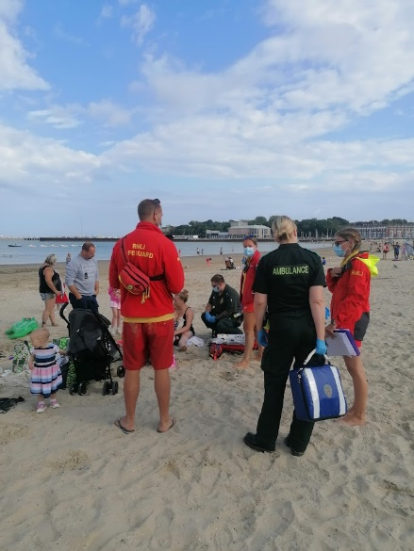

*[Photos: Taken by Lifeguard Supervisor (for training purposes) to show the various Casualty Care incidents at Weymouth Main Beach throughout the 2021 season. Working closely with Beach Control staff and Ambulance Crews to provide a high-level of professional care.]*

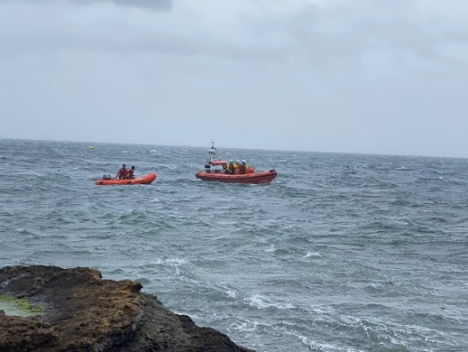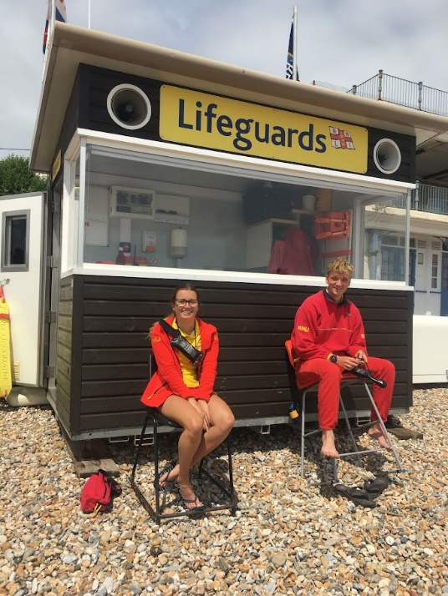

**WATER BASED**

Along with the inevitable inflatable user assists via both the Inshore Rescue Boat (IRB) and Rescue Boards the Lifeguard Team responded to several water-based incidents during 2021.

One of the earliest was to a male at the base of the Nothe suffering with poor mental health on the 3rd of May. Two Lifeguards responded in the IRB alongside Weymouth’s RNLI Inshore Lifeboat crew. Both boats stood off just in case the male entered the water. Fortunately, Coastguard Teams were able to stretcher the casualty to safety and into the care of an Ambulance Crew and Police.

In June Lifeguards responded in the IRB to another mental health incident at the rock groyne, Greenhill, where a 14year old female was refusing to get out of the water. Lifeguards and a member of public were able to encourage her to make her way to shore and get checked by a waiting Ambulance Crew.

Later in June a 14year old suffered extremely serious injuries (open fractures and large lacerations) to both lower legs after a boat accident in Newtons Cove. Lifeguards responded to the ‘Mayday’ call and helped stabilise the casualty whilst the vessel was alongside in Weymouth Harbour with Ambulance crews, ready to be transferred to hospital.

In July Lifeguards spotted two persons struggling near to the pier wall in a small easterly swell and incoming tide. The IRB immediately launched to find an older brother holding his younger brother above his head, neither able to swim. Both would have been unable to move from that position and get to safety without the Lifeguards quick response.

On the last weekend of the Lifeguard Service at Weymouth, the IRB launched to a Jet Ski that was sinking off the Harbour Entrance. The Lifeguards were able to recover the two casualties and helped with returning the vessel to the shore.

The Lifeguard service at Greenhill started back again on the 10th of July. Numerous members of public were rescued/assisted by the guards on the rescue boards trying to swim too and from the swim rafts (back in after a year away due to Covid). A ‘Thank-You’ from which is described below…

*[Photo: Mental Health incident at the case of the Nothe – 3rd May 2021]*

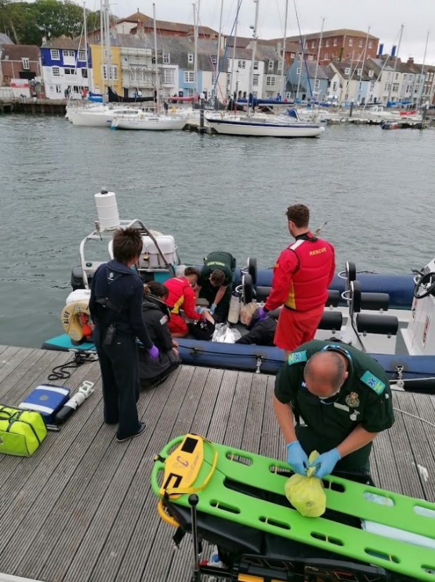

*[Photo: 10th July 2021, Operational at Greenhill again since ending in September 2019 due to Covid]*

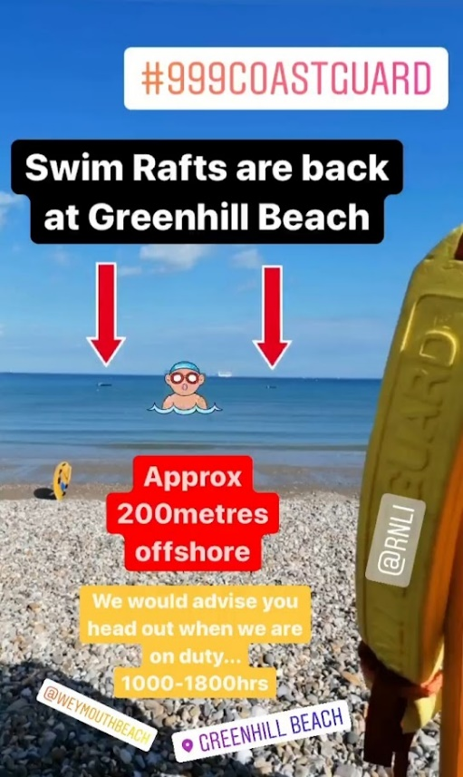

*[Photo: Boat accident 20th June 2021]*

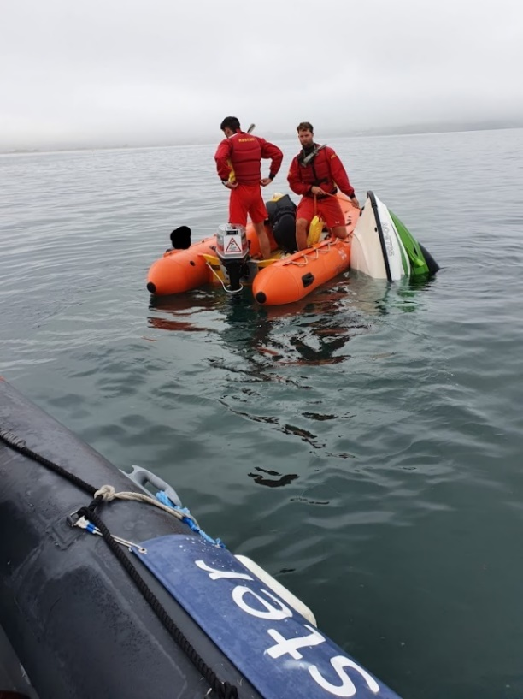

*[Photo: Sinking Jet Ski near Harbour Entrance, 25th September 2021]*

*4th August 2021 – “Dear Sir/Madam, can I ask that this message be passed to you lifeguard Team at Greenhill Beach stationed at Weymouth who pulled my son from the water today., Can you pass on my heartfelt thanks to them for their fast and prompt action in helping my son.”*

*[Photo: ‘rnlilifeguards_weymouth’ Instagram story, July 2021.]*

**3. Community engagement**

*Public engagement statistics:*

***UNFORTUENTLY NO SCHOOL TALKS WERE HELD DURING 2021 DUE TO COVID***

**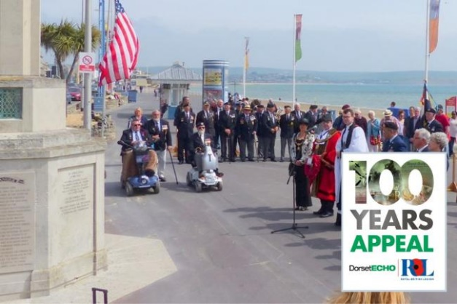***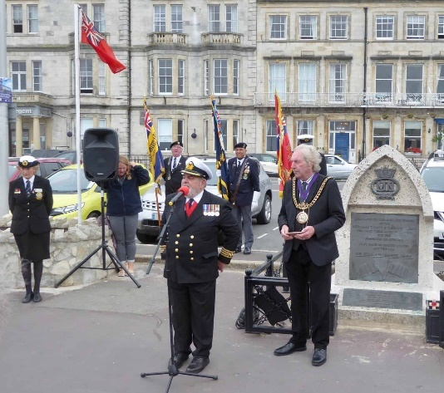Major public events covered:*

On the **31st of May**, 2 Lifeguards provided first aid cover for the US Memorial service held on the Esplanade.

Similarly, on the **3rd of September** 2 Lifeguards provided first aid cover for a service that was part of the Merchant Navy Day.

First Aid equipment to hand by the 2 RNLI Casualty Care trained Lifeguards included Oxygen, plastic airways, an AED, drugs for Asthma and Chest Pain, immobilisation capabilities for fractures, bandages, and the ability to stop major bleeds. Thankfully none of which was required at both events!

*[Photos: Both taken from Dorset Echo website. US Memorial (Left) and Merchant Navy Day (Right) held along the Esplanade, 2021]*

**RNLI Face to Face 2021**

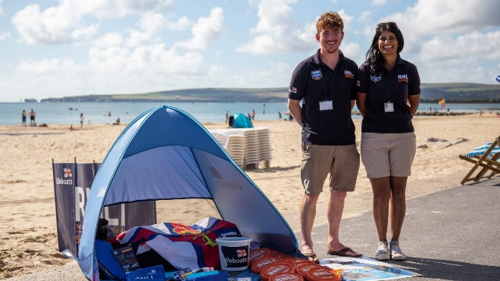

|  |  |  |  |
| --- | --- | --- | --- |
| **Location** | **RTW Messages** | **Youth Messages** | **Sign-ups 2021** |
| **Weymouth Beach** | 884 | 478 | 99 |
| **Weymouth Seafood Festival** | 144 | 25 | 35 |

The table above shows the statistics (provided by areas RNLI Face to Face Manager, Marissa Laing) of safety messages and sign-ups by the RNLI Face to Face team that were based on the esplanade behind the Lifeguard Tower throughout the summer as well as a stand at the Seafood Festival.

The Respect the Water safety messages given out were relevant to Weymouth and Greenhill beaches, primarily around the dangers of using inflatables at the beach along with the importance of always swimming at a Lifeguard beach and in between the Red and Yellow flags.

*[Photo: Taken by RNLI media team of a local face to face team]*

**Weymouth Surf Life Saving Club, Est 2018**

Weymouth SLSC currently has 26 Nippers (30 on a waitlist), 18 Youth (17 on a waitlist), 31 Seniors (including local RNLI Lifeguards) and 21 Masters (the majority of which make up the volunteer coaches and helpers for the Nipper and Youth sessions) members.

Due to Covid limitations, Nipper and Youth sessions numbers were capped, meaning no new members between 7-15yrs were invited to join this year unfortunately.

With the implementation of a Covid Safety Officer (a master’s club member and local Paramedic) club activities on the beach were thankfully able to resume once again. Nippers and Youth met on a Saturday morning 1000 till 1130 and Seniors/Masters on a Thursday evening between 1700 and 1830.

In 2021 six 2018/2019 Youth members progressed onto gaining their Surf Lifeguard qualification where two were selected for a paid role within our RNLI Lifeguard team and four (along with 8 others) volunteered as RNLI Lifeguards with us. A brilliant achievement and great to see the club structure providing highly skilled and professional Lifeguards coming through. In total 17 *new* Lifeguards were qualified this year through the club. Including 2 Masters who plan to help with Nipper sessions in 2022.

*Third party relationships:*

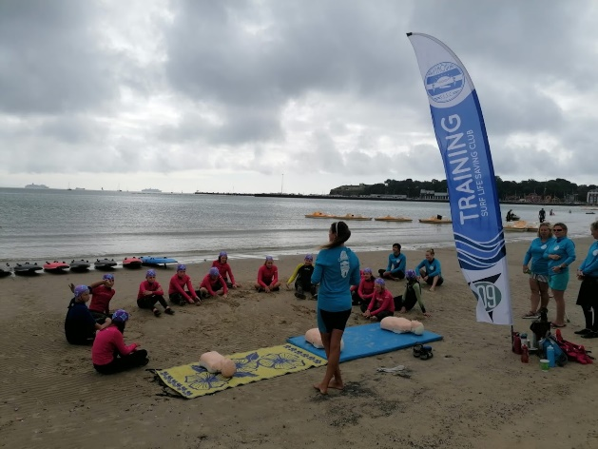

**NIPPERS (7-12yrs)**

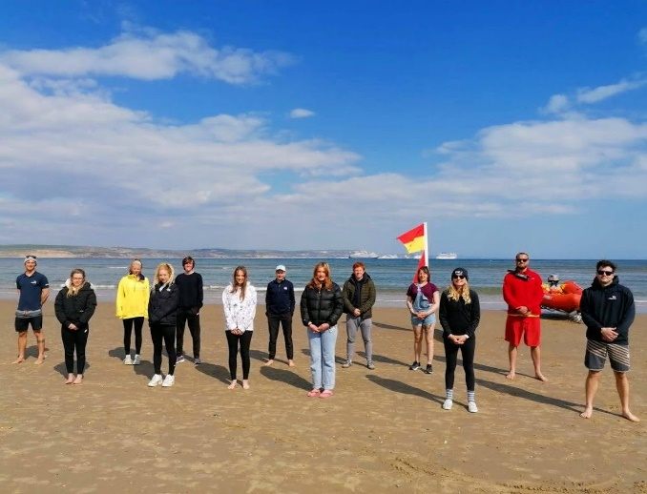

**APRIL**

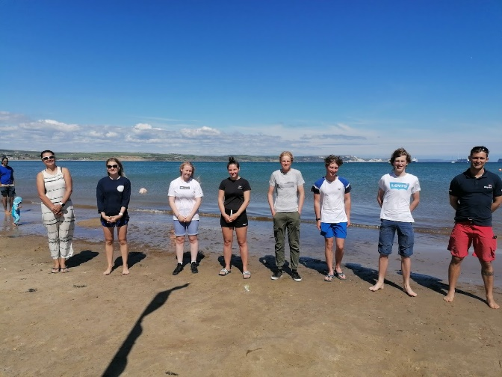

**MAY**

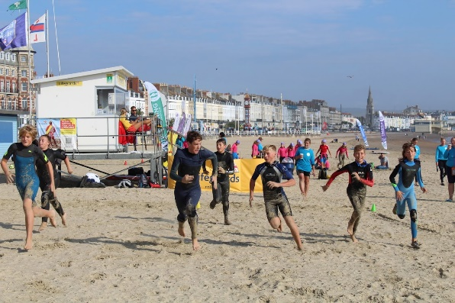

**YOUTH (13-15yrs)**

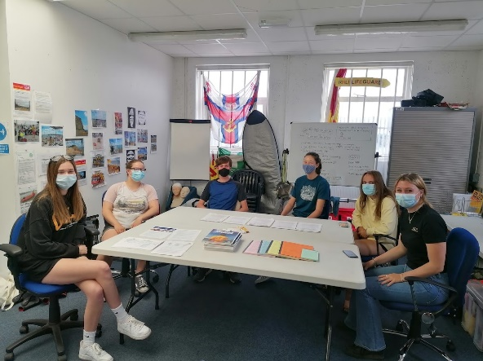

**SENIORS (16yrs+)**

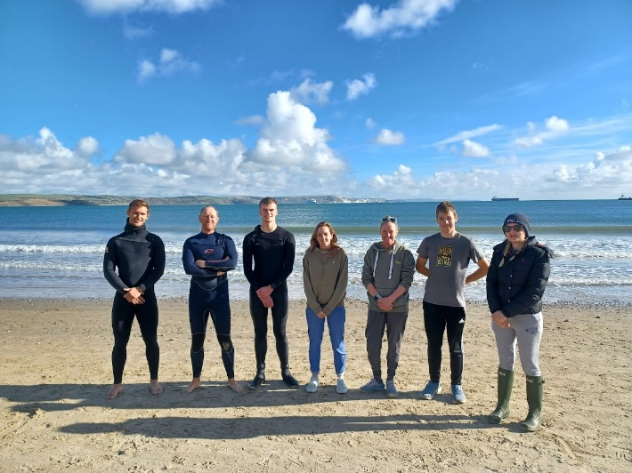

**OCTOBER**

*[Photos: Progression from Nippers to Youth to Seniors, who (once qualified as Surf Lifeguards at 16yrs old) can do a RNLI induction and volunteer alongside the team.]*

*[Photos: Three Beach Lifeguard Courses were successful run in April, May and October 2021. Qualifying 17 *new* Lifeguards!]*

**\*RNLI LIFEGUARD VOLUNTEERS, JULY 2021\***

**South Western Ambulance Service NHS Foundation Trust (SWASFT)**

As part of the 2020 Lifeguard Inductions (amidst the earlier part of the pandemic) a local Lead Paramedic, with links through Weymouth SLSC, offered their assistance to go through what was then a new concept of wearing additional PPE to help protect from Covid. No RNLI Casualty Care trainers were allowed to travel during this time either, which meant the only update the Lifeguard team were provided with was from the Supervisor Team. This extra input from a Paramedic level was extremely beneficial and allowed for any clinical questions to be answered on the spot. This year (thankfully!) restrictions eased, and all Lifeguards received either a 3-day full Casualty Care course or 1 day revalidation by an RNLI Casualty Care trainer, upskilling to a high level in the use of all the equipment available to use for a first aid incident. Due to the success of 2020s SWAST input they were kind enough to return during both Main and Peak 2021 season inductions to explain some of the equipment that Lifeguards could potentially help with if needed (stretchers, vacuum splints, medivac chairs etc), discussing their continued Covid procedures as well as showing around an operational Ambulance.

On a couple of occasions throughout the summer local ambulance crews, who were on standby on the seafront, were able to head over and say hello to the Lifeguards on duty. This allowed for a great opportunity to explain what equipment and casualty care training that the RNLI provides, which was otherwise unknown by some.

.

*[Photo: Senior Lifeguard explaining the Casualty Care training RNLI Lifeguards receive to a local ambulance crew.]*

*[Photos: Local Ambulance/Paramedic visiting Weymouth RNLI Lifeguard Support Centre during Main and Peak Season Inductions, 2021]*

**Weymouth & Portland Police**

Having retained contact details of a local PC that delivered a talk during the 2019 season Inductions to the Lifeguard Team we were able to re-establish links for 2021. Both Supervisors and two of the early season Senior Lifeguards met up with PC Sandra Rigby, who was heading up the Weymouth Neighbourhood Police Team (NPT), to talk about their response capabilities and best means of communication etc. Sandra then kindly also offered to run through a presentation during Main Season inductions that covered topics such as Antisocial behaviour, Safeguarding, Missing Persons, Deceased Persons and chat about any known issues and hot spots along the seafront etc. A local PCSO who sat in on this presentation was then able to deliver the same information to those on their Peak Season induction during the following month. This increased knowledge from both sides of the different processes when responding to certain incidents (especially Missing Persons) proved beneficial during the Lifeguard season, allowing for a much greater level of interaction between the teams.

*[Photo: A local PC and PCSO delivering a presentation during Main Season Inductions]*

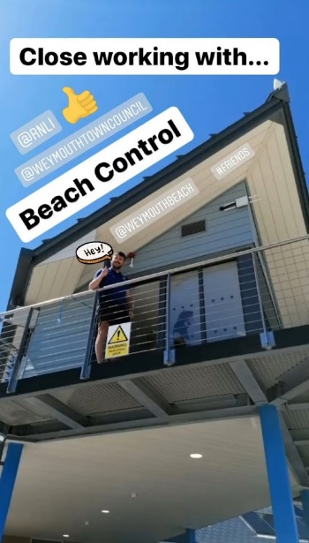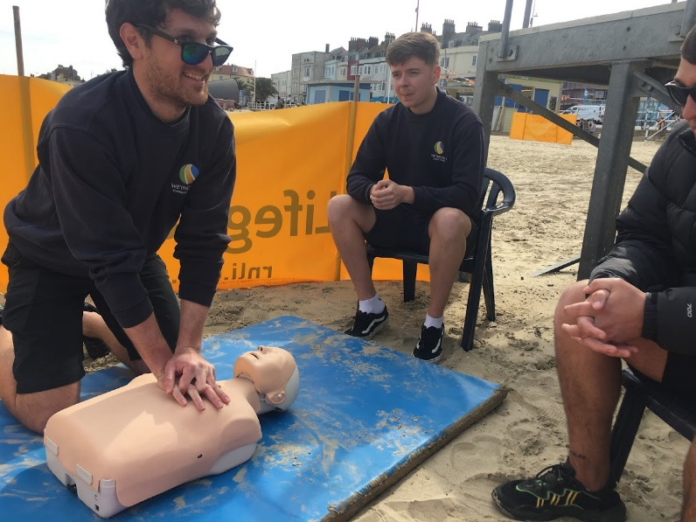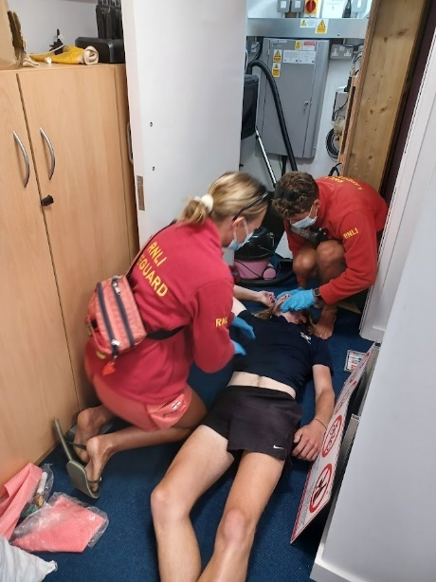

**Weymouth Town Council** **Beach Control**

As per previous years the Lifeguard Team worked extremely closely with Beach Control staff throughout the summer months.

During the early season we held some First Aid training for the Beach Control Seniors, explaining to them the priorities and procedures for different situations that might occur and how best to respond. Beach Control were also kind enough to let us use them as part of a scenario in the Office for the guards on a quiet day in September. Thank You!

**Wyke Coastguard Response Teams**

*[Photos: ‘rnlilifeguards_Weymouth’ Instagram post (Left); Senior Beach Control Staff First Aid Training (Middle), An ‘electric shock’ scenario held in the Beach Office (Right)]*

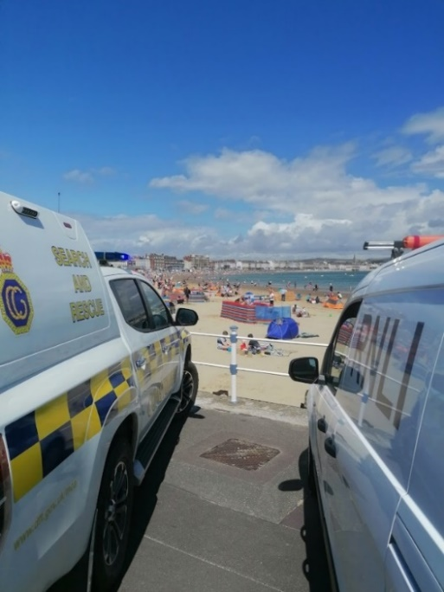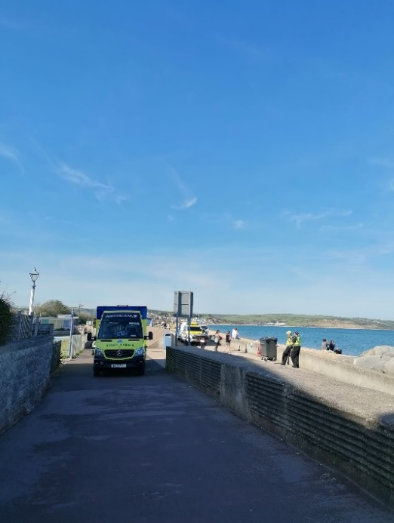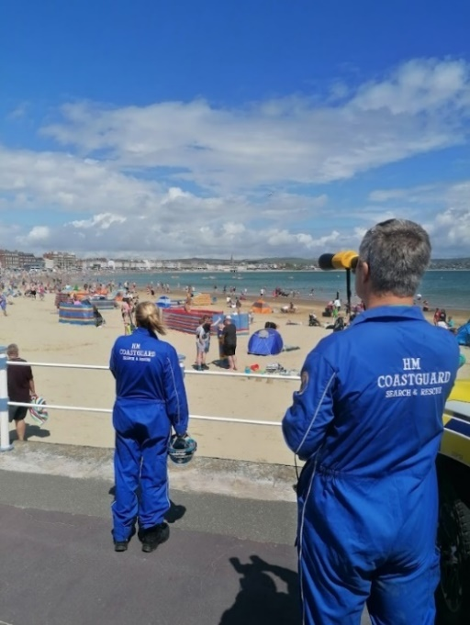

Unfortunately, due to Covid we were unable to carry out any specific joint training exercises with Wyke CRT this year.

However, there were numerous occasions where the Lifeguards and Coastguard Teams worked closely together throughout the season.

Wyke CRT were especially helpful during a spell of sunny weather and high offshore winds, resulting in an influx of beach users being blown out to sea on inflatables and requiring rescuing by Lifeguards in the IRB.

In July, after a 999 call by a member of public about two children being blown offshore near the Pavilion, the CRT were kind enough to stay and help deliver safety advice to those positioned in the Dog Area and away from the Lifeguards Primary and Secondary areas of observation/response.

*[Photo: Wyke CRT helping provide inflatable dangers safety advice during Peak 2021 (Left & Middle) and joint response by CRT, Police, Lifeboat, Ambulance and Lifeguards to a female in the water off the Groyne at Greenhill in June, 2021]*

**Weymouth RNLI Lifeboat Station**

Our 2021 Lifeguard Team were able to regain a level of joint working with Weymouth Lifeboat Station this year, compared to no interaction unless when responding to an incident together back in 2020, due to Covid. In May, Lifeboat Mechanic Andy Tattersall kindly offered to show two of the Lifeguards on their Main Season Induction around Weymouth’s All-Weather Lifeboat and Inshore Lifeboat. Acting as a great opportunity for them to learn about the work that the volunteer RNLI Lifeboat crews do locally and nationally.

As volunteer crew for Weymouth Lifeboat Station and Helm for the Inshore Lifeboat I was able to arrange a couple of joint exercises. The first scenario being a suspected ‘spinal injury’ off the Pleasure Pier where the Lifeguards secured the casualty into a stretcher in the water and transferred to the IRB then ILB. With the second being a swimmer who was picked up by the ILB ‘not breathing’ with the crew performing CPR and then handing over to the Lifeguards on the beach who have an AED and better access for Ambulance crews and the Air Ambulance if they were to land on the beach. Both proved to be extremely beneficial for both sides.

Lifeguards were also able to support Weymouth Lifeboat Station fundraisers (including Teresa as seen in the photos on the left) who carried on the best they could this summer with Covid restrictions and with the decision to cancel Weymouth Lifeboat Week.

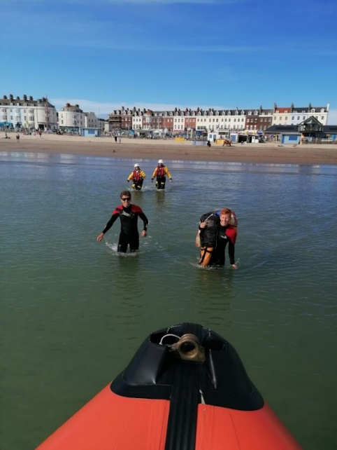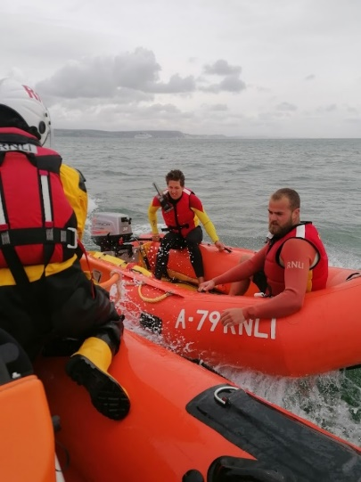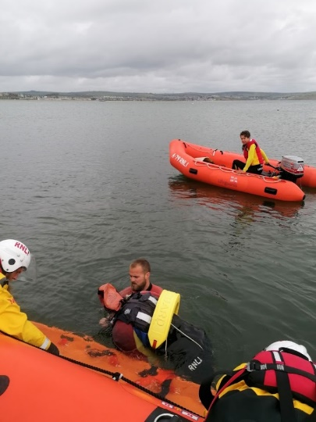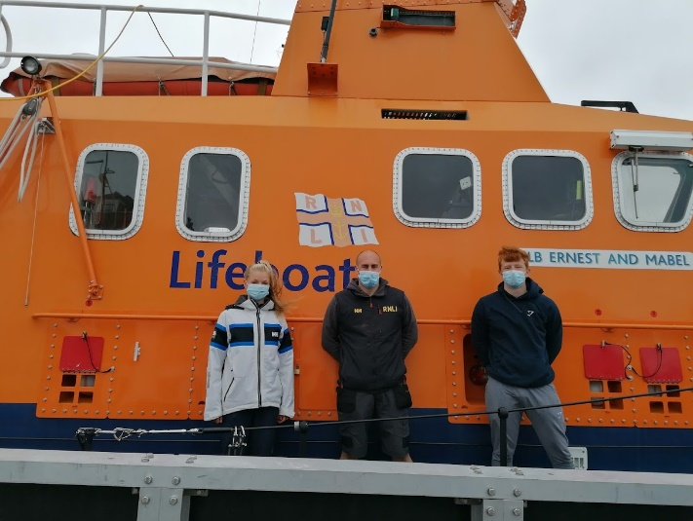

*[Photos: Main Season Induction to Weymouth Lifeboat Station (Left), and IRB and Weymouth ILB joint exercises during August and September]*

**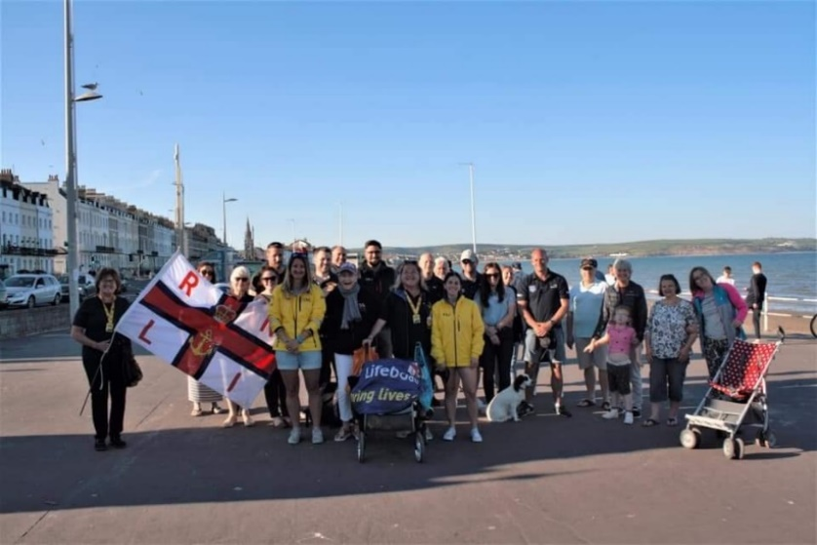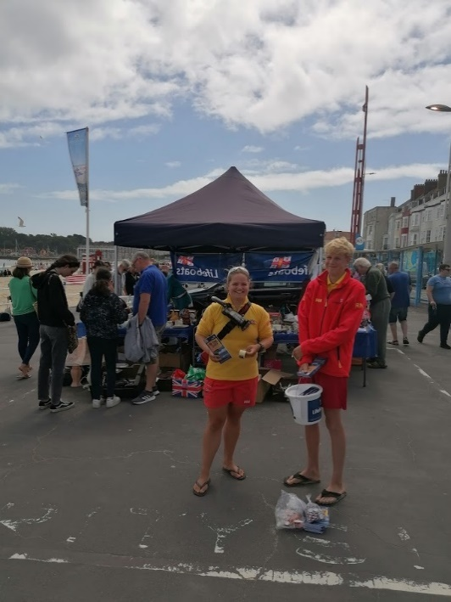***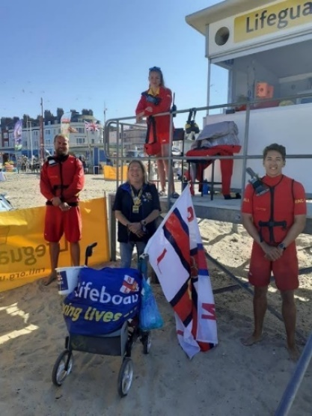*

*[Photos: Supporting Weymouth Lifeboat’s Fundraising Officer Teresa Drage on her Mayday challenge to walk at least one mile a day in May (Left and Middle), Lifeguards helping to fundraise on the Esplanade during August 2021 (Right)]*

1. **Assistance required from the council**

**Greenhill:**

None

**Weymouth Main Beach:**

Discussion with RNLI Shoreworks regarding the future of Weymouth Main Beach facilities. With the view to improve the existing council units on the beach that could be modernised and multi-purpose as well as reducing the amount of RNLI units that need to be installed and removed each year.

1. **Risk assessment**

*Risk assessment headlines:*

**Weymouth is a, medium risk beach during peak season, a lower-medium, risk beach during early / late season and a lower risk beach during winter.**

During the assessment there were a number of hazards identified where the level of risk was felt to be high. Control measures should be considered. Priority hazards are:

* 3.2 Coastal defences
* 3.3 Jetties/piers
* 10.4 Inflatable users
* 10.9 Pier Jumping

*Full risk assessment review:*

Last conducted: 11.11.19

*Annual review:*

Last conducted: 11.11.21

*Signage/public rescue equipment review:*

Last conducted: 08.04.15

**Greenhill is a, lower-medium risk beach during peak season, a lower, risk beach during early / late season and a lower risk beach during winter.**

During the assessment there were a number of hazards identified where the level of risk was felt to be high. Control measures should be considered. Priority hazards are:

* 3.7 Other – Swim rafts
* 10.4 Inflatable users

*Full risk assessment review:*

Last conducted: 11.11.19

*Annual review:*

Last conducted: 11.11.21

*Signage/public rescue equipment review:*

Last conducted: 08.04.15

***Recommendations for next year:***

Regional level recommendations:

* Review of public rescue equipment across all beaches is recommended.

Beach level recommendations:

* **Greenhill:** Signage & PRE review
* **Weymouth Main Beach:** Signage & PRE review

1. **RNLI news and updates**

*RNLI management changes:*

No changes in 2021. Matt Cridland remained as Area Lifesaving Manager, Alice Higgins as Lead Lifeguard Supervisor and Dominik Fajkiel as Lifeguard Supervisor.