Council Offices, Commercial Road, Weymouth, Dorset, DT4 8NG
01305 239839 - office@weymouthtowncouncil.gov.uk

This is an advisory meeting to make recommendations to the Town Clerk under the Council’s approved scheme of delegation.

NOTICE OF MEETING

MEETING: Advisory Human Resources Committee
DATE & TIME: Wednesday 02 February 2022 at 6:00pm.
PLACE: Zoom

This is a meeting in public, not a public meeting.
Members of the public can view the meeting on the Council’s Facebook page www.facebook.com/WeymouthWTC
Should members of the public and press wish to attend meetings or ask a public question, please email office@weymouthtowncouncil.gov.uk
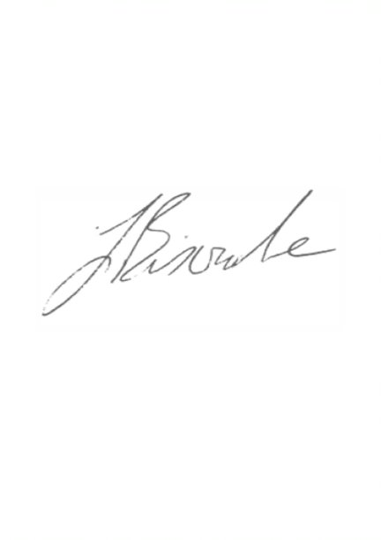
Agenda and papers are available at www.weymouthtowncouncil.gov.uk

J L Biscombe, FSLCC, CiLCA
Town Clerk 27 January 2021 ____________________________________________________________________________

Agenda
- Welcome by the Chair
- Election of Chair and Vice-Chair
- Apologies for Absence and Substitutions
- Declarations of Interest
- Councillor questions and statements
- Public questions
- Information items
- Actions from previous meetings
- Forward Plan
- Exclusion of the press and public
- Update on Staffing
- Casual Staff
- HR Support
- Catering Staff

Welcome by the Chair

Election of Chair and Vice Chair

Cllr Wakeling and Cllr Roos are standing down from their respective roles as Chair and Vice-chair of this Committee.

Councillors are asked to agree a Chair and Vice-Chair for this Committee as per Standing Order 4.4.6

Apologies for Absence and Substitutions
To approve apologies for absence and substitutions.

Declarations of Interest
To receive Councillor declarations of interest in matters on the agenda

Councillor’s Questions and statements
In accordance with Standing Order 29, one clear day’s notice in writing to the Clerk of the meeting is required. In the case of urgent items permission must be sought from the Chairman and the question submitted to the Clerk of the meeting by 3:00pm on the day of the meeting.

Public Question Time
The length of time available for public questions will be determined by the Chairman.

Information Items
Actions from previous meetings
Date | Who | Action | Status
29/09/21 | JB | Consider amendments to the Annual Appraisal document | In progress
29/09/21 | JB | Bring forward updates on staffing arrangements to each meeting | Ongoing
13/04/21 | JB | Ensure a review of the Parks team is on the Services Committee forward plan. | Jane to update
11/03/20 | JB | Bring forward an updated Apprentice Pay Policy | On hold
27/11/19 | JB | Put an SLA in place with DC regarding the CSAS officers | In progress

Forward Plan
Date | Items for consideration
18/05/21 | Town Clerks Annual Appraisal arrangements  Update on staffing structure
21/09/21 | Town Clerks Annual Appraisal outcomes
16/11/21 | Union recognition agreement  Salary Budget 22/23

Recommendation:
That the Committee notes the information above.

Exclusion of the press and public
Under the Public Bodies (Admissions to Meetings) Act 1960 members of the public and press are required to leave the meeting due to the sensitive nature of the item next to be considered relating to individual members of staff.

Recommendation:
That Councillors agree to exclude the public and press.

Update on staffing

Councillors will be given a briefing on the current staff reorganisation and future plans.

Casual Staff
Councillors are asked to consider the confidential Appendix A accompanying this agenda which outlines considerations around casual and seasonal staff.

Recommendation
That Councillors agree to recommend to the Town Clerk any actions that may be appropriate for the use of casual and seasonal staff.

HR Support
Councillors are asked to consider the confidential Appendix C accompanying this agenda which outlines considerations around the provision of HR support.

Recommendation
That Councillors agree to recommend to the Town Clerk any actions that may be appropriate in respect of the provision of HR support.

Catering Staff
Councillors are asked to consider the confidential Appendix D accompanying this agenda which reviews and outlines considerations around the provision of catering staff.

Recommendation
That Councillors agree to recommend to the Town Clerk any actions that may be appropriate in respect of the catering staff.

