Council Offices, Commercial Road, Weymouth, Dorset, DT4 8NG
01305 239839 - office@weymouthtowncouncil.gov.uk

Councillors are hereby summoned to attend the following meeting.
Please inform the Clerk if you are unable to attend.

MEETING: Meeting of Weymouth Town Council
DATE & TIME: Monday 17th January 2022 at 11.00 am
PLACE: Council Chamber, Council Offices, Commercial Road, Weymouth,
Dorset, DT4 8NG

This is a meeting in public, not a public meeting.
Should members of the public and press wish to attend the meeting or ask a public question, please email office@weymouthtowncouncil.gov.uk by no later than 9am the day prior to the meeting. Agenda and papers are available at www.weymouthtowncouncil.gov.uk
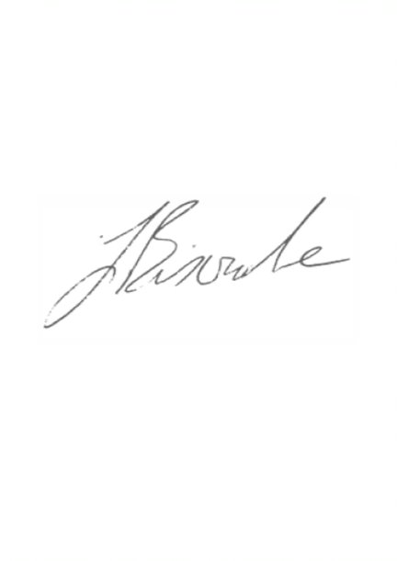
All attendees are asked to wear a mask whilst moving around the building and Council Chamber. Masks may be removed when sitting. Please observe social distancing. Please take a Covid test in the 24 hours prior to the meeting. Attendees will be asked to sign in to assist with track and trace.

J L Biscombe, FSLCC, CiLCA Town Clerk 11 January 2022 ____________________________________________________________________________

Agenda
- Welcome
- Apologies
- Declarations of Interest
- Minutes of last meeting
- Minutes and recommendations from other Committees
- Councillor Questions and Updates
- Town Mayor’s Announcements
- Public Questions
- Budget and Precept for 2022/23

Welcome

Apologies for Absence

Declarations of Interest

Minutes of last meeting

Recommendation:
Members are asked to agree the minutes of the last meeting held on 17 November 2021 as a true and accurate record.

Minutes and recommendations from other Committees
Committee | Date | Minute Nos | Recommendations
Draft Services Committee | 20/10/21 | S0148 – S0159 | None
Finance & Governance Committee | 03/11/21 | F0183 – F0198 | None
Planning & Licensing Committee | 09/11/21 | P00437-P00450 | None
Draft HR Committee | 24/11/21 | HR0128-HR0137 | None
Draft Services Committee | 01/12/21 | S0160 – S0176 | None
Draft Planning & Licensing Committee | 07/12/21 | P00451-P00464 | None
Draft Finance & Governance Committee | 15/12/21 | F0199 – F0212 | None

Recommendation:
Members are asked to note the attached minutes and recommendations of other Committees, as detailed above.

Councillor Questions and Updates

Town Mayor’s Announcements

Public Question Time
Questions referring to the work of Dorset Council or other external organisations will not be taken at this meeting. The length of time available for public questions will be determined by the Chairman.

Budget and Precept 2022/23
An advisory Full Council meeting will be held on Wednesday 12th January 2022 where this item will be fully discussed by Full Council. The decision on the precept requires a decision by Full Council and cannot be delegated to the Clerk. This meeting is asked to formally confirm the decisions recommended at the Full Council meeting held on 12 January 2022.

The detail of the recommendation was not available at the time of despatch and will be circulated to all Councillors as soon as possible.

Recommendation:
To confirm the decisions made by Full Council on 12 January 2022:
- On the revenue budgets and fees and charges for 2022/23
- On the precept amount

