Council Offices, Commercial Road, Weymouth, Dorset, DT4 8NG
01305 239839 - office@weymouthtowncouncil.gov.uk

Councillors nominated to the Human Resources Committee are hereby summoned to attend the following meeting. Please inform the Clerk if you are unable to attend.

NOTICE OF MEETING

MEETING: Human Resources Committee
DATE & TIME: Wednesday 24 November 2021 at 7:00pm.
PLACE: Council Offices, Commercial Road, Weymouth, DT4 8NG

This is a meeting in public, not a public meeting.
Members of the public can view the meeting on the Council’s Facebook page www.facebook.com/WeymouthWTC
Should members of the public and press wish to attend meetings or ask a public question, please email office@weymouthtowncouncil.gov.uk
Agenda and papers are available at www.weymouthtowncouncil.gov.uk

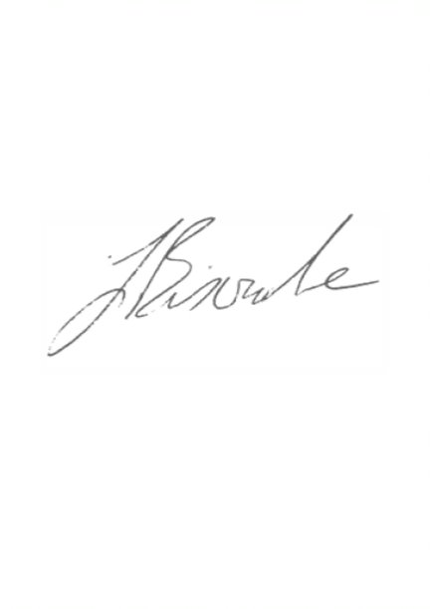
All attendees are asked to wear a mask whilst moving around the building and Council Chamber. Masks may be removed when sitting. Please observe social distancing. Please take a Covid lateral flow test in the 24 hours prior to the meeting. Attendees will be asked to sign in to assist with track and trace.

J L Biscombe, FSLCC, CiLCA
Town Clerk 17 November 2021 ____________________________________________________________________________

Agenda
- Welcome by the Chair
- Apologies for Absence and Substitutions
- Declarations of Interest
- Minutes of the last meeting
- Councillor questions
- Public questions
- Information items
- Early findings from the staff survey 21/22
- Actions from previous meetings
- Forward Plan
- Exclusion of the press and public
- Update on Staffing
- Salary budget 22/23

Welcome by the Chair

Apologies for Absence and Substitutions
To approve apologies for absence and substitutions.

Declarations of Interest
To receive Councillor declarations of interest in matters on the agenda

Minutes of the last meeting
To agree the minutes of the last formal Committee meeting held on 13th April 2021 as a true and accurate record.

Recommendation:
Members are asked to agree the minutes of the last formal Committee meeting held on 13th April 2021 as an accurate and true record, and that they be duly signed as such.

Councillor’s Question Time and statements
Prior notice preferred where possible.

Public Question Time
The length of time available for public questions will be determined by the Chairman.

Information Items

Early findings from the Staff Survey 21/22

Councillors will receive a verbal update from the Town Clerk.

Actions from previous meetings
Date | Who | Action | Status
29/09/21 | JB | Consider amendments to the Annual Appraisal document | In progress
29/09/21 | JB | Bring forward updates on staffing arrangements to each meeting | Ongoing
13/04/21 | JB | Ensure a review of the Parks team is on the Services Committee forward plan. | On as part of the Parks Strategy
11/03/20 | JB | Bring forward an updated Apprentice Pay Policy | On hold
27/11/19 | JB | Put an SLA in place with DC regarding the CSAS officers | In progress

Forward Plan
Date | Items for consideration
23/02/22 | Update on staffing structure
18/05/22 | Town Clerks Annual Appraisal arrangements  Update on staffing structure
21/09/22 | Town Clerks Annual Appraisal outcomes
16/11/22 | Union recognition agreement  Salary Budget 22/23

Recommendation:
That the Committee notes the information above.

Exclusion of the press and public
Under the Public Bodies (Admissions to Meetings) Act 1960 members of the public and press are required to leave the meeting due to the sensitive nature of the item next to be considered relating to individual members of staff.

Recommendation:
That Councillors agree to exclude the public and press.

Update on staffing

Councillors are asked to note the confidential update at Appendix A accompanying this agenda.

Salary budget 22/23

Councillors are asked to consider the confidential Appendix B accompanying this agenda which outlines considerations to enable Councillors to determine the staffing budget for 22/23.

Recommendation
That Councillors agree an overall staffing budget to recommend to the Finance and Governance Committee on 15 December 2021 as part of the annual budget setting process to be taken to Full Council on 12 January 2022.

