Council Offices, Commercial Road, Weymouth, Dorset, DT4 8NG
01305 239839
office@weymouthtowncouncil.gov.uk
This meeting will recommend action to the Town Clerk

and is not in itself a decision-making meeting.

NOTICE OF MEETING

MEETING: Planning & Licensing Advisory Meeting
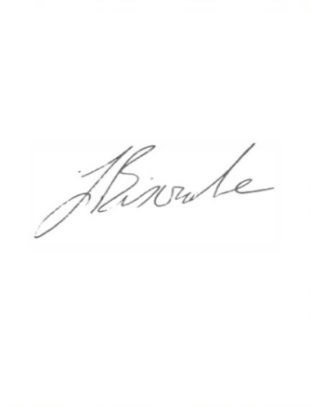
LOCATION: Zoom
DATE & TIME: Tuesday 14 September 2021, 7.00 pm

J Biscombe, FSLCC, CiLCA
Town Clerk 8 September 2021
This is a meeting in public, not a public meeting.
Due to the current restrictions in place the Council is unable to meet in person and so will be meeting virtually. Members of the public are able to attend the virtual meeting to ask a questions and this should be pre-arranged with the meeting clerk via office@weymouthtowncouncil.gov.uk by 9am on the day prior to the meeting. Members of the public can also view the meeting live on the Council’s Facebook page www.facebook.com/WeymouthWTC.
Members of the public are reminded that Weymouth Town Council are not the planning authority and are only consultees on planning applications. Members of the public are encouraged to submit their views via the Dorset Council website as usual on the following link https://planning.dorsetcouncil.gov.uk/. Residents can also contact their local Town Councillor if they wish to discuss Weymouth Town Council’s comments on any application.

Members of the public are urged to regularly check the Council’s social media for updates.

A G E N D A
- Apologies
- Declaration of Interests
- Public Participation
- Planning Applications for discussion
- Planning Applications – no comment
- Planning Applications responded to under Delegated Powers (for information)
- Licensing, Enforcement, Appeals & Phone Masts
- Sitting Out License Applications – Standard Responses (for information)
- Other Development Consultations
- Traffic Calming and Parking Restriction Requests from the public
- Traffic Regulation Orders (TROs)
- Information Items
- Emergency Items

Item 1 – Apologies for absence
Members are asked to approve any apologies received.

Item 2 – Declarations of Interest
To receive Member’s declarations of interest in matters on the agenda.

Item 3 – Public Participation
Members of the public are able to attend the virtual meeting to ask questions and this should be pre-arranged with the meeting clerk via office@weymouthtowncouncil.gov.uk by 9am on the day prior to the meeting. The meeting will also be available to view live on the Council’s Facebook page.

Item 4 – Planning Applications for Discussion
Members have expressed a desire to discuss the following planning applications. Members are requested to review the following planning applications and recommend to the Town Clerk any comments to be forwarded to Dorset Council.

Planning applications and associated documents can be viewed at https://planning.dorset.gov.uk/public-access/

Plan No. | Details | Deadline
P/LBC/2021/01617 | 16 St Edmund Street, Weymouth, Dorset, DT4 8AR  Replace 5no. sash windows (on the third floor flat 4). | 01/09/21
P/FUL/2021/01654 | Eweleaze Farm, Main Road, Osmington, Dorset, DT3 6ED Change of use of agricultural land to camping for 56 days per year (10th July to 3rd September) Temporary Permission until October 2024. | 01/09/21
P/FUL/2021/02462 | 25-27 Park Street, Weymouth, Dorset, DT4 7DF  Installation of four conservation rooflights to provide additional ventilation for prevention of covid-19 transmission. | 15/09/21
WP/21/00077/FUL | Digby House, The Nothe, Weymouth, Dorset, DT4 8UF  Create accommodation at second storey by removing existing roof structure and providing new roof with ridge 0.75m higher than existing. Provision of two flat roof dormers to rear with one Juliet balcony and roof windows to four sides. Material finishes to include brickwork, render and tiles to match existing. Application in addition to approved work under WP/19/00072/FUL. | 15/09/21
P/FUL/2021/01905 | Park Mews - Building A, 26 Park Street, Weymouth, DT4 7DQ Replace windows and external doors in Flat 1, Flat 2 and Maisonette 7. To be replaced with white pvc-u on a 'like for like' basis. | 15/09/21
P/FUL/2021/01878 | 42 Radipole Lane, Southill, Weymouth, DT4 9RW  Erect of 1no. dwelling with garage following demolition of existing garage on adjacent dwelling. | 21/09/21

The following planning applications were received just prior to agenda despatch and Members are therefore requested to decide whether a comment is required or if the applications can be added to the “en bloc” vote in Item 5.

P/FUL/2021/02260 | Catering Kiosk, Preston Beach Promenade, Preston Beach Road, Weymouth  Erection of beach kiosk including seated decked area & 'sail' cover. | 24/09/21
P/COU/2021/02350 | 44 Lennox Street, Weymouth, Dorset, DT4 7HB  Change of use from guest house to single dwelling house. | 28/09/21
P/VOC/2021/02409 | 2 Coombe Valley Road Weymouth Dorset DT3 6NH Proposal: Erection of rear, front and side extensions. Conversion of roof space to form additional accommodation, with installation of 2no. dormer windows to front. Replacement and increase of roof height. Erection of terraces, pool and fire pit. Erection of a double height garage / store.( without compliance/variation of condition 2 of permission WP/20/00955/FUL - Change to plans approved ). | 28/09/21
P/ADV/2021/02538 | Land At Junction Of Dorchester Road And Mercery Road, Weymouth, DT3 5FA  Installation of a illuminated freestanding totem sign. | 28/09/21
P/COU/2021/02313 | 81 Dorchester Road, Weymouth, DT4 7JY  Change of use from house of multiple occupancy to 5 self contained flats. | 29/09/21

Item 5 – Planning Applications – no objection
Members have expressed that they do not wish to make any comments on the following planning applications and therefore an en bloc comment of “no objection” will be submitted to Dorset Council.

Plan No. | Details | Deadline
P/LBC/2021/02801 | 17 Hope Street, Weymouth, Dorset, DT4 8TU  Internal alterations including a proposed shower room with works associated and the reinstatement of an existing historic doorway. | 26/08/21
WP/21/00029/FUL | 12 Spa Avenue, Weymouth, Dorset, DT3 5EJ  Change of use to convert existing dwelling (use class C3) into dental practice (use class E(e)) and creation of vehicular access (amended). | 20/08/21
P/VOC/2021/01623 | 5 Glendinning Avenue, Weymouth, Dorset, DT4 7QF  Extension of time for implementation of pp 08/00446/FUL for Alterations and extensions to form 2 additional flats(variation of condition 2 - amendment to the agreed plans ). | 27/08/21
P/FUL/2021/01707 | 22B Carlton Road South, Weymouth, Dorset, DT4 7PR  Conversion of loft increasing pitch of roof with rear dormer. Erect single storey extension to front and formation of steps to front door and new bay window. Lower front garden and formation of driveway to include 2no. parking bays. | 01/09/21
P/HOU/2021/02469 | 17 Barclay Road, Weymouth, DT4 0JB  Erect single storey rear extension. | 01/09/21
P/RES/2021/01586 | 56 Preston Road, Weymouth, Dorset, DT3 6QA  Application for approval of reserved matters for landscaping in relation to outline approval WP/20/00506/OUT. | 02/09/21

P/RES/2021/02802 | Land South of Louviers Road, Gentian Way, Weymouth, DT3 6FH  Application for approval of reserved matters for appearance & landscaping in relation to outline approval WP/15/00341/OUT. | 15/09/21
P/CLE/2021/02542 | 5 Moorside Avenue, Weymouth, DT4 7RH  Single Storey rear Extensions. | 15/09/21
P/ADV/2021/01709 | 2-4 Coburg Place, St Thomas Street, Weymouth, Dorset, DT4 8HR  Display of 5 no. non-illuminated hand painted wooden fascia signs and 2 no. externally illuminated hand painted wooden projecting signs. | 15/09/21
P/LBC/2021/02962 | 2-4 Coburg Place, St Thomas Street, Weymouth, Dorset, DT4 8HR  Display of 5 no. non-illuminated hand painted wooden fascia signs and 2 no. externally illuminated hand painted wooden projecting signs. | 03/09/21
P/HOU/2021/02772 | 55 Chafeys Avenue, Weymouth, DT4 0EJ  Single storey rear extension and raised patio. | 15/09/21
P/HOU/2021/02761 | 6 St Helens Road, Weymouth, DT4 9DY  Erection of single story extension to side and rear of property. | 15/09/21
P/COU/2021/01714 | First Floor Offices, 9 Westham Road, Weymouth, Dorset, DT4 8NP  Change of use from offices to residential dwelling. | 15/09/21
P/VOC/2021/01777 | 29 Grafton Avenue, Weymouth, Dorset, DT4 9RZ  Single storey extension (Variation of condition 2 of planning approval WP/19/00206/FUL - Amended Plans). | 15/09/21
P/FUL/2021/01914 | 29C Abbotsbury Road, Weymouth, DT4 0AD  Erect 1no. one bedroom dwelling incorporating existing single bay garage. | 15/09/21
P/HOU/2021/02581 | 32 Gallwey Road, Weymouth, DT4 9AH  Erection of rear extension. | 14/09/21
P/HOU/2021/02377 | 38 Field Barn Drive, Weymouth, DT4 0ED  Erect rear one storey extension and extend west elevations. Extend Front porch. New pitch roof to replace current flat roof on existing garage, porch, and bay window. Garage conversion to office space and second downstairs reception room. | 15/09/21
P/CLP/2021/02502 | 1 Elwell Manor Gardens, Weymouth, DT4 8RJ  Proposed Replacement of existing garage to side elevation with Single Storey Extension. | 15/09/21
P/FUL/2021/01974 | 14 Grosvenor Road, Weymouth, Dorset, DT4 7QL  Demolish existing garage, erect 2 storey side extension. | 16/09/21
P/HOU/2021/02543 | 5 Moorside Avenue, Weymouth, DT4 7RH  Erect Single storey rear extension. | 16/09/21
P/LBC/2021/02075 | Deutzia Cottage, Nottington Lane, Weymouth, DT3 4BJ  Repointing and repair to north west and south east gables, rebuild two principal chimney stacks to existing dimensions, application of lime parging to internal flue surface and install flexible steel liner. | 21/09/21
P/HOU/2021/02658 | 55 Field Barn Drive, Weymouth, DT4 0EE  Proposed Two Storey Side Extension and Internal Alterations. | 21/09/21

P/LBC/2021/01856 | 6 Radipole Lane, Westham, Weymouth, Dorset, DT4 9RP Replacement of Front Door. | 21/09/21
P/LBC/2021/02157 | 68 The Esplanade, Weymouth, DT4 7AA  Carry out minor alterations to basement and first floor. Please note some stripping out of plasterboard linings and recently constructed stud partitions have been carried out for explorative purposes. | 22/09/21
P/FUL/2021/02035 | 524 Littlemoor Road, Weymouth, DT3 5PA  Demolition of existing single storey extension and erection of single storey extension with roof space accommodation providing 3.no dwellings. | 23/09/21
P/FUL/2021/02664 | 10 Kirtleton Avenue, Weymouth, Dorset, DT4 7PT  Change of use from Class C2 residential institution to Class C3 residential dwelling houses and C4(a) houses in multiple occupation. | 23/09/21
P/FUL/2021/02076 | Marsh Sports Complex Full Site, Weymouth Outdoor Education Centre, Knightsdale Road, Weymouth, DT4 0HS  Construction of a temporary compound comprising of a kiosk unit to house data exchange for telecommunications (Jurassic Fibre) including concrete slab for placement, and 1.8 metre high steel palisade perimeter fencing. | 24/09/21
P/LBC/2021/02649 | 67 St Thomas Street, Weymouth, DT4 8HB  Window replacement repairs and redecorations. Minor pointing and re-bedding stonework. Stonework refurbishment to Upper tower, repairing downpipes and Roof repairs. | 24/09/21
P/CLP/2021/02728 | 6 Chandler Close, Weymouth, DT3 5BJ  Proposed use of Unit 6 Chandler Close as a Solarium used class E as lawful. | 24/09/21

Recommendation
That the Committee recommends to the Town Clerk that a comment of “no objection” is returned for the above planning applications.

Item 6 - Planning Applications responded to under Delegated Powers (gas central heating installation/electric vehicle charging points) (for information)
None

Item 7 - Licensing, Enforcement, Appeals & Phone Masts
None

Item 8 – Sitting Out License Applications – Standard Responses (for information only)
None

Item 9 - Other development consultations
None

Item 10 – Traffic Calming and Parking Restriction Requests from The Public

Request for change of road markings outside 25 Westham Road, Weymouth
A request has been made for the road markings outside the booking office of Fleetline Taxis, 25 Westham Road, Weymouth, to be altered from a double yellow line, which allows disabled drivers to park for up to 3 hours, to a “picking up only” loading bay similar to the one operating outside the Prince Regent Hotel, 139 The Esplanade. As an alternative to this request, a restricted access marking of a solid white line with “Keep Clear” markings has been suggested, to be placed alongside the kerb to deter parking and allow private hire vehicles to load.

The request has been made to alter the road markings after a risk assessment was carried out. The risk of accident caused by vehicles parking directly outside the Fleetline booking office could be reduced if a “picking up only” loading bay were to be implemented, allowing private hire vehicles to pull into the kerbside directly outside the booking office. Currently, drivers must pull up in the middle of the road displaying hazard lights whilst picking up customers and loading their belongings into the car. A designated bay would allow them to carry out this task without fear of harm from cyclists, motorcyclists and motor vehicles trying to negotiate around the loading vehicle. Verbal abuse from fellow motorists is commonplace, and the blocking of a busy town centre route whilst vehicles load causes unnecessary congestion.

The photographs below show the issues being experienced outside the Fleetline Booking Office.

Cllr Ken Whatley has confirmed that he supports the request.

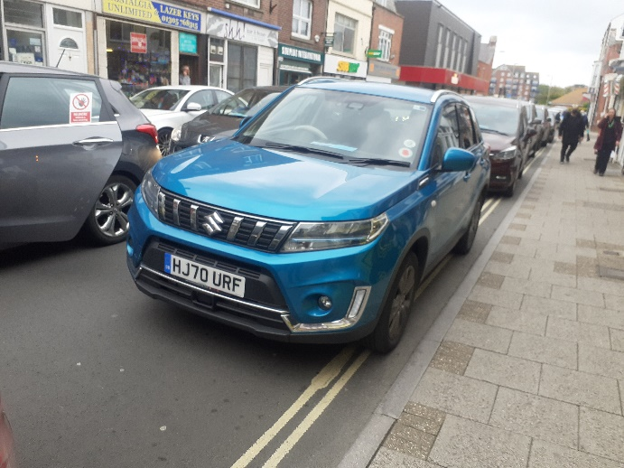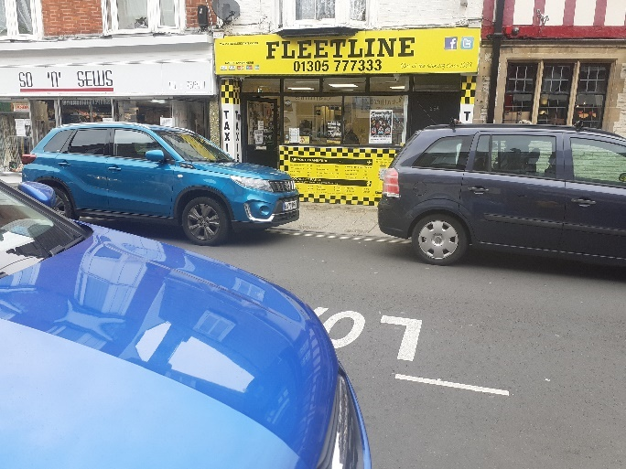
Image 1 Fleetline Taxi Office Image 2 Fleetline Taxi Office

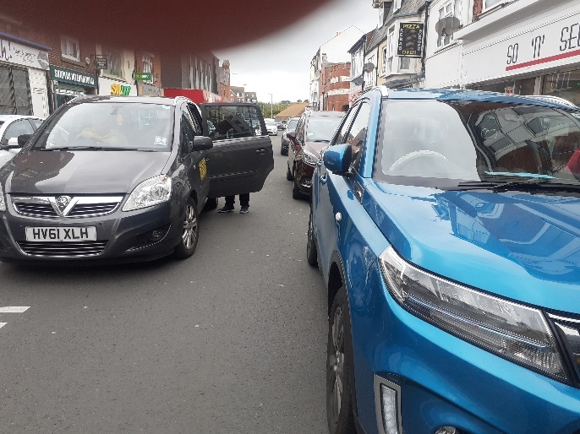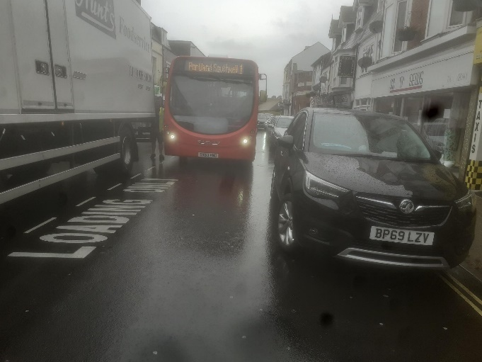
Image 3 Fleetline Taxi Office Image 4 Fleetline Taxi Office

Recommendation:
Members are asked to consider the request for alterations to the road markings outside of the Fleetline Taxi Office and agree whether or not the Committee supports the request, in which case it will be passed to Dorset Council for assessment.

Item 11 – Traffic Regulation Orders (TROs)

Proposed Traffic Regulation Order (TRO)

Double Yellow Lines - Radipole Lane & Hereford Road
Please see the attached plan detailing a proposal to add a “no waiting at any time” restriction (double yellow lines) on a section of Radipole Lane continuing into Hereford Road. Members are being asked only to agree to the proposals being advertised at this stage and not to comment on the proposals themselves as this will come when the proposals go out to public consultation.

Recommendation:
Members are asked to agree whether the Committee is happy for the proposal to be advertised for public consultation. The deadline for response is 14th September 2021.

Item 12 – Information Items

P/PALH/2021/02831
4 Faircross Avenue, Weymouth, Dorset, DT4 0DD
Erect single storey rear extension; depth from wall 4.60m; max height 2.70m; height to eaves 2.70m
The above application has been received by Dorset Council and Weymouth Town Council is being notified for information purposes. This application is not a planning application but a request for a legal determination of Dorset Council as to whether or not Prior Approval is required for the proposal. The application and any supporting documents can be viewed by clicking on the application number above. If Members have any queries about this application the Case Officer can be contacted.

P/PALH/2021/03080
346 Dorchester Road, Weymouth, Dorset, DT3 5AW
Erection of single storey rear extension - depth from wall 6m; maximum height 2.90m; height to eaves 2.90m
The above application has been received by Dorset Council and Weymouth Town Council is being notified for information purposes. This application is not a planning application but a request for a legal determination of Dorset Council as to whether or not Prior Approval is required for the proposal. The application and any supporting documents can be viewed by clicking on the application number above. If Members have any queries about this application the Case Officer can be contacted.

P/PALH/2021/02323
23 Dale Avenue, Weymouth, Dorset, DT4 7RB
Erection of single storey rear extension - to extend beyond the rear wall 4.4m; max height 3.0m; height to eaves 3.0m
The above application has been received by Dorset Council and Weymouth Town Council is being notified for information purposes. This application is not a planning application but a request for a legal determination of Dorset Council as to whether or not Prior Approval is required for the proposal. The application and any supporting documents can be viewed by clicking on the application number above. If Members have any queries about this application the Case Officer can be contacted.

P/PALH/2021/03166
6 Sutcliffe Avenue, Weymouth, DT4 9SA
Single storey rear extension
The above application has been received by Dorset Council and Weymouth Town Council is being notified for information purposes. This application is not a planning application but a request for a legal determination of Dorset Council as to whether or not Prior Approval is required for the proposal. The application and any supporting documents can be viewed by clicking on the application number above. If Members have any queries about this application the Case Officer can be contacted.

P/PABA/2021/03224
Fields at the rear of 102 Westhill Road
Erect Agricultural barn
The above application has been received by Dorset Council and Weymouth Town Council is being notified for information purposes. This application is not a planning application but a request for a legal determination of Dorset Council as to whether or not Prior Approval is required for the proposal. The application and any supporting documents can be viewed by clicking on the application number above. If Members have any queries about this application the Case Officer can be contacted.

Item 13 – Emergency Items
To be advised at the meeting.

