

**Parks and Open Spaces**

**DRAFT Biodiversity Policy**

**2021-2025**

**Introduction**

Weymouth benefits from a wealth of parks, public gardens and open spaces across the town. These provide opportunities for exercise, recreation and relaxation as well as helping connect people with nature and each other. They can also help mitigate against climate change and pollution. Having access to green spaces enhances physical health, mental well-being and life satisfaction.[1]

Greenspaces and parks in urban areas are also essential for biodiversity, providing food and habitat for wildlife. They also act as corridors or ‘stepping stones’ linking areas of higher wildlife value. This becomes increasingly important in the context of the ongoing biodiversity decline in the UK, in which 41% species are declining and 1 in 10 is threatened with extinction.[2] The Environment Bill 2020 may require Local Authorities to not only conserve but to enhance biodiversity as part of a Local Nature Recovery Strategy.[3]

Weymouth Town Council (WTC) Parks and Open Spaces team manage over 80 ha of land throughout Weymouth incorporating parks, gardens, playgrounds, open spaces, allotments and cemeteries. These areas range widely from heavily used and highly managed formal gardens, to more wildlife rich, less intensively manged open spaces. This considers how to maintain and enhance biodiversity across WTC’s open spaces in order to maximise gains for wildlife in the town and consequently across the wider area.

It is important to understand how WTC’s sites fit into the wider Dorset biodiversity context. The Local Nature Partnership for Dorset has produced an Ecological network map across the county, including for Weymouth (Appendix 1). WTC has one site with a national wildlife designation – Tumbledown Farm (SSSI) which is considered separately in the Tumbledown Farm Management Plan. There is also a Site of Nature Conservation Interest (SNCI) at Melcombe Regis Cemetery and a Local Nature Reserve (LNR) at Radipole Park Gardens. In addition, a number of WTC sites are considered as ‘wildlife corridors’ or ‘stepping stones’ forming part of a wider Ecological Network for Dorset and of these, some are also highlighted as having potential for higher ecological value. Therefore, increasing biodiversity on these sites will not only have local benefits but will help support the wider biodiversity network.

**General principles**

1. **Maintain and enhance existing wildlife-rich habitats**

It is important to protect and enhance areas within WTC that are already benefiting wildlife. These include Melcombe Cemetery SNCI and Radipole LNR as well as other undesignated areas which are relatively wildlife-rich or buffer wildlife-rich sites. For example, there is relatively species rich grassland in Pottery Lane, Miles Gardens and Whitehead Drive open space areas.

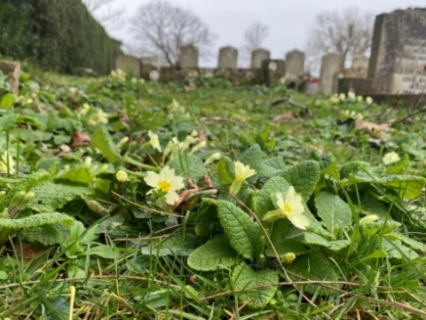

*Primroses, Birdsfoot Trefoil and Bugle at Melcombe Regis Cemetery*

There are lengths of native hedgerows at a number of sites. These are high value for biodiversity and are a national Biodiversity Action Plan habitat. WTC’s high value hedgerows will be sensitively managed with wildlife in mind. There will be no significant hedge works on native hedges during the bird breeding season, and their cutting regimes will be managed to reduce impact where this does not impact on public access or amenity.

There are also areas of scrub (for example at the Nothe and Lodmoor Country Park) which are valuable for birds and small mammals. Where these are not encroaching onto species rich grassland or impacting recreational use, these can be maintained and allowed to develop.

Trees are an extremely valuable habitat for wildlife both as standards and copses. Trees across the WTC land are retained where possible. If trees are lost through natural causes or are felled for safety reasons, these are replaced with appropriate species. Refer to the Weymouth Town Council Tree Policy for further detail.

1. **Create new habitats**

Increasing the amount and types of available habitat benefits wildlife. WTC will seek opportunities to create new habitats such as wildflower meadows, tree copses, native hedges and log piles. Where appropriate, vegetation within existing habitats can be diversified by adding wildflowers, long grass areas, shrubs and trees. Even something as simple as incorporating areas of long grass creates new habitats such as long hollow stems and seed heads. Allowing natural processes to occur also creates new habitats. For example, winter die back of herbaceous plants provides overwintering habitat for invertebrates, whilst leaving standing or fallen deadwood (where it doesn’t impact public safety) provides valuable habitat for fungi and invertebrates.

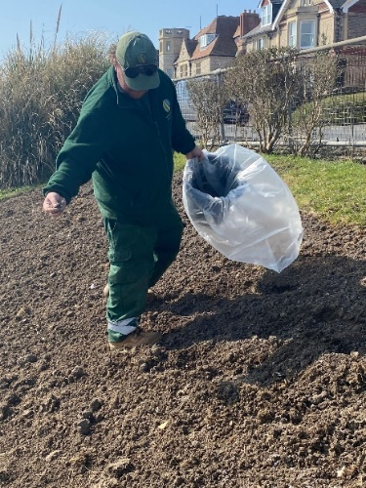

Log pile at Links Road Open Space

Sowing locally sourced wildflower seeds at Greenhill Gardens.

1. **Reduce pesticide and herbicide use**

Insects and weeds are biodiversity - they make up the vast majority of the species found across our sites, and they are food for other groups of animals such as birds. Pesticides are indiscriminate and will kill organisms other than their targets and can also accumulate in animals that eat sprayed insects. Similarly, herbicides can affect non-target species through direct accidental spraying or by drifting in the air. Biodiversity in our open spaces will benefit from minimising pesticide and herbicide use. However, in some instances (for example controlling non-native invasive species and keeping paths safe) there is currently no viable alternative. In these situations, the minimal possible amount of herbicide will be safely and carefully applied. WTC are currently trialling the use of horticultural vinegar, have invested in a ‘weed wiper’ machine and will continue to investigate new technologies as they emerge.

1. **Schedule vegetation clearance to avoid nesting birds**

Breeding birds and their nests are protected by law. WTC will continue to avoid vegetation clearance and tree works during the bird breeding season from March to September. During the ‘shoulders’ of the season, vegetation will be checked prior to starting work because climate change is altering nesting times.

1. **Remove invasive non-native plants**

Fortunately, there are limited occurrences of non-native plant species on WTC land. WTC will continue to remove non-native species, such as Japanese Knotweed and Giant Hogweed where they are found and ensure they do not spread onto neighbouring land, as required by Defra.

1. **Engage the public**

It is important to keep the public well informed when making changes for biodiversity in public areas, both to retain their support and as an opportunity to increase their awareness. For example, when leaving grass uncut to allow wildflowers to thrive, educational signs can help mitigate any impression of neglect. WTC will consult the public when undertaking biodiversity enhancement projects and will offer opportunities for public involvement where appropriate and resources allow.

WTC will endeavour to encourage more people into green spaces through communications (press and social media) and by working with the Friends Groups and the local community to organise events and activities in the gardens. There are currently a range of activities available for the public into our parks, including Park Run, Orienteering and Nature Trails. This will continue to expand and be publicised to engage more people. Keeping the gardens tidy, colourful, welcoming and maintained to Green Flag standards also increase the number of visitors and their enjoyment of the site.

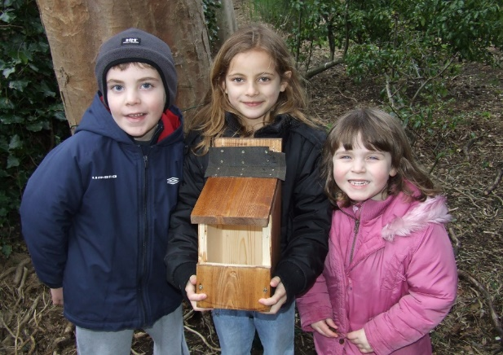

1. **Connect habitats**

As mentioned in the introduction, many WTC sites are part of Weymouth’s ecological network, acting as wildlife corridors and stepping stones between more wildlife rich habitats. These allow species to travel from one patch of land to another which is very important for healthy biodiversity and mitigating for climate change. Where sites fall within the ecological network map (Appendix 1), or show potential for higher ecological value, their enhancement will be prioritised and enhancement opportunities proactively sought out.

**Habitat Specific Principles**

1. **GRASSLAND**

The majority of the land managed by WTC is grassland. This includes amenity grassland, play areas and wildflower areas.

* 1. **Amenity grassland**

WTC maintain a significant number of amenity grassland sites, sports pitches and ornamental lawns. These are regularly cut and of very low value to biodiversity. These habitats support grassland invertebrates in low numbers (in comparison to long grass) and provide limited foraging resource for birds, mammals and other predators that feed on grassland invertebrates. Where these sites are heavily used for recreation, such as football pitches (ie. on part of the Marsh) or heavily used lawns (ie. in the gardens), there are few options to enhance biodiversity.

However, WTC will seek opportunities for enhancement in those areas which are less heavily used. These include:

* Changing the mowing regime on site or part of the site to allow longer grass and any flowers to grow – this more diverse structure will increase habitat and food sources for invertebrates and their predators. Leaving a buffer strip of long grass along hedges, boundaries and around trees (at least 50 cm) where it does not impact the amenity value of sites. Donated trees with plaques will continue to be strimmed.
* Leaving a proportion of long grass over the winter to allow cover for overwintering invertebrates.
* Enhancing areas of grassland by introducing wildflowers or spreading with species rich green hay and managing as a meadow.
* Allowing scrub areas to develop in areas of amenity grassland, providing food and habitat for invertebrates, birds and mammals.
* Planting trees or native hedges on areas of amenity grassland.

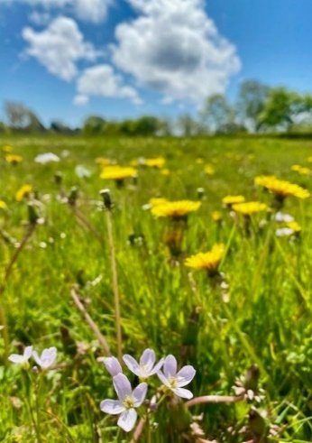

*Leaving areas of amenity grassland uncut provides food and habitat for insects. It is important to keep the public informed of changes both to gain support and to increase their awareness.*

* 1. **Wildlife-rich grassland**

Wildlife-rich grasslands are extremely valuable for wildlife but have undergone a catastrophic decline over the past century. These grasslands provide food and habitat to a high diversity of invertebrates, in turn supporting greater numbers of predators, such as birds and mammals. Wildflower meadows are particularly wildlife rich, supporting an array of pollinators, such as bees and butterflies.

WTC currently have three created wildflower meadow areas: Lodmoor Country Park, Radipole Park Gardens and a recently sown site at Greenhill Gardens.

* These areas will be managed as meadows, with an early cut and then left until the flowers have set seed later in the summer. The meadow then needs to be cut and the arisings removed. The sites may need some reseeding/over-sowing depending on species composition. Meadow areas will be expanded where funding and capacity allows using seed or green hay.

There are also a number of areas of existing higher quality grassland, for example at Melcombe Regis Cemetery and Pottery Lane open space, which can be managed to enhance their wildlife value.

* The mowing regimes of these sites will be altered to allow wildflowers to thrive and set seed. They will then be cut in the autumn and the arisings removed. These areas can also be enhanced with supplementary sowing/planting and expanded where practical.
* Scrub and bramble will be controlled where it is encroaching onto valuable grassland.
  1. **Naturalised bulbs in grass**

Naturalised bulbs, such as snowdrop and crocus, provide a flush of colour and interest for grasslands in spring. These habitats are of medium value to biodiversity as they provide a range of vegetation structures, and pollen and nectar early in the season.

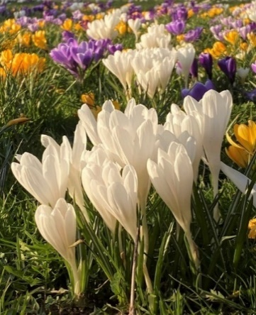

WTC will increase plant species diversity by planting native spring-flowering wildflower bulbs and increase the area of naturalised bulbs by expanding into ornamental lawns or amenity grasslands.

Some areas where bulbs have been planted (for example along the hedges at Melcombe Cemetery) will be left to grow throughout the year, mowing in late winter, to provide seed heads and hollow stems for birds and invertebrates.

1. **SHRUB BEDS**

The value of shrub beds to biodiversity depends on the species used. Most shrubs are high valuable to biodiversity due to the range of structures and habitat niches they provide (e.g. woody stems, foliage at varying height from the ground, flowers, seed heads/hips/berries). Shrubs with lots of flowers and a long flowering period are good for pollinators, especially if they flower early or late in the season when pollen and nectar sources are in short supply. WTC will adhere to the following guidelines for shrub beds:

* Consider wildlife value when planting new shrubs using flowering and fruiting shrubs that provide food sources for wildlife.
* Reduce intensive trimming of shrubs where appropriate, allowing a variety of shrub heights to develop.
* Consider replacing mulch and cultivated soil with herbaceous groundcover or woodland wildflowers.
* Add structure to shrub beds by planting single standard trees in appropriate places.
* Leave woody cuttings in piles within the shrub bed to create deadwood habitat.

1. **FLOWER BEDS**

Flower beds create a visual spectacle and can be of high biodiversity value if they contain a variety of nectar rich flowers. WTC will:

* A bee on a flower

  Description automatically generated Increase species and structural diversity within the bed.
* Select plants which encourage pollinators or have other wildlife benefits.
* Select species for future plantings that do not need protection from slugs to survive, thereby avoiding the need to use slug pellets. Also consider plants resistance to pests and diseases, which may require spraying.
* Retain dead seed heads and skeletons of dead plants where practical and where it does not impact visual amenity, leaving to stand over winter for seed-eating birds and winter invertebrate shelter and strimming in late winter or spring. Signage can be used to explain to the public why this is being carried out.

1. **PONDS AND WETLANDS**

Water features are of great value to biodiversity, however there are very few under WTC management. The amenity fishpond at Sandsfoot Gardens is of fairly low biodiversity value, with hard straight edges and surrounded by paving, although it does provide a supply of freshwater to birds. Some of the allotments have ponds or water features on their plots and even these small, temporary water bodies provide water for wildlife to drink and will support some invertebrates. The wet grassland at Radipole Park Gardens has higher potential value to wildlife and will be enhanced as part of the RPG lottery project.

WTC will seek potential sites to create ponds or wet areas if appropriate funding and locations can be secured.

1. **HEDGES**

Hedgerows are a priority habitat in the UK Biodiversity Action Plan (UKBAP) and creating and enhancing hedges will be of high value to biodiversity if they are well-managed and species-rich. They act like long linear woodland edges to provide shade, shelter and a range of habitat niches within a small area. Hedges within the WTC area range from native hedge boundaries in various management conditions to ornamental hedges, which are intensively managed. WTC will:

* Reduce frequency of cutting in native hedgerows where it does not impact the visual amenity or safety of the site. WTC will promote a more varied structure by aiming to cut once every two or three years or by cutting only one side of a hedge each year.
* Identify hedges needing restoration work (gapping up, coppicing) and those that will be left to grow out – both of which are valuable for wildlife.
* Increase the diversity of single-species hedges by incorporating a range of native hedging species or including flowering and fruiting species.
* Create a buffer strip of biodiversity grass or meadow extending 2 metres from the base of the hedge.
* Allow trees to grow up within the hedge.

1. **TREES**
   1. **Wooded areas**

Copses and wooded areas are of high value to biodiversity mainly due to having a huge range of habitat niches. An area of trees can support many more species than the same area of any other park habitat. WTC has wooded areas at the Nothe Gardens and Lodmoor Country Park, however, there are few areas with varied age and structure of trees with a native understory.

WTC will consider the following options for trees:

* A picture containing outdoor

  Description automatically generatedConsider planting trees where appropriate on low value amenity grassland where this does not impact recreation or amenity.
* Where there is dense tree cover, allow glades and pathways to increase sunlight reaching the ground which will stimulate undergrowth.
* Leave logs, prunings and other dead wood in place to decompose or create nearby log piles, including standing dead wood where it does pose a risk to the public or compromise the visual amenity of a site.
* Introduce woodland wildflowers and ground flora.
* Create a buffer strip of long grass around the edge of copses and under trees.
* Maintain a shrub understorey and encourage trees to regenerate naturally.
* Develop a wide range of tree ages and sizes from young regeneration to standing damaged or dead trees.

More detail can be found in WTC’s Tree Management Policy.

* 1. **Single standard trees**

Single trees can be of great value to biodiversity if allowed to mature and reach a good size. Tree species which flower and produce fruit are valuable to pollinators in summer and birds in winter. WTC will:

* Leave grass uncut underneath single trees, to a radius of 50 cm or more where viable. Trees with dedication plaques will continue to be strimmed, as will some trees in formal gardens.
* Plant bulbs underneath single trees to provide spring colour where resources allow.
* Encourage or introduce wildflowers underneath single trees to maintain display after bulb flowering.
* Leave dead wood in place on trees unless it poses a safety risk.
* Install bat or bird boxes where appropriate to increase nesting habitat, bearing in mind the need for bird box maintenance.

1. **PLAY AREAS**

These are of low value to biodiversity but there are opportunities to enhance them for wildlife, which can make them more engaging for young people and provide some natural play opportunities.

* Install bat and insect boxes where appropriate.
* If resources allow, to incorporate planting trees/shrubs into play areas, whilst having regard for safety and vandalism considerations.
* Consider creating natural play features with logs, sticks for den making or water.

1. **DEADWOOD AREAS AND COMPOST HEAPS**

Standing and fallen deadwood are important habitats for a huge range of invertebrates and fungi. Deadwood includes fallen branches, felled trees, log piles, dead branches on living trees and standing dead trees. Similarly compost heaps provide additional resources of dead plant matter for fungi and invertebrates to feed on and inhabit; the compost can be used in horticultural operations once it has broken down. The heavy recreational use of WTC Parks and Gardens and aesthetic sensibilities of the public (as well as health and safety) will limit our opportunities to create deadwood habitats and compost heaps on our parks and gardens, however, in less used or visible areas we will consider the following options:

* Leave some dead trees and shrubs standing (whilst having regard to both health & safety and aesthetics)
* Leave some old tree and shrub stumps to decay naturally.
* Create log piles from cuttings of various thicknesses, leave in contact with the ground, in light shade, and in a compact pile.
* Create compost heaps, fed with grass cuttings, strimmings from herbaceous perennials, old bedding plants, and chipped wood.

1. **ALLOTMENTS**

WTC manage 350 allotments across eight sites. Allotments are ideal places for biodiversity. The sheer number and density of different plants and habitats brings a huge diversity of invertebrates, birds and other wildlife. WTC allotment sites are included in Weymouth’s ecological network.

Allotment holders can be encouraged to garden in a wildlife friendly way. For example, delaying the winter tidy up until March will retain dry plant stems and seed heads, which provide winter food for birds and places to rest and hibernate for invertebrates. Allotment holders can also be encouraged to avoid peat and pesticides, provide water for birds and leave some plants to bolt to provide extra flowers for pollinators.

The common areas of WTC allotments provide opportunities to create new habitats to benefit wildlife. WTC allotments need to be assessed for potential biodiversity enhancements which could include the following.

* Pond creation – this will attract frogs and toads which help control slug and snails as well being a huge biodiversity boost.
* Planting native or fruit trees on common areas.
* Create hedgerows along boundaries. Natives like hawthorn, blackthorn, holly and brambles can be mixed with non-native pyracantha or Japanese rose to create a hedge rich in flowers and berries for wildlife. These species are all thorny so double-up as a security measure. Allow scrub areas to develop in uncultivated corners and edges of the allotment.
* Affix bat and bird boxes to mature trees. Consider an owl box where they are present (e.g. Green Lane).
* Create habitat piles using stones and dead wood. This will be used by many different invertebrates and maybe frogs or hedgehogs. Compost heaps are also good habitats for wildlife.

**Conclusion**

Whilst the priority for the WTC Parks and Open Spaces Team is to provide safe, aesthetically pleasing recreational spaces for the community, a wealth of research indicates that spending time with nature benefits people’s health and wellbeing. Enhancing WTCs sites for wildlife will therefore help both mitigate the biodiversity crisis and will also benefit the users of the sites. Keeping the public informed and engaging them, where possible, ensures increased public support and wider benefits. WTC will strive to continue to enhance its parks and open spaces to benefit both people and wildlife into the future.

**Biodiversity Actions**

Note, this is currently a working list which will be revised annually with the Biodiversity Policy. Funding, capacity and logistics as well as public and council support will determine which actions can be undertaken.

|  |  |  |
| --- | --- | --- |
| **ACTION** | **LOCATION** | **DATE** |
| Identify high value grassland areas and revise mowing regime accordingly. This will need to be accompanied by a publicity campaign and signage. | Pottery Lane  Whitehead Drive  Melcombe Cemetery | Spring 2021 and ongoing |
| Create long grass margins (2-5 m) next to boundaries and around the base of trees (at least 50 cm) in less heavily used amenity grassland where trees are not donated. | Bowleaze  Bincleaves  Ryemead  Cemeteries | Spring 2021 and ongoing |
| Implement recommendations for Radipole from bat conservation guidance and conservation management plan. See appendix 2 for details. | Radipole Park Gardens | Autumn 2021 ongoing as part of HLF |
| Work to bring Melcombe Regis SNCI back into favourable conditions – see appendix 3. | Melcome Regis Cemetery | 2021/22 |
| Seek opportunities for native hedge planting on perimeters. | Allotments  Weymouth Cemetery  Southill | Autumn 2021, Autumn 2022 |
| Assess hedges across estate and identify appropriate management and restoration. | All sites | Autumn/Winter 2021 |
| Plant native trees on low value grassland sites or to supplement current tree stock. | Links Road  Lodmoor  Assess other sites | Winter 2021  Winter 2021  Ongoing |
| Investigate opportunities for enhancing grassland biodiversity by creating wildflower areas using seeds, plugs or by planting naturalised bulbs. | Cemeteries  Greenhill wildflower area  Ryemead  RPG  Marsh | Spring 2021  Autumn 2021  Spring 2021  Autumn 2021 |
| Continue to reduce herbicide use and seek alternative technologies as they emerge. | All sites | Ongoing |
| Identify high value scrub areas and manage appropriately. | Nothe  Lodmoor  Links Road  More sites | Autumn 2021 |
| Investigate potential for bat/bird/owl boxes. | All sites | As and when funding becomes available |
| Assess allotments for potential wildlife enhancements in common areas – specifically ponds and plantings. | All allotments | 2022 |
| Engage allotment holders in wildlife friendly gardening and consider if our approach to inspections is enhancing biodiversity. | All allotments | 2022/23 |

**Appendix 1** – Ecological Network for Weymouth (can be seen in detail on Dorset Explorer)

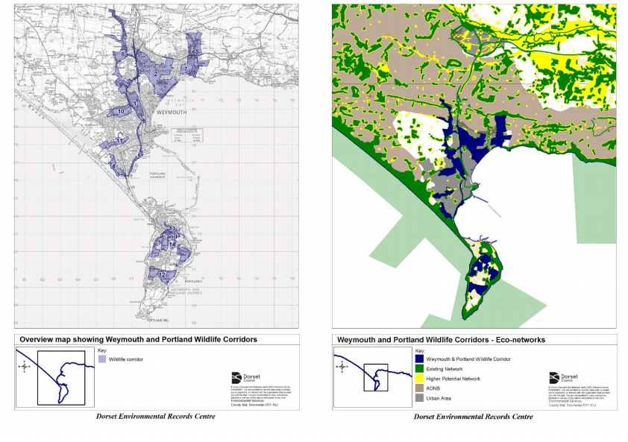

**Appendix 2**

Bat survey management recommendations for Radipole Park Gardens:

4.2.1 Install some bat boxes on trees around the exterior of the gardens. These should be of a type which are suitable for Pipistrellus nathusii. If the residency is successful in these boxes then there is potential for this to further the current research into the species. These should be of type Schwegler 2F-DFP or similar.

4.2.2 Consider further planting of trees/hedge alongside the adjacent road at the northern end of the site next to the playing field.

4.2.3 To provide further habitat for invertebrates, which the support the bats, consider leaving edges of the grass areas, where they meet boundary trees and shrubs, uncut.

4.2.4 In terms of planting, use a variety of plants which will attract insects, especially important are pale colours which can be seen by insects at dusk. Evening primrose and honeysuckle are very good for moths and so should be considered.

4.2.5 When undertaking any remedial tree works consider if bat habitat can be added to the tree, in terms of slits and crevices. This should only be done if the tree is in a safe location to do so. Any arisings in the form of wood should be stacked and left to decay for invertebrate habitat.

**Appendix 3: Melcombe Regis Cemetery Site of Nature Conservation Interest survey and management recommendations**

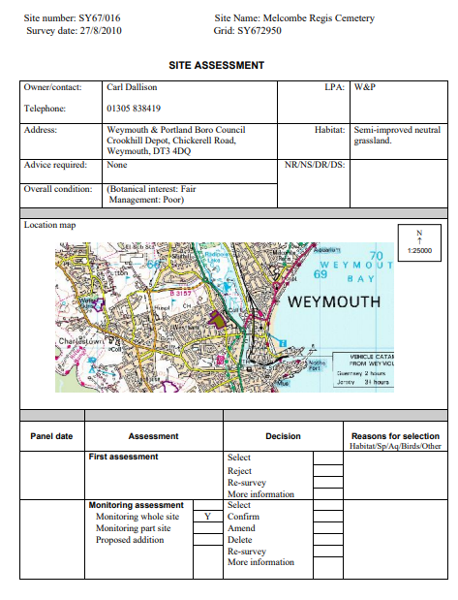

1. Citation Dobson, J., Harris, C., Eadson, W., and Gore, T. (2019). **Space to thrive: A rapid evidence review of the benefits of parks and green spaces for people and communities.** The National Lottery Heritage Fund and The National Lottery Community Fund, London.
2. Hayhow DB, Eaton MA, Stanbury AJ, Burns F, Kirby WB, Bailey N, Beckmann B, Bedford J, Boersch-Supan PH, Coomber F, Dennis EB, Dolman SJ, Dunn E, Hall J, Harrower C, Hatfield JH, Hawley J, Haysom K, Hughes J, Johns DG, Mathews F, McQuatters-Gollop A, Noble DG, Outhwaite CL, Pearce-Higgins JW, Pescott OL, Powney GD and Symes N (2019) The State of Nature 2019. The State of Nature partnership
3. [10 March 2020: Nature and conservation covenants (parts 6 and 7) - GOV.UK (www.gov.uk)](https://www.gov.uk/government/publications/environment-bill-2020/10-march-2020-nature-and-conservation-covenants-parts-6-and-7)