CLOCKWORKS DISPLAY BUILDING

IN GREENHILL GARDENS, WEYMOUTH

BACKGROUND

The floral clock in Greenhill Gardens was originally installed in 1936. The clock hands are driven by a mechanism that is currently housed in a wooden shed located close by. The building is ageing and requires replacement. The Friends of Greenhill Gardens (FOGG) have worked with Tara Williams, Parks and Open Spaces Manager for Weymouth Town Council to propose a new building. Provisional approval has been given.

The building has been designed to display the historic clockworks mechanism, and to enhance the appearance of Greenhill Gardens. The quality of materials should be suitable for it’s setting in the Conservation Area. In particular, the materials to be used and the appearance of the roof and windows echo the design of the “Bennett’s Shelter”.

The existing stone and concrete plinth should be retained together with the existing position of the clockworks mechanism and the underground connection to the floral clockface. This limits the footprint to 2.4m by 2.4m (8ft by 8ft). Due to the size and type of the building, there is no additional requirement for Planning Permission, or for Building Regs.

The site is in Greenhill Gardens, and is approx. halfway between the Seascape Café, and the Bennett’s Shelter. Vehicle access to the site is possible with permission.

REQUEST FOR CRAFTSMEN AND BUILDERS
If you are interested in working on the construction of the new building (either all or part), please contact Tony Tunbridge on 07504 818 064

PLANS AND ELEVATIONS

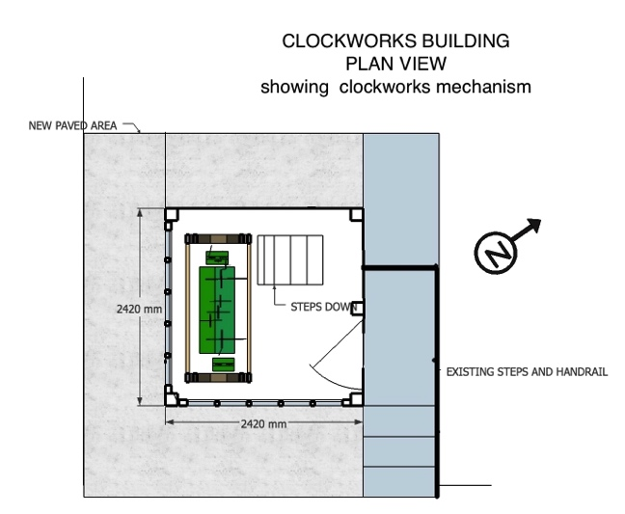 No change to existing steps and handrail
Clockworks mechanism to be protected

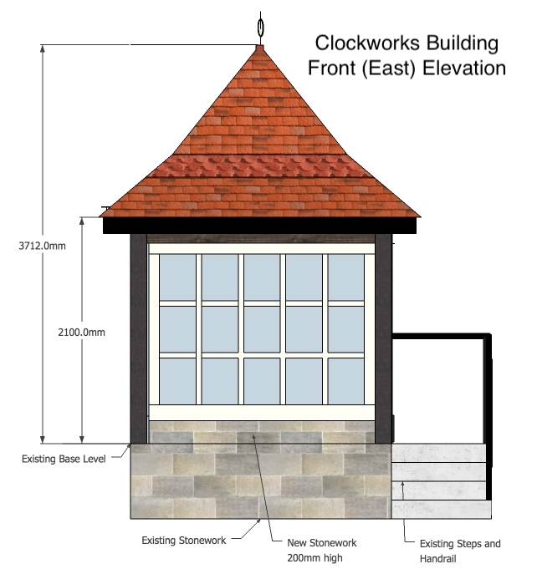

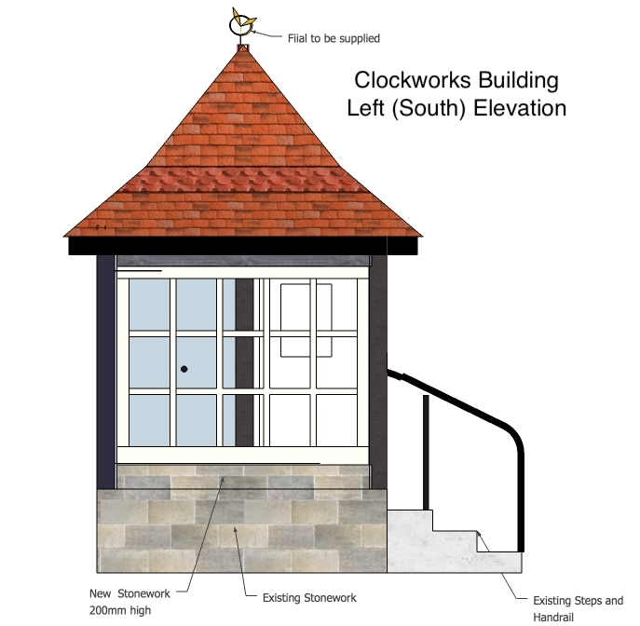

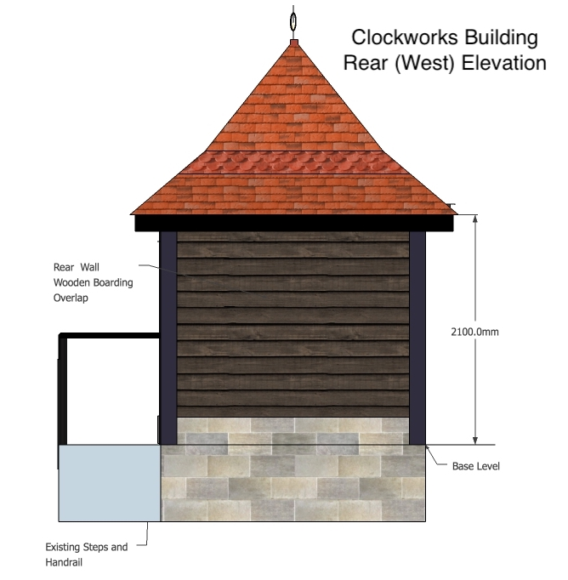

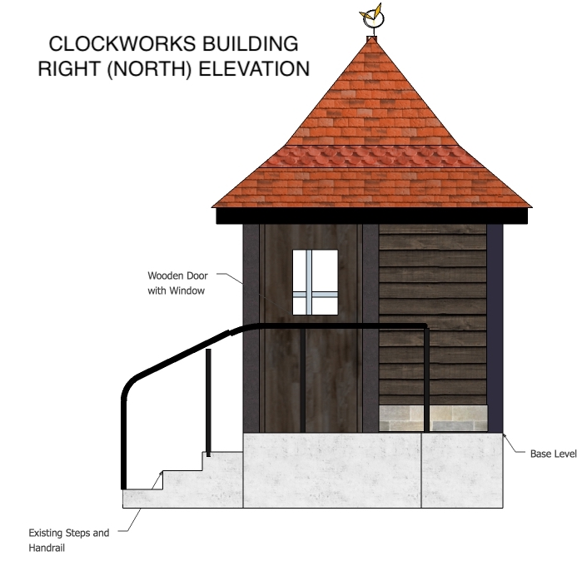

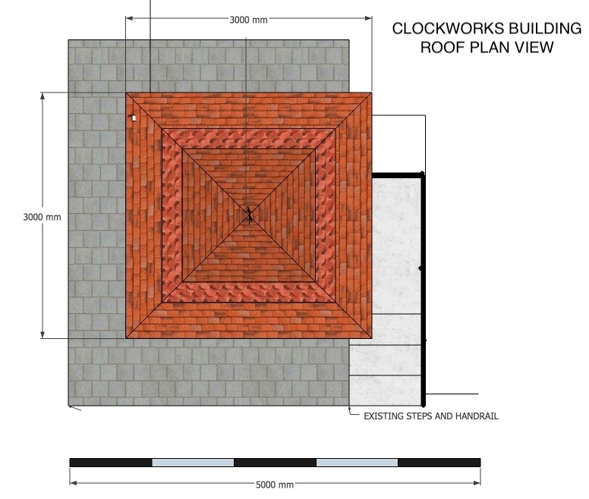

MATERIALS AND FINISHES
FRAME
Wooden frame. Corner posts 150x150mm (oak)

WINDOWS
Wooden. Single glazed. Toughened glass.
Construction to match windows at either end on the Bennett’s shelter.

WALLS (Rear and right side)
External - Wooden boarding, overlap. Similar to Bennett’s Shelter
Internal - ply (to be painted)

DOOR
Wooden flush panel. Small window.

ROOF
Tiles in clay. Double row of decorative “club” tiles.
Roof total width 3000mm, overhang approx. 300mm
Roof slope at lower part 35 degrees. Upper part approx. 45 degrees
100 x 100 mm post at centre able to take finial (to be provided by FOGG)
Ceiling can be left open if roof under tiles is boarded.

FINISHES
Windows – white gloss
Frame, External Wall, Door - stain, mid brown or dark
Internal walls - white paint.

