Council Offices, Commercial Road, Weymouth, Dorset, DT4 8NG
01305 239839 - office@weymouthtowncouncil.gov.uk

Councillors nominated to the Services Committee are hereby summoned to attend the following meeting. Please inform the Clerk if you are unable to attend.

NOTICE OF MEETING

MEETING: Human Resources Committee Meeting
DATE & TIME: Tuesday 13 April 2021 at 6.30pm
PLACE: Zoom

This is a meeting in public, not a public meeting.
Due to the current restrictions in place the Council is unable to meet in person and so will be meeting virtually. Members of the public can view the meeting on the Council’s Facebook page www.facebook.com/WeymouthWTC
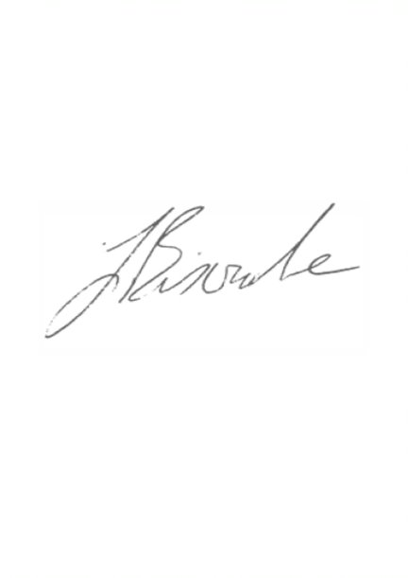
Should members of the public and press wish to attend Full Council meetings or ask a public question, please email office@weymouthtowncouncil.gov.uk
Agenda and papers are available at www.weymouthtowncouncil.gov.uk
.

J L Biscombe, FSLCC, CiLCA
Town Clerk 07 April 2021 ____________________________________________________________________________

Agenda
- Welcome by the Chair
- Apologies for Absence and Substitutions
- Declarations of Interest
- Minutes of the last meeting
- Councillor questions
- Public questions
- Information items
- Actions from previous meetings
- Forward Plan
- Exclusion of the Press and Public
- Staffing update

Welcome by the Chair

Apologies for Absence and Substitutions
To approve apologies for absence and substitutions.

Declarations of Interest
To receive Councillor declarations of interest in matters on the agenda

Minutes of the last meeting
To agree the minutes of the last meetings held on 03 November as a true and accurate record.

Councillor’s Question Time and statements
Prior notice preferred where possible.

Public Question Time
The length of time available for public questions will be determined by the Chairman.

Information Items

Actions from previous meetings
Date | Who | Action | Status
11/03/20 | JB | Bring forward an updated Apprentice Pay Policy | In progress
27/11/19 | JB | Put an SLA in place with DC regarding the CSAS officers | In progress

Forward Plan
Date | Items for consideration
09/06/21 | Staff Review  Town Clerk’s annual appraisal arrangements
29/09/21 | Town Clerk’s annual appraisal outcome  Out of Hours arrangements  Union recognition agreement
24/11/21 | Establishment and salary budget for 21/22

Recommendation:
That the Committee notes the information above.

Exclusion of the press and public
Under the Public Bodies (Admissions to Meetings) Act 1960 members of the public and press are required to leave the meeting due to the sensitive nature of the item next to be considered relating to individual staff members.

Recommendation:
That Councillors agree to exclude the public and press.

Staffing update
Councillors will receive a verbal update on any current staffing, HR and recruitment issues.

Recommendation:
Councillors are asked to note the verbal update and agree any actions that may be appropriate.

