Council Offices, Commercial Road, Weymouth, Dorset, DT4 8NG
01305 239839 - office@weymouthtowncouncil.gov.uk

Councillors are hereby summoned to attend the following meeting.
Please inform the Clerk if you are unable to attend.

NOTICE OF MEETING
MEETING: Annual Meeting of Weymouth Town Council
DATE & TIME: Wednesday 5th May 2021 at 7.00pm
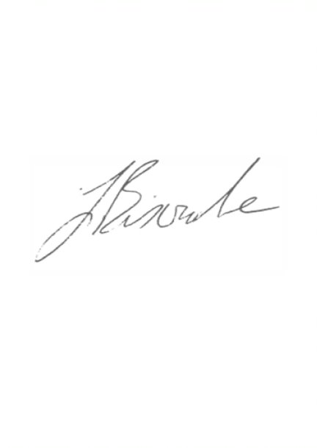
PLACE: Zoom
This is a meeting in public, not a public meeting.
Due to the current restrictions in place the Council is unable to meet in person and so will be meeting virtually. The public can view the meeting on the Council’s Facebook page www.facebook.com/WeymouthWTC. Should members of the public and press wish to attend Full Council meetings or ask a public question, please email office@weymouthtowncouncil.gov.uk. Agenda and papers are available at www.weymouthtowncouncil.gov.uk

J L Biscombe, FSLCC, CiLCA Town Clerk 28th April 2021 ____________________________________________________________________________

Agenda
- Election of Chairman (Mayor)
- Election of Deputy Chairman (Deputy Mayor)
- Election of Mayor Elect
- Apologies
- Declarations of Interest
- Minutes of the last meeting
- Councillor Questions and Updates
- Committee Minutes and Recommendations from other Committees
- Public Questions
- Decision making by the Council after 6th May 2021

Election of the Chairman (Mayor)
To elect the Chairman for 21/22. This item will be chaired by Cllr Graham Winter. Following items will be chaired by the Chairman elected in this item.

Following the election, the Chairman will make the following statement:

I, (state name) having been elected to the office of Chairman of Weymouth Town Council declare that I take that office upon myself and will duly and faithfully fulfil the duties of it according to the best of my judgement and ability. I undertake to observe the code as to the conduct which is expected of members of Weymouth Town Council.

Election of the Deputy Chairman (Deputy Mayor)
To elect the Deputy Chairman (Deputy Mayor) for 21/22

Election of the Mayor Elect
To elect the Mayor Elect for 21/22

Apologies for Absence
To approve apologies for absence.

Declarations of Interest
To receive Member’s declarations of interest in matters on the agenda.

Minutes of the last meeting
To confirm the minutes of the meeting held on 07 April 2021.

Recommendation:
That Members approve the minutes as a true and accurate record and agree they be signed as such on a future date.

Councillor Questions and Updates
Prior notice preferred for questions.
Updates require a written report within agreed guidelines.
Please note that this item encompasses Councillor Questions, Councillor Updates and Updates from Representatives on Outside Bodies

Cllr Bergman has asked the following question:
There has been a recent incident in which a young child could have been severely injured or even killed as a result of safety standards not being adhered to by a building contractor working in Weymouth. The Health and Safety Executive was informed and at the time of writing my question, was in the process of investigating the incident. Would Weymouth Town Council support my request that in liaison with Dorset Council, it reviews potential actions a council can take, to prevent building companies which do not adhere to safety guidelines, operating in Weymouth?

A response will be provided by the Town Clerk.

Committee Minutes and Recommendations from other Committees

Committee | Date | Minute Nos | Recommendations
Human Resources | 13/04/21 | HR0119–HR0127 | None
Planning & Licensing | 13/04/21 | P00425-P00436 | None
Services | 21/04/21 | S0135 – S0147 | Tree Management Policy (19 May)

Recommendation:
That Members note the minutes for the meetings listed above.

Public Question Time
Questions referring to the work of Dorset Council will not be taken at this meeting.
The length of time available for public questions will be determined by the Chairman.

Decision making by the Council after 06 May
The regulations that currently allow local authorities to hold meetings remotely until 06 May 2021 will not be extended by the Government, and so face-to-face meetings will need to resume from 07 May. The Council considered options at the Full Council meeting held on 07 April 2021. At that meeting the Council agreed that if virtual meetings were not enabled in law to continue after 06 May 2021, then the Council would agree to the second option in the options paper, namely delegation to the Clerk.

The Association of Democratic Services Officers (ADSO), Lawyers in Local Government (LLG) and Hertfordshire County Council lodged a legal challenge in the High Court that sought a continuation of local authority remote meetings beyond the 06 May 2021. The Courts have not upheld the challenge and as such Councils are required to return to face-to-face meetings. The Courts have confirmed that a change in legislation is required to enable virtual meetings A ruling is awaited on the provision for the public attending those meeting is permitted via virtual methods.

In light of the ruling above, the Council is asked to agree the following temporary amendment to Standing Orders to allow delegation to the Clerk for a period of 6 months.

15.18 To enact the decisions delegated to them by the Council’s Committees and Full Council until such time as virtual meetings are enabled in law, or face to face meetings resume. This delegation will be reviewed on or before 05 November 2021.

This delegation will be backed up by the meetings plan as usual. Committee and Full Council meetings will go ahead virtually and instead of making decisions, Councillors will recommend decisions to the Town Clerk, who will then enact those recommendations under the temporary delegation. The delegation will remain in place until Councillors decided that a return to face-to-face meetings is appropriate, or that the delegation should cease for any other reason.

The signing of the Annual Governance and Audit statements cannot be delegated. This needs to be done by 30 June. The Town Clerk will arrange a single item meeting with a pre-agreed quorate in attendance to agree the signing of these statements after a Full Council meeting has discussed them and agreed for them to be signed.

Impact Assessment:
Equalities – Those who find it difficult to attend face-to-face meetings will be able to continue to engage with proceedings virtually.
Environmental – The use of virtual meetings will continue to bring with it the associated reduction in the use of cars and other motorised transport, along with the associated reduction in building and resource use.
Crime and Disorder – There are no direct impacts from this report.
Financial – Virtual meetings are at a lower cost financially to the Council than physical meetings.
Resources – Virtual meetings are at a lower cost in terms of resources – especially time - to the Council than physical meetings.
Economic – There are no direct impacts from this report.
Risk Management – The amendments to SOs will allow effective virtual decision making to continue until the Council feels the risks of Covid permit a return to face to face meetings.
Council Priorities – This decision will contribute to the following agreed priorities:
- Manage the Council’s assets and resources responsibly and transparently.
- Manage the Council’s services effectively to meet the needs of the communities we serve.
- Work to become greener and cleaner in our activities as well as supporting our communities and partners to be as green as possible.
Recommendation
That Full Council agree the amendment to Standing Orders for a period of six months

