APPENDIX C

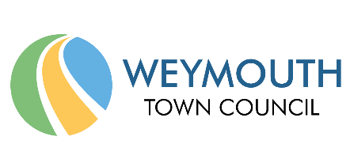
Events and Festivals Policy 2020 – 2025

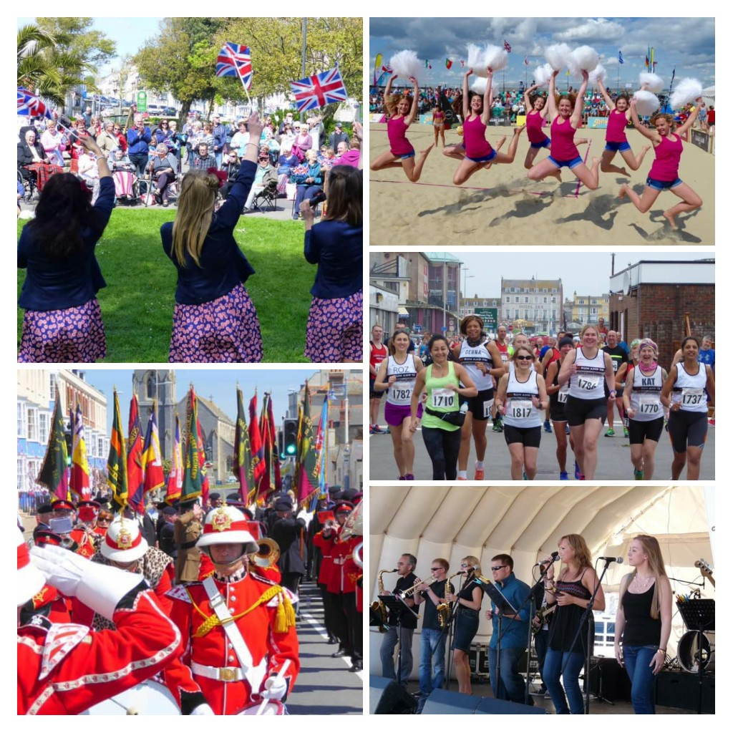

Index

- Vision
- Background
- Context
- Events and Festival Priorities
- Application Process
- Use of Council Land and Assets
- Safety Advisory Group
- Funding of Events
- Marketing and Promotion
- Useful Contacts

Annex 1. Green Events Guide
Annex 2. Scale of Charges

Pol Document | Version | Owner | Date  Approved | Review  Date
WTC Events Policy | Draft 13/11/20 | Matt Ryan/ Charlie Sheppard |  | April 2025

- Vision:

That by 2025 Weymouth has developed a comprehensive programme of high-quality sustainable community inspired and tourism-based events and festivals that cultivates community creativity for maximum economic and environmental benefit and social enjoyment throughout the town council area.

- Background:

Weymouth has a long-established history and tradition of hosting events and festivals in support of its community and economy throughout the year. It has developed into a comprehensive and diverse range of activities; from local community events that have many direct links to the well-being, fundraising and cohesion of the local community to International events placing the town on the world stage.

Events and festivals are acknowledged in improving the quality of life of a local population. They provide occasions for expressing collective belonging to a group or a place, creating opportunities for drawing on shared histories, cultural and ideals.

Weymouth is fortunate to have many local, regional, and international event organisers that deliver safe, sustainable and well managed activities year on year. The Town Council’s Events Management Service plays a valuable role by the enabling, delivering and facilitating the events programme.

There are also may local organisations such as the Weymouth Business Improvement District (BID), Weymouth & Portland Chamber of Commerce and Weymouth Civic Society that provide important and helpful support towards the enhancement, development, community engagement and delivery of Weymouth’s tourism and annual events calendar.

It should be noted that this Policy relates to the hosting of events or activities on land or assets owned by the Council, including those under the Council’s assigned management responsibility. This Policy will also apply to events and festivals organised by the council itself. It does not apply to those events held on private land or property. The Policy also defines the type and form of activities that the Town Council will prioritise and support with its resources.

- Context:

A dynamic events and festivals programme, that includes sports, leisure, special interest, culture, community, heritage and the arts, will have a positive impact and make a significant contribution to the positive status and image of the Town and surrounding area. It will provide opportunities for community development and community-led events; generating positivity and cohesion within the local community, offering opportunities for engagement and involvement; building community spirit and creating civic pride.

The priorities set out within this policy supports the Town Council’s vision and values detailed within the Weymouth Town Council Strategy 2019 – 2025 as follows:

‘Creating thriving communities in Weymouth where everyone is proud to live, work, play and visit’; where it is the Council’s ambition is to:

- Improve the wellbeing of the people of Weymouth.
- Manage the Council’s assets and resources responsibly and transparently.
- Manage the Council’s services effectively to meet the needs to the communities we serve.
- Work to become greener and cleaner in our activities as well as supporting our communities and partners to be as green as possible
- Promote opportunities for economic success of the area.
- Strive for continuous improvement and service development.
- Work with partners to deliver our core values

The Policy aims to provide a prioritised and consistent approach to the type and form of events and activities that the Town Council will support and encourage during the lifespan of this policy - focusing on Weymouth’s community, unique history, culture and community, natural environment; and achieving this using best practice sustainable measures.

The priorities detailed within this policy are intended to provide clarity and focus on the opportunities that makes “Weymouth” distinct and unique in comparison to other destinations; and embraces those aspects of Weymouth that are important to the Community.

The priorities also embrace visitor market research such as the 2016 Blue Sail Tourism study report, commissioned by the former Councils that identifies emerging visitor markets and opportunities for future economic growth and success. This included:

Activity Seekers – All ages, socio-demographic groups ABC1C2 – families, friends, couples; All levels of expertise - enthusiasts, dabblers, learners and tasters; Range from those passionate about their sport/activity to those who want to try things out or have some fun while on holiday.

Cultural Couples - Aged 40+, socio-demographic AB; Relatively affluent, interested in culture, food, well-being and spending time together.

- Event & Festival Priorities:

The priorities set out the form of Events, Festivals and activities that the Council will encourage and support during the continuance of this policy:

Priority 1: Community Events and Engagement: Supporting the Community with the delivery of events inspired by the Community; helping to build community capacity and knowledge to deliver events in compliance with national legislation. This also includes the use of the Councils assets to facilitate events that raise funds for local good causes.

Priority 2: Health & Active Lifestyle Events: Enabling events and festivals that contribute to physical, mental and social wellbeing of the Community and Visitors to the Weymouth.

Priority 3: Local Heritage and Culture: Weymouth has extensive local history and heritage that should be celebrated and remembered by this and future generations to come. Arts and Culture also play a vital role within this and also contribute to the local economy. Events that engage and define the area should be encouraged.

Priority 4: Sustainability and Green: Weymouth Town Council has declared a climate emergency and we have committed to making the Council’s activities net zero carbon by 2030. In turn, we would ask all events organisers to undertake an Environment Impact assessment and apply best practice sustainable measures to the way their events are planned and delivered.

It is also acknowledged that many events and festivals can raise the profile of Weymouth both nationally and internationally, and which deliver significant economic benefits for the town and surrounding area.

Attached at Annex 1 is the Council’s Green Events Guide.

Please note: Although this Events Policy is for 5 years, the Green Events Guide will be reviewed on an annual basis –in January each year to ensure that its meets current best practice.

- Application Process:

The Town Council looks forward to working with event organisers that support the Town Council’s vision and priorities for a high-quality sustainable programme of annual Events & Festivals.

In addition to being sustainable, all activities should be able to demonstrate evidence of meeting at least one of Priorities 1 to 3 listed above.

It is expected for the Event Organiser to thoroughly complete and read the Event Application Form and Guidance information provided by the Town Council following the initial event enquiry.

Event organisers will be required to establish:
- Their accountability for the event through their associated event management plan which will be subject to scale and size of the proposed Festival / Event and depending on the nature of the event this would also include traffic management plan, crowd management plan, waste management plan and the like.
- Hold open and honest dialogue with the Council and its partners throughout the pre and post planning phase and delivery of the event. Event organisers may be required to present their event plan to the Dorset Safety Advisory Group.
- Show how the event will comply, where relevant, with legal, licensing and conditions specific to the event and its location.
- Produce an environmental impact assessment / define achievable targets to minimise the impact of your event.

Where appropriate Event Applications will be subject to consultation with relevant stakeholders and groups. Please note that this could take up to 28 days.

Health & Safety, Event Management Best Practice:

All events and festivals will be required to comply with event management or other such applicable legislation and recognised best practice including the guidance provided by the Health and Safety Executive and the Events Industry Forum’s ‘Purple Guide’.

Guidance can be found at the following websites:
- The Purple Guide to Health, Safety and Welfare at Music and Other Events produced by the Events Industry Forum. www.thepurpleguide.co.uk
- Managing crowds safely, A guide for organisers at events and venues (HSG154) by the Health and Safety Executive. www.hse.gov.uk
- National Counter Terrorism Security Office publication - Crowded Places Guidance 2017 - www.gov.uk
- The Good Practice Safety Guide for small and sporting events taking place on the highway, roads and public places. www.gov.uk
- Sustainable Event Management - BS 8901 provides requirements for planning and managing sustainable events of all sizes and types.

- Use of Council land & assets

Whilst the Town Council provide free advice and guidance to event organisers who wish to hold Events and Festivals on Council Land and there is currently no event application fee, the Town Council do have a scale of charges for use of its land.

The rates are subject to varying factors such as type, size, location, length, time of year and classification.

Weymouth Town Council manage a variety of different potential event locations with the Beach and local Parks environments and a full list is available on the website.

Details of the hire charges and the definitions applied to events are at Annex 2.

Damage Deposits:

In some instances, the Council will request a damage / deposit bond to cover any damage or repair to Council land and / or property; and any infringement of the Event Terms and Conditions. Damage deposits amounts and detail will be discussed directly with the event organiser and specifically listed with the terms and conditions for site that will be issued and agreed.

- Safety Advisory Group:

The Dorset Safety Advisory Group is a non-statutory group of multi-agency representatives formed to promote safety at public events and exist to:

- Promote high levels of safety and welfare at events by giving advice and guidance.
- Promote good practice in safety and welfare planning for events.
- Ensure events have a minimal adverse impact on the Community.

The purpose of the SAG is to consider events both licensed and unlicensed occurring in the area covered Dorset Council. The criteria will be events where 5,000 people at any one time (not daily) or 2,000 people or more reside (camp) on site temporarily. However, the group will consider any other event as part of its remit to share information and consult stakeholders, and to ensure effective event planning where there is potential risk to members of the public.

There will be occasions where it is necessary and appropriate for Event organisers to attend group meeting/s of a safety advisory group (SAG).
See Dorset Safety Advisory Group Terms of Reference – https://www.dorsetcouncil.gov.uk/business-consumers-licences/licences-and-permits/event-licences/public-events-planning/public-events-planning.aspx

Licensing

In conformity of best practice and to facilitate cultural events and activities; defined as regulated entertainment under the Licensing Act 2003 the Council has licensed a number of the main open space locations and will waive associated fees at its discretion.

Highway Closures & Events

Should your event require a road closure, traffic or parking suspension, an application to Dorset Council Highway Team is required to be undertaken by the event organiser. Full details on road closures for events can be found at: https://www.dorsetcouncil.gov.uk/roads-highways-maintenance/highway-licences-and-services/events-on-the-highway-licences/special-events-on-the-highway.aspx

- Funding of Events

As a Town Council, we are committed to helping to make Weymouth the best it can be, and a way of doing this is by supporting non-profit organisations who provide invaluable services within our communities.
These grants offer local groups and organisations a chance to easily access much needed funding to make Weymouth an even better place to live, work and learn. We are looking forward to receiving diverse applications that support a range of communities within the area.
If you think that your organisation could benefit from a Town Council grant, please contact office@weymouthtowncouncil.gov.uk

- Marketing and Promotion

Weymouth Town Council is proud of its annual events and festival calendar and through various platforms markets and promotes these Events and Festival throughout the year.

The full colour events and festival leaflet is produced and printed annually in January and May. The publication is distributed through locally and at regional outlets. The Town Council website offers further promotion and features a full section on local events and has a free listing section within the online calendar.

- Useful Contacts

Weymouth Town Council:
www.weymouthtowncouncil.gov.uk

Charlie Sheppard, Events Manager, Weymouth Town Council, Commercial Road, Weymouth, Dorset, DT4 8NG
Tel: 01305 239309
Email: charliesheppard@weymouthtowncouncil.gov.uk

Steve Davies, Events and Promotions Officer, Weymouth Town Council, Commercial Road, Weymouth, Dorset, DT4 8NG
Tel: 01305 239839
Email: stevedavies@weymouthtowncouncil.gov.uk

Dorset Council: www.dorsetcouncil.gov.uk
Tel: 01305 221000
For Highways, Road Closures, Licensing, Collection Licences, Harbour Service and more.

ANNEX 1 - Green Events Guide

The impacts of climate breakdown are already causing serious damage around the world. The Special Report on Global Warming of 1.5°C, published by the Intergovernmental Panel on Climate Change:
- describes the enormous harm that a 2°C average rise in global temperatures is likely to cause compared with a 1.5°C rise, and
- confirms that limiting Global Warming to 1.5°C may still be possible with ambitious action from national and sub-national authorities, civil society and the private sector.
If the world is to stay within 1.5°C rise, developed countries like the UK need to cut emissions faster than poorer countries and achieve net-zero carbon by 2030. Strong policies to cut emissions also have associated health, wellbeing and economic benefits.
In response to the climate threat, Weymouth Town Council have declared a climate emergency and we have committed to making the Council’s activities net zero carbon by 2030.This includes activities that we permit to take place from our land and assets; or premises that are the management responsibility of the Council.
Festivals and events have an impact on the environmental, this can take form in many ways such as single use plastics, waste, energy, transport, procurement of services.

Festivals and events organisers are required to understand their associated environmental impacts caused by their events and activities. We would like each event organiser to detail these and to put in place strategies to minimise, and reduce these impacts; helping the Council to reach its net zero carbon emissions by 2030 .

This guide provides advice and outlines some simple steps that you should take to reduce the impacts of each aspect of your event operation to inform your Environment Impact assessment (Template attached).

We encourage all organisers to read this guide, review and put practical steps in place to mitigate their event carbon footprint accordingly.

As the World that we live in is rapidly changing, this guide will be update yearly.

Waste:

Weymouth Town Council is committed to reducing waste throughout the Town and is an active member of Litter Free Dorset which promotes working together to reduce the social, economic and environmental impacts of litter.

Litter is unsightly and can travel into our waterways to contribute towards plastic pollution. The Town Council believe in the importance of the waste hierarchy and always encourage people to reduce their waste and reuse items before recycling.

Event organisers need to consider:

- Prevent: preventing waste from being generated in the first place, by using less materials when planning and developing events.
- Repurpose and Reuse: repurpose or reuse items by using them in other events or by donating them to charities and community projects.
- Recycle: Recycling as much as possible and turn items into new products and materials, by promoting and utilising recycling waste bins.
- Responsible disposal: Always dispose of waste responsibly utilising a specialist and responsible waste company.

Event Organisers should:

- Follow the waste hierarchy – prevent, reduce, reuse and dispose responsibly.
- Make sure bins are located throughout the event site, ensuring they are clearly marked and accessible to event users.
- Ensure event staff regularly check bins to make sure no waste has been built up in key locations.
- Use receptacles of an appropriate category and size (eg 1100L).
- Confirm with suppliers and specifically caterers how do they manage waste during and after the event.
- Organisers to provide clearly signed collection points at their stalls where items can be deposited for compostable purposes, rather than the items ending up in general waste.
- Confirm with your waste management provider where the waste is being taken and how it is processed, what proportion is recycled and what is the level of contamination.

Always eliminate single use plastics where there is an alternative, this includes plastic bottles, plastic bags, stirrers, straws, sachets, milk pots. Where possible, use serve-ware such as cups, cutlery and plates which are re-useable / compostable instead.

Encourage attendees to bring own water bottles, utilise and promote water filling stations.

Promotion & Marketing

- Small changes can make big differences and utilising promotion and marketing materials for updates and messages can be very beneficially.
- You could use social media channels to communicate your green commitment to the people that are looking to attend your event.
- Use digital technology instead where possible, lessen printing ink use. Should ticketing or registration be part of the event, try and use web based e-tickets to reduce paper waste.
- Add to the signature of your email “think before you print”.
- For events, spread across a large area, the investment and creation of event app for visitors to use to navigate larger event sites to pin point areas of interest and assistance which reduces the need for printed visitor maps. You can also highlight within the app where bins are located, free water refill stations, travel advice of how to get to the Festival by cycle routes footpaths, public transport etc.
- With main event banners, try to avoid date-marking on promotional material to allow the banners and signage to be re-usable year after year.
- Where possible do not use single plastic-coated laminates for identification and signage.
- Use lanyards and wristbands made from sustainable materials.
- Try and use only recycled, sustainably sources, un-chlorinated and uncoated paper and card for posters and merchandising.
- When working with sponsors try to ensure giveaways are made from sustainable materials and minimize the use of giveaways.
- Communicate your expectations to your suppliers and traders.

Travel & Transport

- Encourage and promote event staff, participants and visitors to the event to use sustainable travel such as walk or cycle. Discourage single occupancy car journeys and increase car occupancy when car journeys are unavoidable.
- Promote routes that minimise environmental impact.
- Promote bike parking or create a zone within the event allocated for cyclists.
- Make the most of websites, social media and messaging to promote travel preferences.
- Ask if deliveries are being made using sustainable transport modes (electric vehicles and cargo bikes).
- Plan journeys to avoid peak times and minimise impact on rush hour congestion and transport emissions.
- Encourage and publicise public transport links available for the destination / event location.

Energy

We are committed to reducing the carbon footprint of events, minimising energy use and using energy efficient equipment.

Practical ways to reduce your environmental impact:

- Minimise your energy use, work with suppliers to see if they can reduce the amount of power you require.
- Ensure you switch off equipment when not in use. Perhaps use timers to switch off equipment that is not needed for a long period of time.
- Ensure staff are aware of how to use energy responsibly to minimise energy use
- Use energy efficient equipment (eg LED lights, microphones powered by rechargeable batteries).
- Do not use water coolers, link into fresh water taps.
- Where possible do not use generators, if you can’t avoid it, ensure your generator is hybrid.
- Assess of how much power you will need prior to the event and book generators accordingly. Conduct an energy assessment.
- Do not use water coolers.

Water

Aim to reduce water consumption, manage water responsibly and minimise the environmental impact of procuring water.

- At events, provide refill stations or water fountains.
- Erect signs at water points and ensure water wastage is kept to a minimum.
- Discourage sale of plastic bottles and provide refill stations.
- Provide event staff with reusable water bottles or ask them to bring their own.
- If you are installing temporary taps, use reduced flow taps with timed release (push taps) or sprinkler fittings.

Did you know: Canned drinking water has the lower possible environmental impact. Aluminium cans have the highest recycling rate of any drink on the market.

Grey water

- Hire compostable toilets where possible.
- Use water efficient, waterless or dual flush toilets.
- Work with traders to reuse grey water. Use compost toilets or biocide free flushing liquid.

Food and Drink

- Try an eliminate single use plastic. This include plastic bags, stirrers, straws, condiment sachets, milk pots etc. Ensure all containers and cutlery are recyclable or compostable.
- All containers and cutlery need to conform to EN13432.
- Consider reusable cups and drinking containers for staff and visitors.
- All information about sustainable food are displayed on menus.
- Consider local businesses and suppliers – Check out the Totally Local scheme.
- Organisers to provide clearly signed collection points at their stalls where items can be deposited for compostable purposes, rather than the items ending up in general waste.

Catering, Procurement and Suppliers

- Use companies that are ISO14001 certified, that have an environmental certification or at least an environmental policy.
- Minimise travel for deliveries / collections by consolidation and using local companies.
- Hire equipment, props and decorations rather than purchase single use.
- Consider local caterers, breweries and businesses for food and drink.
- Try and source Fairtrade products, locally sourced and organic.
- Use wood products from a certified sustainable source.
- Use chemical free cleaning products.
- Do not use personal generators.
- Monitor the carbon dioxide equivalent of the event (eg from generators, distance travelled, mode of transport used, water used, deliveries).
- Develop targets to minimise your environmental impact and publish a report post event to display clearly what results you have achieved.

Offset your carbon footprint:
Carbon offsetting is based on calculating how much CO2 you emit through the activities that you do to run the event and then funding a project designed to reduce emissions by the same (eg planting a forest or investing in renewable energy).

Please note: Although the Events Policy is for 5 years, the Green Events Guide will be reviewed on an annual basis – January each year to ensure that its meets current best practice.

ANNEX 2 – Scale of Charges Use of Council land & assets

Whilst the Town Council provide free advice and guidance to event organisers who wish to hold Events and Festivals on Council Land and there is currently no event application fee, the Town Council do have a scale of charges for use of its land.

The rates are subject to varying factors such as type, size, location, length, time of year and classification.

A full list of the Authority’s land / event locations are listed on www.weymouthtowncouncil.gov.uk

- Charity / Fundraising & Community Events: From £90 plus VAT per day
Event or activities organised by or on behalf of a registered charity, community or voluntary group with all proceeds / funds generated for the community group, good causes and registered charities.

- Not for Profit Events: From £220 plus VAT per day
An Organisation, Association or Committee that organises an event or activity with a balanced bottom-line budget i.e. no profit / non-commercial purposes.

- Commercial Events: From £330 plus VAT per day

Events that do not fall within the above categories. Profit-making event that could include but are not exclusive to product launches, corporate events, marketing and promotional activities for organisations, fairgrounds and circuses.

Set-up and break-down days incur 50% daily rate charge plus VAT per day.

Payment terms: A council invoice will be sent for full payment of site and any other associated fees, 28 days prior to the event date.

Please note. All charges within the Council’s Scale of Charges are subject to an annual inflationary increase unless otherwise agreed by Committee.

Grant Support
As a Town Council, we are committed to helping to make Weymouth the best it can be, and a way of doing this is by supporting non-profit organisations who provide invaluable services within our communities.
These grants offer local groups and organisations a chance to easily access much needed funding to make Weymouth an even better place to live, work and learn. We are looking forward to receiving diverse applications that support a range of communities within the area.
If you think that your organisation could benefit from a Town Council grant, please contact office@weymouthtowncouncil.gov.uk
Although, Town Council grants are not available for Commercial events, there is an opportunity to apply for a 50% reduction in hire fee costs for the first year of your event, applications for this will be viewed on a case by case scenario.

In addition, in order to sustain the level and quality of the event equipment owned by Weymouth Town Council and to contribute towards the maintenance and replacement costs, a proportionate hire fee will be levied.

A full list of equipment including hire costs is available from the Council’s Events Team.

