Council Offices, Commercial Road, Weymouth, Dorset, DT4 8NG
01305 239839 - office@weymouthtowncouncil.gov.uk

Councillors nominated to the Services Committee are hereby summoned to attend the following meeting. Please inform the Clerk if you are unable to attend.

NOTICE OF MEETING

MEETING: Human Resources Committee Meeting
DATE & TIME: Wednesday 11 September 2019 at 7.00pm
PLACE: Council Offices, Commercial Road, Weymouth, DT4 8NG

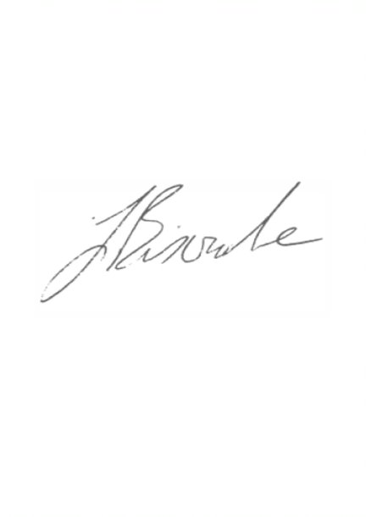
This is a meeting in public, not a public meeting. If you would like to attend and have any special requirements eg access or a copy of the agenda in another format, eg large print, please contact us.

Agenda and papers are available at www.weymouthtowncouncil.gov.uk

J L Biscombe, CiLCA
Town Clerk 05 September 2019 ____________________________________________________________________________

Agenda
- Welcome by the Chair
- Apologies for Absence and Substitutions
- Declarations of Interest
- Councillor questions
- Public comments and questions
- Policy adoption
- Employee Assistance Programme
- Cycle to Work Scheme
- Town Clerk’s Annual Appraisal
- Information items
- Exclusion of the public
- Staff Updates

- Welcome by the Chair

- Apologies for Absence and Substitutions
To approve apologies for absence and substitutions.

Apologies have been received from Cllr Mark Tewkesbury

- Declarations of Interest
To receive Councillor declarations of interest in matters on the agenda

- Councillor’s Question Time
Prior notice preferred where possible

- Public Question Time
The length of time available for public questions will be determined by the Chairman.

- Policy Adoption
Members are asked to discuss the following policies (attached to this agenda) and agree them for adoption:
- Appraisal Policy
- Bullying and Whistleblowing Policy
- Updated pay and flexi-time policy

Recommendation:
That Members agree the following policies adoption and for immediate use:
- Appraisal Policy
- Bullying and Whistleblowing Policy
- Updated pay and flexi-time policy

- Employee Assistance Programme
As a modern, supportive employer, WTC could provide staff with an Employee Assistance Programme (EAP). Such programmes are usual in larger Councils and Dorset Council provide a scheme for their staff.

Such schemes typically offer:
- A 24/7/365 confidential helpline
- Face-to-face, online or telephone counselling per issue, per employee, per year
- Medical information
- Online advice and support

Three quotes have been obtained to provide cover to all staff. These are £750, £750 and £1,180.

One of the £750 quotes comes with some additional benefits:
- Active Care - Day 1 intervention for stress and follow-ups
- 6 Sessions of face-to-face, online or telephone counselling per issue, per employee, per year (higher than average)
- A mobile app
- Critical incident and trauma support – on site in 6 hours

Thus far in 19/20 WTC has spent £120 on support for staff which would have been covered by this scheme. This scheme can be funded from existing HR budgets.

Recommendation:
Councillors are asked to agree to fund the EAP scheme, detailed in the report, at £750 pa

- Cycle to work scheme
Cyclescheme is the UK’s leading provider of tax-free bikes for the Government’s Cycle to Work initiative. Employees make savings on new bikes and/or accessories, whilst the Council gets a healthier, more motivated workforce and enjoy significant National Insurance Contribution savings. There is no net cost to the Council for this scheme, although the Council would need to meet the initial cost which is then recuperated from employees.

The employer buys the bikes and/or accessories at full retail price. The balance is then recovered from a reduction in the employees’ gross wages (salary sacrifice). Through salary sacrifice, employees can expect to save a minimum of 25% whilst employers benefit from worthwhile National Insurance Contribution savings of up to 13.8%.

At the end of the hire period the employee must make another payment to take ownership of the Cyclescheme Package. Without this payment HMRC would class the agreement as hire purchase (rather than hire), and as such the tax exemption would not be available.

The Cyclescheme process offers three simple hire end options: extend, pay or return. 94% of Cyclescheme participants opting to ‘extend’. This is a simple online process.

Once signed, the Hire Agreement is non-cancellable following a cooling-off period of 14-working days following collection of the goods. This means that if an employee leaves or is made redundant from their employment during the hire period they are obliged to pay the remaining salary sacrifice amount in full from net pay i.e. without any tax exemptions. This reduces the risk to the Council.

The bike and/or accessories remain the property of the employer throughout the hire period and employees are expected to ensure the items are covered by suitable insurance.

Employers can implement Cycle to Work schemes and offer a maximum certificate value of £1,000 inc. VAT per employee, thanks to a Cycle to Work exemption issued by the Financial Conduct Authority (FCA).

Although there may be personal, operational, health or weather related reasons why employees may be unable or unwilling to cycle into work, a significant number of staff live within a short distance of their base. Several have voiced an interest in a cycle to work scheme.

7 officers live within 2 miles of Crookhill
9 officers live between 2 and 3 miles of Crookhill
4 officers live further than 3 miles of Crookhill

6 officers live within 1 mile of the commercial road
8 officers live between 1 and 2 miles of commercial road
2 officers live between 2 and 3 miles of commercial road
3 officers live further than 3 miles of commercial road
The Council is installing new, secure bike racks at Commercial Road in September.

Recommendation:
That Councillors agree to adopt the Cyclescheme process to offer a Cycle to Work Scheme.

- Town Clerk’s Annual Appraisal
The Committee is asked to nominate two Councillors to carry out the Town Clerk’s Annual Appraisal in late September/early October to allow other appraisals to cascade from this. The full staff annual appraisal scheme needs to be completed in mid-November to allow any budget implications to be determined and fed back to the HR Committee on 27 November to be included in the draft budget for 20/21 being brought to the Finance and Governance Committee in December.

- Exclusion of the Public
Under the Public Bodies (Admissions to Meetings) Act 1960 members of the public and press are required to leave the meeting due to the sensitive nature of the item next to be considered relating to individual staff members.

Recommendation:
That Councillors agree to exclude the public and press.

- Staff Update
Members will receive a briefing on confidential staff matters.

Recruitment
The Council’s new Contracts and Procurement Officer starts at Commercial Road on 09 September 2019. This is a full time, permanent appointment and fills a vacancy in the base staff establishment.

The Council’s new Parks and Open Spaces Administrative Officer starts at Crookhill on 23 September 2019. This is a part time, permanent appointment and fills a vacancy in the base staff establishment.

The Parks and Open Spaces team are currently running an internal recruitment process for a semi-skilled worker. This is a full time, permanent appointment and will be met from existing allocated budgets.

Officers will now prioritise the recruitment of a Lengthsman.

Councillors will be presented with options for Enforcement Officers in the winter.

