

Council Offices, Commercial Road, Weymouth, Dorset, DT4 8NG
01305 239839
office@weymouthtowncouncil.gov.uk

Notice of Meeting
Members of the Planning and Licensing Committee are hereby summoned to the following meeting

MEETING: Planning & Licensing Committee

LOCATION: Council Offices, Commercial Road, Weymouth, DT4 8NG
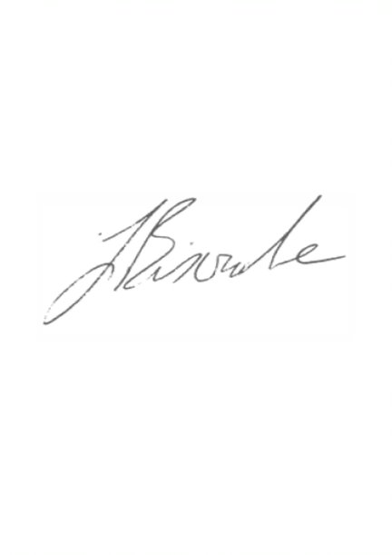
DATE & TIME: Tuesday 3 September 2019, 7.00 pm

J Biscombe CiLCA
Town Clerk 28 August 2019
------------------------------------------------------------------------------------------------------------------------------------

A G E N D A

- Apologies

- Declaration of Interests

- Minutes of the Previous Meeting

- Public Participation

- Planning Applications

- Licensing, Enforcement, Appeals & Phone Masts

- Other Development Consultations

- Traffic Calming and Parking Restriction Requests from the public

- Emergency Items

Item 1 – Apologies for absence
Members are asked to approve any apologies given.

Item 2 – Declarations of Interest
To receive Members declarations of interest in matters on the agenda

Item 3 – Minutes of the Previous Meeting
To confirm and sign the minutes of the Planning and Licensing Committee held on 13 August 2019 as a true record.

Item 4 – Public Participation
The length of time available for public participation will be determined by the Chairman.

Item 5 – Planning Applications
Members are requested to review the following planning applications and agree any comments to be forwarded to Dorset Council.

Planning applications and associated documents can be viewed at https://planning.dorset.gov.uk/public-access/

Plan No. | Details | Deadline
WP/19/00650/DOM | Erection of single storey rear extension; depth from wall 4.1m; 3.8m max height ; 2.3m height to eaves.  Location: 412 Dorchester Road, Weymouth, DT3 5AJ | 03/09/19
WP/19/00630/SOL | Installation of Solar Photovoltaic equipment  Location: Wey Valley School, Wey Valley Campus, 436 Dorchester Road, Weymouth, DT3 5AN (no prior approval needed but comments invited) | 03/09/19
WP/19/00592/FUL | Erect ground floor rear extension; replace existing first floor lean to roof with flat roof. Location:  18 Hardy Avenue, Weymouth, DT4 0RJ | 07/09/19
WP/19/00597/VOC | Demolish existing dwelling and erect a block of 7 no 2 bed flats (with variation of condition 2 of planning permission WP/17/00902/FUL to amend approved plans)  Location: 38 Preston Road, Weymouth | 08/09/19
WP/19/00600/FUL | Remodel existing rear extension and front porch together with internal alterations and insertion of roof lights.  Location: High House, Verlands Road, Weymouth, DT3 6BY | 08/09/19
WP/19/00605/VOC | Erect single storey front and side extensions and linked single storey pool hall. Change of use of agricutural land to residential. (with variation of condition 2 of planning permission WP/16/00309/FUL - to amend approved plans) Location: 30 Verlands Road, Weymouth, DT3 6BY | 08/09/19
WP/19/00601/CLP | Location: Mill House, Causeway, Weymouth, DT4 9RX Proposal: Installation of solar panels on the roof (this is not a planning application but an application for a Certificate of Lawfulness) | N/A
WP/19/00585/FUL | Roof alterations - install dormer window.  Location: 4 Blenheim Road, Weymouth, DT3 5AZ | 09/09/19

WP/19/00603/FUL | Sever land and erect 3 no 3 bedroom houses with undercroft parking.  Location: 15 Cranford Avenue, Weymouth, DT4 7TL | 09/09/19
WP/19/00594/FUL | Erection of 3 storey side extension to accommodate a wheel chairlift to each floor.  Location: 36 Whitehead Drive, Weymouth, DT4 9XT | 12/09/19
WP/19/00608/FUL | Erect First Floor Extension  Location: Bethany Hall, Westham Road, Melcombe Regis, Weymouth, DT4 8NP | 13/09/19
WP/19/00593/OUT | Demolish existing workshop and erect 10.No Dwellings (Outline)  Location: 12 Queen Street, Weymouth, DT4 7HZ | 13/09/19
WP/19/00613/VOC | Erect 1 No. dwelling and double garage and modify vehicular access - (Without compliance with condition 2 of planning permission reference WP/15/00858/VOC - retrospective)  Location: 42 Church Street, Weymouth, DT3 5QB | 21/09/19
WP/19/00611/FUL | Removal of stables and redundant barn/store. Erect 4.no detached houses and two double car ports.  Location: Martleaves House, 41 South Road, Weymouth, DT4 9NR | 21/09/19
WP/19/00614/FUL | Erection of Coach House at rear  Location: 239 Chickerell Road, Weymouth, DT4 0QW | 21/09/19

Item 6 - Licensing, Enforcement, Appeals & Phone Masts
None

Licensing applications may be viewed at: https://www.dorsetcouncil.gov.uk/business-consumers-licences/licences-and-permits/alcohol-and-entertainment-licences/comment-on-a-licence-application/current-licence-applications.aspx

Item 7 - Other development consultations
Application to modify the definitive map of Rights of Way in Weymouth (four documents attached)
The definitive map and statement is the legal record for public rights of way. An application has been made to modify the definitive map and statement of rights of way in the Weymouth area. The effect of the application, if successful, will be to alter Dorset Council’s record of public rights of way by adding a footpath in the Weymouth Town Council area.

Item 8 – Traffic Calming and Parking Restriction Requests from The Public
Councillors are asked to consider adopting a provisional policy for the consideration of such matters.

Officers suggest that Councillors agree that requests must be made in writing (email is encouraged) and will only be considered if supported by 10 named residents over the age of 18, directly affected by the requested measures. For suggested speed tables or bumps etc, these should include the residents who live closest to the site of the tables or bumps. For double yellow lines and other parking restrictions, the 10 should include people who live on the section of road to be affected.

Written requests should detail the names, addresses and contact details of the supporters, in a similar style to a traditional petition.

Written requests must also be accompanied by the name of at least one of the local ward Town Councillors who already supports the proposal.

Requests without the required level of support will be returned to the requester detailing the additional information needed.

Recommendation:
That Councillors agree the above policy as an interim measure pending a full policy being brought to a future Finance and Governance meeting.

Item 9 – Emergency Items
Members are asked to discuss any emergency items and agree comments to be made.

